UNITED STATES
SECURITIES AND EXCHANGE COMMISSION
Washington, D.C. 20549

FORM 8-K

Current Report
Pursuant to Section 13 or 15(d) of the Securities Exchange Act of 1934

Date of Report (Date of earliest event reported): July 22, 2026

CVB FINANCIAL CORP.
(Exact name of registrant as specified in its charter)

California | 000-10140 | 95-3629339
(State or other jurisdiction of  incorporation or organization) | (Commission file number) | (I.R.S. employer identification number)

701 North Haven Ave., Suite 350 Ontario, California |  | 91764
(Address of principal executive offices) |  | (Zip Code)

Registrant’s telephone number, including area code: (909) 980-4030

Not Applicable
(Former name or former address, if changed since last report)

Check the appropriate box below if the Form 8-K filing is intended to simultaneously satisfy the filing obligation of the registrant under any of the following provisions (See General Instruction A.2. below):
[ ] Written communications pursuant to Rule 425 under the Securities Act (17 CFR 230.425)
[ ] Soliciting material pursuant to Rule 14a-12 under the Exchange Act (17 CFR 240.14a-12)
[ ] Pre-commencement communications pursuant to Rule 14d-2(b) under the Exchange Act (17 CFR 240.14d-2(b))
[ ] Pre-commencement communications pursuant to Rule 13e-4(c) under the Exchange Act (17 CFR 240.13e-4(c))

Securities registered pursuant to Section 12(b) of the Act:

Title of each class | Trading Symbol(s) | Name of each exchange on which registered
Common Stock, No Par Value | CVBF | The Nasdaq Stock Market LLC

Indicate by check mark whether the registrant is an emerging growth company as defined in Rule 405 of the Securities Act of 1933 (§230.405 of this chapter) or Rule 12b-2 of the Securities Exchange Act of 1934 (§240.12b-2 of this chapter).

Emerging growth company ☐

If an emerging growth company, indicate by check mark if the registrant has elected not to use the extended transition period for complying with any new or revised financial accounting standards provided pursuant to Section 13(a) of the Exchange Act. ☐

Item 2.02 Results of Operations and Financial Condition.
On July 22, 2026, CVB Financial Corp. issued a press release setting forth the financial results for the quarter ended June 30, 2026, and information relating to our quarterly conference call and webcast. A copy of this press release is attached hereto as Exhibit 99.1 and is being furnished pursuant to this Item 2.02. The information in this report (including Exhibit 99.1) shall not be deemed to be “filed” for the purposes of Section 18 of the Securities Exchange Act of 1934, as amended (the “Exchange Act”), or otherwise subject to the liability of that section, and shall not be incorporated by reference into any registration statement or other document filed under the Securities Act of 1933, as amended (the “Securities Act”), except as expressly set forth by specific reference in such filing.

Item 7.01 Regulation FD Disclosure.

The Chief Executive Officer, President and Chief Financial Officer of CVB Financial Corp. (the “Company”) will make presentations to institutional investors at various meetings throughout the third quarter of 2026. The July 2026 slide presentation, updated to reflect second quarter 2026 financial information, is included as Exhibit 99.2 of this report. The information in this report (including Exhibit 99.2) shall not be deemed to be “filed” for the purposes of Section 18 of the Exchange Act, or otherwise subject to the liability of that section, and shall not be incorporated by reference into any registration statement or other documents filed under the Securities Act, except as shall be expressly set forth by the specific reference in such filing. A copy of the slide presentation will also be available on the Company's website at www.cbbank.com under the “Investors” tab.

Item 9.01 Financial Statements and Exhibits.*
(d) Exhibits.
Exhibit No | Description
99.1 | Press Release issued by CVB Financial, dated July 22, 2026
99.2 | CVB Financial Corp. July 2026 slide presentation
104 | Cover Page Interactive Data File (embedded within the Inline XBRL document)

SIGNATURES
Pursuant to the requirements of the Securities Exchange Act of 1934, the registrant has duly caused this report to be signed on its behalf by the undersigned hereunto duly authorized.
 |  |  | CVB FINANCIAL CORP.
Date: | July 23, 2026 | By: | /s/ E. Allen Nicholson
E. Allen Nicholson
Executive Vice President and Chief Financial Officer

Exhibit 99.1



Press Release | Contact: David A. Brager
For Immediate Release | Chief Executive Officer
 | (909) 980-4030
CVB Financial Corp. Reports Earnings for the Second Quarter 2026
Second Quarter 2026
•
Net Earnings of $48.3 million, or $0.29 per share
•
Assets totaled $21.18 billion as acquisition of Heritage Commerce Corp completed on April 17, 2026
•
Net Interest Margin expanded to 3.72%
•
$31.4 million of acquisition expense and $4.25 million provision for unfunded loan commitments

Ontario, CA, July 22, 2026 - CVB Financial Corp. (NASDAQ: CVBF) (“CVBF” or the “Company”) and its subsidiary, Citizens Business Bank, National Association (“Citizens” or the “Bank”), announced earnings for the quarter ended June 30, 2026.
CVB Financial Corp. reported net income of $48.3 million for the quarter ended June 30, 2026, compared with $51.0 million for the first quarter of 2026 and $50.6 million for the second quarter of 2025. Diluted earnings per share were $0.29 for the second quarter, compared to $0.38 for the prior quarter and $0.37 for the same period last year.
For the second quarter of 2026, annualized return on average equity (“ROAE”) was 6.41%, annualized return on average tangible common equity (“ROATCE”) was 10.85%, and annualized return on average assets (“ROAA”) was 0.97%.

On April 17, 2026, the Company completed its acquisition of Heritage Commerce Corp (“Heritage”), including its banking subsidiary, Heritage Bank of Commerce, and also completed the systems conversion during the second quarter of 2026. The Company’s second quarter 2026 financial results included 74 days of Heritage's operations, post-merger, which impacts the comparability of the current quarter's results to prior periods. At close, the Company acquired loans with a fair value of $3.4 billion, assumed $1.2 billion of noninterest-bearing deposits, $3.5 billion of interest-bearing deposits, and $38.7 million of subordinated debentures. The acquisition resulted in $450.7 million of intangible assets, including a core deposit premium of $116.6 million and goodwill of $334.1 million. During the quarter, $31.4 million of acquisition expenses were incurred and a $4.25 million provision for unfunded loan commitments was recorded.
1

David Brager, Chief Executive Officer of the Company, commented, “Our consistent financial performance is highlighted by our 197 consecutive quarters, or 49 years, of profitability, and our 147 consecutive quarters of paying cash dividends. I would like to thank our customers and associates for their continued commitment and loyalty, as well as our associates for the outstanding efforts and commitment to the successful systems conversion completed in June" Brager continued, "the merger with Heritage Bank of Commerce marks the most strategic and largest acquisition by asset size in our history, bringing together two premier, relationship focused business banks and advancing our longstanding objective of expanding Citizens throughout California. With the systems integration behind us, we will continue to focus on our vision of serving the comprehensive financial needs of small to medium sized businesses and their owners. We now operate in every major economic center of California and will continue to deliver our relationship focused banking model throughout the state of California. ”

2

Highlights for the Second Quarter of 2026
•
Net interest income grew by $44.6 million, or 37.8% from Q1 of 2026
•
Net interest margin of 3.72% increased by 28 basis points from Q1 of 2026
•
Loans increased by $3.37 billion, or 39.0% from the end of Q1 of 2026
•
Completed sale of SFR mortgage pool loans acquired from Heritage with a fair value of $327 million
•
Average total deposit and customer repurchase agreements increased by $3.60 billion, or 29.0% from Q1 of 2026
•
52.8% of total deposits noninterest-bearing at quarter end
•
Cost of funds decreased to 0.96% from 0.97% in Q1 of 2026
•
Adjusted efficiency ratio of 43.88%, excluding acquisition expense and provision for unfunded loan commitments[1]
•
Announced share repurchase plan up to 15 million shares, replacing the prior 2024 share repurchase program

INCOME STATEMENT HIGHLIGHTS

 | Three Months Ended |  |  |  |  |  |  |  |  |  |  |  | Six Months Ended
 | June 30,  2026 |  |  |  | March 31,  2026 |  |  |  | June 30,  2025 |  |  |  | June 30,  2026 |  |  |  | June 30,  2025
 | (Dollars in thousands, except per share amounts)
Net interest income | $ | 162,415 |  |  | $ | 117,840 |  |  | $ | 111,608 |  |  | $ | 280,255 |  |  | $ | 222,052
Provision for credit losses |  | — |  |  |  | 3,000 |  |  |  | — |  |  |  | 3,000 |  |  |  | 2,000
Noninterest income |  | 17,010 |  |  |  | 14,279 |  |  |  | 14,744 |  |  |  | 31,289 |  |  |  | 30,973
Noninterest expense |  | 114,378 |  |  |  | 60,568 |  |  |  | 57,557 |  |  |  | 174,946 |  |  |  | 116,701
Income tax expense |  | 16,786 |  |  |  | 17,549 |  |  |  | 18,231 |  |  |  | 34,335 |  |  |  | 36,656
Net earnings | $ | 48,261 |  |  | $ | 51,002 |  |  | $ | 50,564 |  |  | $ | 99,263 |  |  | $ | 101,668
Earnings per common share:
Basic | $ | 0.29 |  |  | $ | 0.38 |  |  | $ | 0.37 |  |  | $ | 0.65 |  |  | $ | 0.73
Diluted | $ | 0.29 |  |  | $ | 0.38 |  |  | $ | 0.37 |  |  | $ | 0.65 |  |  | $ | 0.73
NIM - tax equivalent (“TE”) [1] |  | 3.72 | % |  |  | 3.44 | % |  |  | 3.31 | % |  |  | 3.60 | % |  |  | 3.31 | %
ROAA |  | 0.97 | % |  |  | 1.33 | % |  |  | 1.34 | % |  |  | 1.13 | % |  |  | 1.35 | %
ROAE |  | 6.41 | % |  |  | 8.86 | % |  |  | 9.06 | % |  |  | 7.47 | % |  |  | 9.18 | %
ROATCE |  | 10.85 | % |  |  | 13.38 | % |  |  | 14.08 | % |  |  | 11.99 | % |  |  | 14.29 | %
Efficiency ratio |  | 63.75 | % |  |  | 45.84 | % |  |  | 45.55 | % |  |  | 56.15 | % |  |  | 46.12 | %
[1] Includes tax equivalent (TE) adjustments utilizing a federal statutory rate of 21%.

Net Interest Income
Net interest income was $162.4 million for the second quarter of 2026, an increase of $44.6 million, or 37.83%, from the first quarter of 2026, and an increase of $50.8 million, or 45.52%, from the second quarter of 2025. The quarter-over-quarter and year-over-year increases in net interest income largely reflects the impact of operating as a combined company for approximately two and a half months following the Heritage acquisition. Interest income increased by $53.0 million, or 35.56%, from the first quarter of 2026, while interest expense increased by $8.4 million, or 27.00%, to $39.7 million in the second quarter of 2026. The quarter-over-quarter increase in net interest income was primarily due to a 28 basis point increase in net interest margin and a $3.67 billion increase in average interest-earning assets.

_______________________________________________________________________________________________
[1] Non-U.S. generally accepted accounting principles (“GAAP”) financial measures. See GAAP to non–GAAP reconciliations of the measures are set forth at the last section of this press release.
3

Compared to the second quarter of 2025, the $50.8 million increase in net interest income was primarily driven by a $57.9 million increase in interest income driven by a $4.01 billion increase in average interest-earning assets and a 34 basis point increase in the yield on earning assets. The increase in interest income was offset by a $7.1 million increase in interest expense attributable to a $2.83 billion increase in average interest-bearing deposits and customer repurchase agreements.

Net Interest Margin
Our tax equivalent net interest margin was 3.72% for the second quarter of 2026, compared to 3.44% for the first quarter of 2026 and 3.31% for the second quarter of 2025. The 28 basis points increase in our net interest margin compared to the first quarter of 2026 was primarily attributable to a 28 basis points increase in our average interest-earning assets yield, which was primarily driven by a 21 basis points increase in our average loan yield and a 11 basis points increase in our average investment securities yield. The increase in average loan yields reflected the Company's acquisition of Heritage and the addition of higher-yielding acquired assets, including approximately $86.1 million of average factored receivables during the quarter. Through the acquisition, the Company acquired CSNK Working Capital Finance Corp., doing business as Bay View Funding, a wholly owned subsidiary of the Bank that provides working capital factoring financing to businesses throughout the United States. During the quarter, the average yield on factored receivables was 18.04%. Cost of funds remained stable at 0.96% for the second quarter of 2026 compared to 0.97% in the first quarter of 2026, reflecting a 24 basis points decrease in the cost of FHLB borrowing, offset by a five basis point increase in our cost of deposits to 0.83%, from 0.78%.
Our tax equivalent net interest margin for the second quarter of 2026 increased by 41 basis points compared to the second quarter of 2025, reflecting a 34 basis point increase in the average interest-earning assets yield and a seven basis point decrease in cost of funds. The increase in earning assets yield was primarily due to a 31 basis point increase in average loan yields, reflecting the addition of higher-yielding acquired factored receivables portfolio acquired through the Heritage acquisition. Partially offsetting this increase was a lower yield on funds deposited at the Federal Reserve, resulting from the 75 basis points reduction in federal funds target rate by FOMC during the last four months of 2025. The average yield on investment securities increased by 12 basis points from the second quarter of 2025, despite the impact of the fair value hedges of our investment securities available-for-sale ("AFS"), which generated a negative carry during the second quarter of 2026 and reduced interest income by $1.4 million compared to the positive carry recognized in the same quarter last year. Cost of funds decreased to 0.96% in the second quarter of 2026 from 1.03% in the second quarter of 2025. This decrease was driven by a 35 basis point reduction in cost of interest-bearing deposits and a 29 basis point decrease in cost of FHLB borrowing. Partially offsetting these lower funding costs, noninterest-bearing deposits declined as a percentage of average total deposits to 52.3% in the second quarter of 2026 from 59.7% in the second quarter of 2025, resulting in a less favorable deposit mix.

Earning Assets and Deposits
The increases in average earning assets and average total deposits were primarily attributable to the Heritage acquisition. On average, earning assets increased by $3.67 billion compared to the first quarter of 2026 and increased $4.01 billion compared to the second quarter of 2025. The quarter-over-quarter increase in interest-earning assets was primarily attributable to a $2.92 billion increase in average loans, a $388.0 million increase in average interest-earning deposits at the Federal Reserve, and $349.7 million increase in average investment securities. The year-over-year increase in interest-earning assets was primarily attributable to a $3.19 billion increase in average loans, a $423.5 million increase in average investment securities and a $331.2 million increase in average interest-earning deposits at the Federal Reserve.

The average balance on noninterest-bearing deposits increased by $1.23 billion, or 17.83%, from the first quarter of 2026 and by $1.07 billion, or 15.20%, from the second quarter of 2025. The average balance on interest-bearing deposits and customer repurchase agreements increased by $2.38 billion from the first quarter of 2026 and increased by $2.83 billion from the second quarter of 2025. On average, noninterest-bearing deposits were 52.3% of total deposits for the second quarter of 2026, compared to 57.8% for the first quarter of 2026 and 59.7% for the second quarter of 2025.

4

SELECTED FINANCIAL HIGHLIGHTS

 | Three Months Ended
 | June 30, 2026 |  |  |  |  |  |  |  | March 31, 2026 |  |  |  |  |  |  |  | June 30, 2025
 | (Dollars in thousands)
Yield on average investment securities (TE) | 2.74% |  |  |  |  |  |  |  | 2.63% |  |  |  |  |  |  |  | 2.62%
Yield on average loans | 5.53% |  |  |  |  |  |  |  | 5.32% |  |  |  |  |  |  |  | 5.22%
Yield on average earning assets (TE) | 4.62% |  |  |  |  |  |  |  | 4.35% |  |  |  |  |  |  |  | 4.28%
Cost of deposits | 0.83% |  |  |  |  |  |  |  | 0.78% |  |  |  |  |  |  |  | 0.84%
Cost of funds | 0.96% |  |  |  |  |  |  |  | 0.97% |  |  |  |  |  |  |  | 1.03%
Net interest margin (TE) | 3.72% |  |  |  |  |  |  |  | 3.44% |  |  |  |  |  |  |  | 3.31%
Average Earning Assets Mix | Avg |  |  |  | % of Total |  |  |  | Avg |  |  |  | % of Total |  |  |  | Avg |  |  |  | % of Total
Total investment securities | $ | 5,270,895 |  |  |  | 30.01 | % |  | $ | 4,921,215 |  |  |  | 35.43 | % |  | $ | 4,847,415 |  |  |  | 35.75 | %
Investment in FHLB, FRB, and other stock |  | 77,891 |  |  |  | 0.44 | % |  |  | 55,948 |  |  |  | 0.40 | % |  |  | 18,012 |  |  |  | 0.13 | %
Interest-earning deposits with other institutions |  | 669,165 |  |  |  | 3.81 | % |  |  | 290,536 |  |  |  | 2.09 | % |  |  | 337,929 |  |  |  | 2.49 | %
Loans |  | 11,548,138 |  |  |  | 65.74 | % |  |  | 8,624,604 |  |  |  | 62.08 | % |  |  | 8,354,898 |  |  |  | 61.62 | %
Total interest-earning assets | $ | 17,566,089 |  |  |  | 100.00 | % |  | $ | 13,892,303 |  |  |  | 100.00 | % |  | $ | 13,558,254 |  |  |  | 100.00 | %
Average Deposits & Borrowings | Avg |  |  |  | % of Total |  |  |  | Avg |  |  |  | % of Total |  |  |  | Avg |  |  |  | % of Total
Noninterest bearing deposits | $ | 8,123,844 |  |  |  | 49.22 | % |  | $ | 6,894,427 |  |  |  | 53.12 | % |  | $ | 7,051,702 |  |  |  | 55.56 | %
Interest-bearing deposits |  | 7,400,171 |  |  |  | 44.84 | % |  |  | 5,041,899 |  |  |  | 38.85 | % |  |  | 4,755,828 |  |  |  | 37.47 | %
Customer repurchase agreements |  | 564,766 |  |  |  | 3.42 | % |  |  | 541,881 |  |  |  | 4.18 | % |  |  | 376,629 |  |  |  | 2.97 | %
FHLB advances and other borrowings |  | 384,295 |  |  |  | 2.33 | % |  |  | 500,000 |  |  |  | 3.85 | % |  |  | 508,159 |  |  |  | 4.00 | %
Subordinated debentures |  | 31,993 |  |  |  | 0.19 | % |  |  | — |  |  |  | 0.00 | % |  |  | — |  |  |  | 0.00 | %
Total deposits and borrowings | $ | 16,505,069 |  |  |  | 100.00 | % |  | $ | 12,978,207 |  |  |  | 100.00 | % |  | $ | 12,692,318 |  |  |  | 100.00 | %

Provision for Credit Losses
There was no provision for credit losses in the second quarter of 2026, compared to a $3.0 million provision for credit losses in the first quarter of 2026 and no provision for credit losses in the second quarter of 2025.

Noninterest Income
Noninterest income totaled $17.0 million for the second quarter of 2026, an increase of $2.7 million from $14.3 million for the first quarter of 2026 and an increase of $2.3 million from $14.7 million for the second quarter of 2025, including the impact of the Heritage acquisition. The quarter-over-quarter increase includes a $519,000 increase in service charges on deposit accounts, a $460,000 increase in trust and investment services income, and a $353,000 increase in bank-owned life insurance (“BOLI”) income.
Noninterest Expense
Noninterest expense totaled $114.4 million for the second quarter of 2026, compared to $60.6 million for the first quarter of 2026 and $57.6 million for the second quarter of 2025. The increase was primarily attributable to the Heritage acquisition, and the related addition of operations, personnel, and banking centers. Acquisition related expenses associated with the Heritage merger totaled $31.4 million in the second quarter of 2026, compared to $1.1 million for the first quarter of 2026. Excluding acquisition expense, noninterest expense increased $23.5 million compared to the first quarter of 2026. This increase was primarily driven by a $9.1 million increase in salaries and employee benefits, a $3.8 million increase in provision for unfunded loan commitments attributable to day 1 provision from the Heritage acquisition of $4.25 million, and a $2.7 million increase in amortization of intangible assets resulting from the core deposit intangibles associated with the acquisition, and $1.8 million increase in computer software expense. Excluding acquisition expense and the provision for unfunded loan commitments, the increase in noninterest expense compared to the second quarter of 2025 was $21.2 million.

5

As a percentage of average assets, noninterest expense was 2.31% for the second quarter of 2026, 1.58% for the first quarter of 2026, and 1.52% for the second quarter of 2025. The efficiency ratio was 63.75% for the second quarter of 2026, compared to 45.84% for the first quarter of 2026 and 45.55% for the second quarter of 2025. Excluding acquisition related expenses and the provision for unfunded loan commitments, the adjusted efficiency ratio[1] was 43.88% for the second quarter of 2026, compared to 44.61% for the first quarter of 2026 and 45.55% for the second quarter of 2025.

Income Taxes
Our effective tax rate for the quarter ended June 30, 2026 was 25.81%, compared with 25.60% for the first quarter of 2026, and 26.50% for the second quarter of 2025. Our estimated annual effective tax rate can vary depending upon the level of tax-advantaged income from municipal securities and BOLI, as well as tax credit investments.

BALANCE SHEET HIGHLIGHTS
Assets
Total assets were $21.18 billion at June 30, 2026, an increase of $5.68 billion, or 36.60%, from $15.51 billion at March 31, 2026. The increase was primarily attributable to a $3.37 billion increase in total loans, $839.1 million increase in investment securities and a $596.0 million increase in interest-earning balances due from the Federal Reserve. The increases in total assets compared to prior periods primarily reflect the impact of the Heritage acquisition completed on April 17, 2026, partially offset by balance sheet optimization activities during the quarter.
Total assets increased by $5.55 billion, or 35.52%, from $15.63 billion at December 31, 2025. The increase in assets was primarily driven by an increase of $3.32 billion, or 38.14%, in total loans, a $722.8 million, or 14.59% increase in investment securities and a $640.9 million, or 238.36%, increase in interest-earnings balances due from the Federal Reserve.

Total assets at June 30, 2026 increased by $5.77 billion, or 37.42%, from $15.41 billion at June 30, 2025. The increase in assets was primarily driven by an increase of $3.66 billion, or 43.77%, in total loans, an increase of $862.8 million, or 17.92%, in investment securities, and an increase of $366.2 million, or 67.37%, in interest-earning balances due from the Federal Reserve.
Investment Securities
Total investment securities were $5.68 billion at June 30, 2026, an increase of $839.1 million, or 17.35%, from $4.84 billion at March 31, 2026, an increase of $722.8 million, or 14.59%, from December 31, 2025, and an increase of $862.8 million, or 17.92%, from $4.81 billion at June 30, 2025. The increase in investment securities in the second quarter of 2026 compared to prior quarters was primarily the result of approximately $519.0 million of investment securities acquired and retained from the Heritage acquisition as well as approximately $500.0 million of purchases of AFS securities during the quarter. As part of the Company's balance sheet management strategy to improve portfolio yields and reduce asset duration, approximately $490 million of securities acquired from Heritage were sold at close of the merger and reinvested in lower duration securities at an average yield of approximately 4.70%.
At June 30, 2026, investment securities held-to-maturity (“HTM”) totaled $2.22 billion, a decrease of $29.5 million, or 1.31%, from March 31, 2026 and a decrease of $108.7 million, or 4.67%, from June 30, 2025.

_________________________________________________________________________________________________
[1] Non-GAAP financial measures. See GAAP to non–GAAP reconciliations of the measures are set forth at the last section of this press release.

6

At June 30, 2026, investment securities AFS totaled $3.46 billion, inclusive of a pre-tax net unrealized loss of $323.5 million. AFS securities increased by $868.6 million, or 33.55% from March 31, 2026 and increased by $971.5 million, or 39.07%, from $2.49 billion at June 30, 2025. The pre-tax net unrealized loss at June 30, 2026 increased by $13.1 million from March 31, 2026 and decreased by $40.2 million from June 30, 2025.

Loans
Total loans and leases, at amortized cost, of $12.02 billion at June 30, 2026 increased by $3.37 billion, or 39.03%, from $8.64 billion at March 31, 2026. The quarter-over-quarter increase was primarily due to increases of $2.35 billion in commercial real estate loans, $526.6 million in commercial and industrial loans, $166.3 million in consumer loans, $150.7 million in construction loans, $149.9 million in Small Business Administration (“SBA”) loans, and $63.1 million in single-family residential (“SFR”) mortgage loans, partially offset by decreases of $33.8 million in dairy & livestock and agribusiness loans, and $1.4 million in municipal lease finance receivables. The increase in total loans and leases compared to prior quarters was primarily attributable to the Heritage acquisition, which added $3.10 billion of loans held for investment recorded at fair value as of the acquisition date.

Total loans and leases, at amortized cost, increased by $3.32 billion, or 38.14%, from December 31, 2025. The increase included increases of $2.41 billion in commercial real estate loans, $505.3 million in commercial and industrial loans, $172.2 million in construction loans, $166.7 million in consumer loans, $159.2 million in SBA loans, and $59.6 million in SFR mortgage loans. These increases were partially offset by decreases of $150.6 million in dairy & livestock and agribusiness loans associated with the seasonal increase that occurs every calendar year end, and $3.5 million in municipal lease finance receivables loans.

Total loans and leases, at amortized cost, increased by $3.66 billion, or 43.77%, from June 30, 2025. The $3.66 billion increase included increases of $2.47 billion in commercial real estate loans, $566.5 million in commercial and industrial loans, $192.3 million in construction loans, $170.9 million in consumer loans, $169.8 million in SBA loans, $52.9 million in SFR mortgage loans, partially offset by a decrease of $7.6 million in municipal lease finance receivables.

Asset Quality
During the second quarter of 2026, we experienced credit charge-offs of $141,000 and total recoveries of $4,000, resulting in net charge-offs of $137,000, which compares to net recoveries of $9,000 in the prior quarter. The allowance for credit losses (“ACL”) totaled $126.7 million at June 30, 2026, compared to $80.2 million at March 31, 2026 and $78.0 million at June 30, 2025. The ACL increased $46.5 million in the second quarter of 2026, reflecting the initial ACL of $46.6 million on the purchased credit deteriorated (“PCD”) loans and purchased seasoned loans (“PSL”) acquired from the Heritage acquisition. At June 30, 2026, the ACL as a percentage of total loans and leases outstanding was 1.05%. This compares to 0.93% at both March 31, 2026 and June 30, 2025.
7

Nonperforming loans, defined as nonaccrual loans, including modified loans on nonaccrual, plus loans 90 days past due and accruing interest, and nonperforming assets, defined as nonperforming plus OREO, are highlighted below.

Nonperforming Assets and Delinquency Trends |  | June 30,  2026 |  |  |  | March 31,  2026 |  |  |  | June 30,  2025
 |  | (Dollars in thousands)
Nonperforming loans
Commercial real estate |  | $ | 4,905 |  |  | $ | 2,094 |  |  | $ | 24,379
Construction |  |  | 685 |  |  |  | — |  |  |  | —
SBA |  |  | 918 |  |  |  | 477 |  |  |  | 1,265
Commercial and industrial |  |  | 9,672 |  |  |  | 3,573 |  |  |  | 265
Dairy & livestock and agribusiness |  |  | — |  |  |  | — |  |  |  | 60
Consumer and other loans |  |  | 462 |  |  |  | — |  |  |  | —
Total |  | $ | 16,642 |  |  | $ | 6,144 |  |  | $ | 25,969
% of Total loans |  |  | 0.14 | % |  |  | 0.07 | % |  |  | 0.31 | %
OREO
Commercial real estate |  | $ | 206 |  |  | $ | 206 |  |  | $ | 661
Total |  | $ | 206 |  |  | $ | 206 |  |  | $ | 661
Total nonperforming assets |  | $ | 16,848 |  |  | $ | 6,350 |  |  | $ | 26,630
% of Nonperforming assets to total assets |  |  | 0.08 | % |  |  | 0.04 | % |  |  | 0.17 | %
Past due 30-89 days (accruing)
Commercial real estate |  | $ | 2,762 |  |  | $ | 4,715 |  |  | $ | —
SBA |  |  | 785 |  |  |  | 1,553 |  |  |  | 3,419
Commercial and industrial |  |  | 75 |  |  |  | 88 |  |  |  | —
SFR mortgage |  |  | — |  |  |  | 249 |  |  |  | —
Consumer and other loans |  |  | 123 |  |  |  | — |  |  |  | —
Total |  | $ | 3,745 |  |  | $ | 6,605 |  |  | $ | 3,419
% of Total loans |  |  | 0.03 | % |  |  | 0.08 | % |  |  | 0.04 | %
Total nonperforming, OREO,  and past due |  | $ | 20,593 |  |  | $ | 12,955 |  |  | $ | 30,049
Classified Loans |  | $ | 109,718 |  |  | $ | 83,058 |  |  | $ | 73,422

The $10.5 million increase in nonperforming loans from March 31, 2026 was primarily due to the addition of 12 nonperforming commercial and industrial loans totaling $6.2 million, three nonperforming commercial real estate loans totaling $4.3 million, and one nonperforming construction loan for $685,000, offset by three commercial real estate nonaccrual loan payoffs totaling $1.5 million.

Classified loans are loans that are graded “substandard” or worse. Classified loans increased $26.7 million quarter-over-quarter, primarily driven by $29.1 million of classified loans acquired in the Heritage merger.
Deposits & Customer Repurchase Agreements
Deposits of $16.29 billion and customer repurchase agreements of $563.4 million totaled $16.85 billion at June 30, 2026, compared to $12.44 billion at March 31, 2026, $12.56 billion at December 31, 2025, and $12.39 billion at June 30, 2025. Deposits and customer repurchase agreements increased $4.41 billion, or 35.47%, from March 31, 2026, $4.29 billion, or 34.15% from December 31, 2025, and $4.46 billion, or 36.03%, from June 30, 2025. The increases primarily reflected $1.2 billion of noninterest-bearing deposits and $3.5 billion of interest-bearing deposits assumed in connection with the Heritage acquisition completed during the second quarter of 2026.
Noninterest-bearing deposits were $8.61 billion at June 30, 2026, an increase of $1.51 billion, or 21.22%, compared to $7.10 billion at March 31, 2026. Noninterest-bearing deposits increased $1.81 billion, or 26.56%, from $6.80 billion at December 31, 2025 and $1.36 billion, or 18.76%, from $7.25 billion at June 30, 2025. At June 30, 2026, noninterest-bearing
8

deposits were 52.84% of total deposits, compared to 59.44% at March 31, 2026, 56.33% at December 31, 2025, and 60.47% at June 30, 2025. The decrease in noninterest-bearing deposits as a percentage of total deposits primarily reflected the mix of deposits assumed in the Heritage acquisition, which included a higher proportion of interest-bearing deposits.

Borrowings
As of June 30, 2026, total borrowings were $539.0 million, consisting of $500.0 million of Federal Home Loan Bank ("FHLB") advances and $39.0 million of subordinated debt assumed in the Heritage acquisition, compared to $500.0 million of FHLB advances at both March 31, 2026 and December 31, 2025. At June 30, 2026, FHLB advances consisted of $300.0 million of 90 day advances that have been hedged with a cashflow hedge in which the Company pays a fixed rate cost of 4.10% and receives SOFR and $200.0 million putable advance with a cost of 4.27% maturing in May 2027. During the second quarter of 2026, $300.0 million of FHLB advances, with a weighted-average cost of 4.73%, matured in May and were not replaced during the quarter.

Capital
The Company’s total equity was $3.17 billion at June 30, 2026, compared to $2.30 billion at December 31, 2025 and $2.24 billion at June 30, 2025. The increase of $874.5 million from December 31, 2025 was primarily due to $840.2 million of common shares issued and exchanged as a result of the Heritage acquisition and $99.3 million in net earnings, partially offset by $62.5 million in cash dividends declared and $5.1 million common stock repurchases. On June 15, 2026, the Board of Directors approved a program to repurchase up to 15,000,000 shares of CVB common stock (the “2026 Repurchase Program”). The 2026 Repurchase Program replaced in its entirety the Company's previous 2024 share repurchase program. During the second quarter of 2026, the Company purchased 241,034 shares under the 2026 Repurchase Program, at an average price of $21.06 per share for an aggregate purchase price of $5.1 million.

Our tangible book value per share was $11.07 at June 30, 2026, compared to $11.42 at March 31, 2026 and $10.64 at June 30, 2025, respectively.
Our capital ratios under the revised capital framework referred to as Basel III remain well above regulatory standards.

 |  |  |  | CVB Financial Corp. Consolidated
 |  | Minimum Required Plus  Capital Conservation Buffer |  | June 30,  2026 |  | December 31,  2025 |  | June 30,  2025
Tier 1 leverage capital ratio |  | 4.0% |  | 11.7% |  | 11.6% |  | 11.8%
Common equity Tier 1 capital ratio |  | 7.0% |  | 14.7% |  | 15.9% |  | 16.5%
Tier 1 risk-based capital ratio |  | 8.5% |  | 14.7% |  | 15.9% |  | 16.5%
Total risk-based capital ratio |  | 10.5% |  | 15.8% |  | 16.7% |  | 17.3%
Tangible common equity (“TCE”) ratio |  |  |  | 9.8% |  | 10.3% |  | 10.0%

CitizensTrust
As of June 30, 2026, CitizensTrust had approximately $5.18 billion in assets under management and administration, including $3.81 billion in assets under management. Revenues were $4.2 million for the second quarter of 2026, compared to $3.7 million in the first quarter and $3.7 million for the second quarter of 2025. CitizensTrust provides trust, investment and brokerage related services, as well as financial, estate and business succession planning.
Corporate Overview
CVB Financial Corp. (“CVBF”) is the holding company for Citizens Business Bank, National Association. CVBF is one of the ten largest bank holding companies headquartered in California with more than $20 billion in total assets as of the closing of the mergers with Heritage Commerce Corp and its principal banking subsidiary, Heritage Bank of Commerce. Citizens Business Bank, National Association, is consistently recognized as one of the top performing banks in the nation and offers a wide array of banking, lending and investing services with more than 75 banking centers and three trust office locations serving California.
9

Shares of CVB Financial Corp. common stock are listed on the NASDAQ under the ticker symbol “CVBF”. For investor information on CVB Financial Corp., visit our Citizens Business Bank website at www.cbbank.com and click on the “Investors” tab.
Conference Call
Management will hold a conference call at 7:30 a.m. PDT/10:30 a.m. EDT on Thursday, July 23, 2026, to discuss the
Company’s second quarter 2026 financial results. The conference call can be accessed live by registering at: https://register-conf.media-server.com/register/BIf3989c35152a4f7d8d7a5a51b75f972f
The conference call will also be simultaneously webcast over the Internet; please visit our Citizens Business Bank website at www.cbbank.com and click on the “Investors” tab to access the call from the site. Please access the website 15 minutes prior to the call to download any necessary audio software. This webcast will be recorded and available for replay on the Company’s website approximately two hours after the conclusion of the conference call and will be available on the website for approximately 12 months.

Forward-Looking Statements

Certain statements set forth herein constitute forward-looking statements within the meaning of Section 27A of the Securities Act of 1933, as amended, and Section 21E of the Securities Exchange Act of 1934, as amended, which are intended to be covered by the safe harbor for "forward-looking statements" provided by the Private Securities Litigation Reform Act of 1995. Words such as “will likely result”, “aims”, “anticipates”, “believes”, “could”, “estimates”, “expects”, “hopes”, “intends”, “may”, “plans”, “projects”, “seeks”, “should”, “will,” “strategy”, “possibility”, and variations of these words and similar expressions help to identify these forward-looking statements, which involve risks and uncertainties that could cause actual results or performance to differ materially from those projected. These forward-looking statements are based on management’s current expectations and beliefs concerning future developments and their potential effects on the Company including, without limitation, plans, strategies, goals and statements about the Company’s outlook regarding revenue and asset growth, financial performance and profitability, capital and liquidity levels, loan and deposit levels, growth and retention, yields and returns, loan diversification and credit management, stockholder value creation, tax rates, the impact of business, economic, or political developments, the impact of monetary, fiscal and trade policies, and the impact of acquisitions we have made or may make, including our recent acquisition of Heritage Commerce Corp and its wholly-owned banking subsidiary, Heritage Bank of Commerce (collectively “Heritage”) . Such statements involve inherent risks and uncertainties, many of which are difficult to predict and are generally beyond the control of the Company, and there can be no assurance that future developments affecting the Company will be the same as those anticipated by management. The Company cautions readers that a number of important factors, in addition to those set forth below, could cause actual results to differ materially from those expressed in, or implied or projected by, such forward-looking statements.
General risks and uncertainties include, but are not limited to, the following: the strength of the United States economy and the strength of the local economies in which we conduct business; the effects of, and changes in, immigration, trade, tariff, monetary, and fiscal policies and laws, including interest rate policies of the Board of Governors of the Federal Reserve System; inflation/deflation, interest rate, market and monetary fluctuations; the effects of acquisitions we have made or may make, including, without limitation, the failure to achieve the expected efficiencies and financial results from such acquisitions; the timely development of competitive new products and services, and the acceptance of these products and services by potential and existing customers; the impact of changes in financial services policies, laws, and regulations, including those concerning banking, taxes, securities, and insurance, and the application thereof by regulatory agencies; changes in the scope and cost of FDIC insurance; the effectiveness of our risk management framework and quantitative models; changes in the level of our nonperforming assets and charge-offs; the effect of changes in accounting policies and practices or accounting standards, as may be adopted from time-to-time by bank regulatory agencies, the U.S. Securities and Exchange Commission (“SEC”), the Public Company Accounting Oversight Board, the Financial Accounting Standards Board or other accounting standards setters; possible credit related impairments or declines in the fair value of loans and securities held by us; possible impairment charges to goodwill, including any impairment that may result from increased volatility in our stock price; changes in consumer or business spending, borrowing, and savings habits; the effects of our lack of a diversified loan portfolio, including the risks of geographic and industry concentrations; periodic fluctuations in commercial or residential real estate prices or values; our ability to attract or retain deposits (including low cost deposits) or to access government or private lending facilities and other sources of liquidity; the possibility that we may reduce or discontinue the payment of dividends on our common stock; changes in the financial performance and/or condition of our borrowers or depositors; changes in the competitive environment among financial and bank holding companies and other financial service providers; technological changes, including the adoption of artificial intelligence, in banking and financial services; the use, reliability and accuracy of the financial models and data on which we rely; systemic or non-systemic bank failures or crises; geopolitical conditions, including acts or threats of terrorism, actions taken by the United States or other governments in response to acts or threats of terrorism, and/or military conflicts, which could impact business and economic conditions in the United States and abroad; catastrophic events or natural disasters, including earthquakes, drought, climate change or extreme weather events that may affect our assets, communications or computer services, customers, employees or third party vendors; public health crises and pandemics, and their effects on the economic and business environments in which we operate, including on our asset credit quality, business operations, and employees, as well as the impact on general economic and financial market conditions; cybersecurity threats and fraud and the costs of defending against them, including the costs of compliance with legislation or regulations to combat fraud and cybersecurity threats; our ability to recruit and retain key executives, board members and other employees, and our ability to comply with federal and state employment laws and regulations;
10

ongoing or unanticipated regulatory or legal proceedings or outcomes; risks associated with our recently completed merger with Heritage, including difficulties and delays in integrating or retaining Heritage’s business, key personnel and customers, and achieving anticipated synergies, cost savings enhanced geographic coverage, deposit attrition, customer or employee loss, and/or revenue loss as a result of the merger; and our ability to manage the risks involved in the foregoing.
Additional factors that could cause actual results to differ materially from those expressed in the forward-looking statements are discussed in the Company's 2025 Annual Report on Form 10-K filed with the SEC and available at the SEC’s website (http://www.sec.gov).
The Company does not undertake, and specifically disclaims any obligation, to update any forward-looking statements to reflect occurrences or unanticipated events or circumstances after the date of such statements, except as required by law. Any statements about future operating results, such as those concerning accretion and dilution to the Company’s earnings, equity, or shareholder returns, are for illustrative purposes only, are not forecasts, and actual results may differ.
Non-GAAP Financial Measures — Certain financial information provided in this earnings release has not been prepared in accordance with GAAP and is presented on a non-GAAP basis. Investors and analysts should refer to the reconciliations included in this earnings release and should consider the Company’s non-GAAP measures in addition to, not as a substitute for or as superior to, measures prepared in accordance with GAAP. These non-GAAP measures may or may not be comparable to similarly titled measures used by other companies.

11

CVB FINANCIAL CORP. AND SUBSIDIARIES
CONDENSED CONSOLIDATED BALANCE SHEETS
(Unaudited)
(Dollars in thousands)
 |  | June 30,  2026 |  |  |  | December 31,  2025 |  |  |  | June 30,  2025
Assets
Cash and due from banks |  | $ | 194,590 |  |  | $ | 107,511 |  |  | $ | 195,063
Interest-earning balances due from Federal Reserve |  |  | 909,769 |  |  |  | 268,878 |  |  |  | 543,573
Total cash and cash equivalents |  |  | 1,104,359 |  |  |  | 376,389 |  |  |  | 738,636
Interest-earning balances due from depository institutions |  |  | 749 |  |  |  | 13,064 |  |  |  | 11,004
Investment securities available-for-sale |  |  | 3,457,764 |  |  |  | 2,683,070 |  |  |  | 2,486,306
Investment securities held-to-maturity |  |  | 2,218,529 |  |  |  | 2,270,391 |  |  |  | 2,327,230
Total investment securities |  |  | 5,676,293 |  |  |  | 4,953,461 |  |  |  | 4,813,536
Investment in FHLB, FRB, and other stock |  |  | 81,275 |  |  |  | 55,948 |  |  |  | 18,012
Loans and lease finance receivables |  |  | 12,017,055 |  |  |  | 8,699,193 |  |  |  | 8,358,501
Allowance for credit losses |  |  | (126,661 | ) |  |  | (77,161 | ) |  |  | (78,003 | )
Net loans and lease finance receivables |  |  | 11,890,394 |  |  |  | 8,622,032 |  |  |  | 8,280,498
Premises and equipment, net |  |  | 33,114 |  |  |  | 26,505 |  |  |  | 26,606
Bank owned life insurance (“BOLI”) |  |  | 415,118 |  |  |  | 325,299 |  |  |  | 320,596
Intangibles |  |  | 117,927 |  |  |  | 5,774 |  |  |  | 7,657
Goodwill |  |  | 1,099,936 |  |  |  | 765,822 |  |  |  | 765,822
Other assets |  |  | 763,616 |  |  |  | 486,760 |  |  |  | 431,763
Total assets |  | $ | 21,182,781 |  |  | $ | 15,631,054 |  |  | $ | 15,414,130
Liabilities
Deposits:
Noninterest-bearing |  | $ | 8,606,924 |  |  | $ | 6,800,691 |  |  | $ | 7,247,128
Investment checking |  |  | 1,022,887 |  |  |  | 509,272 |  |  |  | 483,793
Savings and money market |  |  | 5,968,351 |  |  |  | 4,185,244 |  |  |  | 3,669,912
Time deposits |  |  | 690,539 |  |  |  | 576,775 |  |  |  | 583,990
Total deposits |  |  | 16,288,701 |  |  |  | 12,071,982 |  |  |  | 11,984,823
Customer repurchase agreements |  |  | 563,405 |  |  |  | 490,601 |  |  |  | 404,154
Federal Home Loan Bank advances and other borrowings |  |  | 500,000 |  |  |  | 500,000 |  |  |  | 500,000
Subordinated debentures |  |  | 38,973 |  |  |  | — |  |  |  | —
Other liabilities |  |  | 622,013 |  |  |  | 273,247 |  |  |  | 284,831
Total liabilities |  |  | 18,013,092 |  |  |  | 13,335,830 |  |  |  | 13,173,808
Stockholders' Equity
Common Stock |  |  | 2,060,555 |  |  |  | 1,222,365 |  |  |  | 1,260,843
Retained Earnings |  |  | 1,337,229 |  |  |  | 1,300,513 |  |  |  | 1,247,611
Accumulated other comprehensive loss, net |  |  | (228,095 | ) |  |  | (227,654 | ) |  |  | (268,132 | )
Total stockholders' equity |  |  | 3,169,689 |  |  |  | 2,295,224 |  |  |  | 2,240,322
Total liabilities and stockholders' equity |  | $ | 21,182,781 |  |  | $ | 15,631,054 |  |  | $ | 15,414,130

12

CVB FINANCIAL CORP. AND SUBSIDIARIES
CONDENSED CONSOLIDATED AVERAGE BALANCE SHEETS
(Unaudited)
(Dollars in thousands)
 |  | Three Months Ended |  |  |  |  |  |  |  |  |  |  |  | Six Months Ended
 |  | June 30,  2026 |  |  |  | March 31,  2026 |  |  |  | June 30,  2025 |  |  |  | June 30,  2026 |  |  |  | June 30,  2025
Assets
Cash and due from banks |  | $ | 168,621 |  |  | $ | 145,001 |  |  | $ | 154,785 |  |  | $ | 156,876 |  |  | $ | 154,557
Interest-earning balances due from Federal Reserve |  |  | 668,130 |  |  |  | 280,163 |  |  |  | 331,956 |  |  |  | 475,218 |  |  |  | 247,165
Total cash and cash equivalents |  |  | 836,751 |  |  |  | 425,164 |  |  |  | 486,741 |  |  |  | 632,094 |  |  |  | 401,722
Interest-earning balances due from depository institutions |  |  | 1,035 |  |  |  | 10,373 |  |  |  | 5,973 |  |  |  | 5,678 |  |  |  | 3,479
Investment securities available-for-sale |  |  | 3,034,877 |  |  |  | 2,660,813 |  |  |  | 2,505,601 |  |  |  | 2,848,963 |  |  |  | 2,522,313
Investment securities held-to-maturity |  |  | 2,236,018 |  |  |  | 2,260,402 |  |  |  | 2,341,814 |  |  |  | 2,248,058 |  |  |  | 2,355,584
Total investment securities |  |  | 5,270,895 |  |  |  | 4,921,215 |  |  |  | 4,847,415 |  |  |  | 5,097,021 |  |  |  | 4,877,897
Investment in FHLB, FRB, and other stock |  |  | 77,891 |  |  |  | 55,948 |  |  |  | 18,012 |  |  |  | 66,980 |  |  |  | 18,012
Loans and lease finance receivables |  |  | 11,548,138 |  |  |  | 8,624,604 |  |  |  | 8,354,898 |  |  |  | 10,094,447 |  |  |  | 8,410,871
Allowance for credit losses |  |  | (118,594 | ) |  |  | (77,219 | ) |  |  | (78,259 | ) |  |  | (98,021 | ) |  |  | (79,181 | )
Net loans and lease finance receivables |  |  | 11,429,544 |  |  |  | 8,547,385 |  |  |  | 8,276,639 |  |  |  | 9,996,426 |  |  |  | 8,331,690
Premises and equipment, net |  |  | 33,177 |  |  |  | 26,897 |  |  |  | 26,982 |  |  |  | 30,054 |  |  |  | 27,194
BOLI |  |  | 398,014 |  |  |  | 326,031 |  |  |  | 319,582 |  |  |  | 362,221 |  |  |  | 318,121
Intangibles |  |  | 100,373 |  |  |  | 5,341 |  |  |  | 8,232 |  |  |  | 53,119 |  |  |  | 8,872
Goodwill |  |  | 1,041,190 |  |  |  | 765,822 |  |  |  | 765,822 |  |  |  | 904,267 |  |  |  | 765,822
Other assets |  |  | 692,558 |  |  |  | 480,068 |  |  |  | 427,776 |  |  |  | 583,764 |  |  |  | 423,469
Total assets |  | $ | 19,881,428 |  |  | $ | 15,564,244 |  |  | $ | 15,183,174 |  |  | $ | 17,731,624 |  |  | $ | 15,176,278
Liabilities
Deposits:
Noninterest-bearing |  | $ | 8,123,844 |  |  | $ | 6,894,427 |  |  | $ | 7,051,702 |  |  | $ | 7,512,532 |  |  | $ | 7,029,156
Interest-bearing |  |  | 7,400,171 |  |  |  | 5,041,899 |  |  |  | 4,755,828 |  |  |  | 6,227,549 |  |  |  | 4,810,767
Total deposits |  |  | 15,524,015 |  |  |  | 11,936,326 |  |  |  | 11,807,530 |  |  |  | 13,740,081 |  |  |  | 11,839,923
Customer repurchase agreements |  |  | 564,766 |  |  |  | 541,881 |  |  |  | 376,629 |  |  |  | 553,387 |  |  |  | 347,140
Federal Home Loan Bank advances and other borrowings |  |  | 384,295 |  |  |  | 500,000 |  |  |  | 508,159 |  |  |  | 441,828 |  |  |  | 510,605
Subordinated debentures |  |  | 31,993 |  |  |  | — |  |  |  | — |  |  |  | 16,085 |  |  |  | —
Other liabilities |  |  | 356,655 |  |  |  | 250,364 |  |  |  | 252,908 |  |  |  | 300,665 |  |  |  | 246,132
Total liabilities |  |  | 16,861,724 |  |  |  | 13,228,571 |  |  |  | 12,945,226 |  |  |  | 15,052,046 |  |  |  | 12,943,800
Stockholders' Equity
Common Stock |  |  | 1,887,018 |  |  |  | 1,222,046 |  |  |  | 1,261,700 |  |  |  | 1,556,368 |  |  |  | 1,276,480
Retained Earnings |  |  | 1,360,935 |  |  |  | 1,332,021 |  |  |  | 1,256,582 |  |  |  | 1,346,558 |  |  |  | 1,244,606
Accumulated other comprehensive loss, net |  |  | (228,249 | ) |  |  | (218,394 | ) |  |  | (280,334 | ) |  |  | (223,348 | ) |  |  | (288,608 | )
Total stockholders' equity |  |  | 3,019,704 |  |  |  | 2,335,673 |  |  |  | 2,237,948 |  |  |  | 2,679,578 |  |  |  | 2,232,478
Total liabilities and stockholders' equity |  | $ | 19,881,428 |  |  | $ | 15,564,244 |  |  | $ | 15,183,174 |  |  | $ | 17,731,624 |  |  | $ | 15,176,278

13

CVB FINANCIAL CORP. AND SUBSIDIARIES
CONDENSED CONSOLIDATED STATEMENTS OF EARNINGS
(Unaudited)
(Dollars in thousands, except per share amounts)
 |  | Three Months Ended |  |  |  |  |  |  |  |  |  |  |  | Six Months Ended
 |  | June 30,  2026 |  |  |  | March 31,  2026 |  |  |  | June 30,  2025 |  |  |  | June 30,  2026 |  |  |  | June 30,  2025
Interest income
Loans and leases, including fees |  | $ | 159,212 |  |  | $ | 113,272 |  |  | $ | 108,845 |  |  | $ | 272,484 |  |  | $ | 217,916
Investment securities:
Investment securities available-for-sale |  |  | 23,229 |  |  |  | 19,400 |  |  |  | 18,299 |  |  |  | 42,629 |  |  |  | 37,033
Investment securities held-to-maturity |  |  | 12,322 |  |  |  | 12,466 |  |  |  | 12,886 |  |  |  | 24,788 |  |  |  | 25,907
Total investment income |  |  | 35,551 |  |  |  | 31,866 |  |  |  | 31,185 |  |  |  | 67,417 |  |  |  | 62,940
Dividends from FHLB, FRB, and other stock |  |  | 1,227 |  |  |  | 1,311 |  |  |  | 411 |  |  |  | 2,538 |  |  |  | 790
Interest-earning deposits with other institutions |  |  | 6,138 |  |  |  | 2,661 |  |  |  | 3,768 |  |  |  | 8,799 |  |  |  | 5,565
Total interest income |  |  | 202,128 |  |  |  | 149,110 |  |  |  | 144,209 |  |  |  | 351,238 |  |  |  | 287,211
Interest expense
Deposits |  |  | 32,119 |  |  |  | 23,052 |  |  |  | 24,829 |  |  |  | 55,171 |  |  |  | 50,151
Borrowings and customer repurchase agreements |  |  | 6,707 |  |  |  | 7,972 |  |  |  | 7,401 |  |  |  | 14,679 |  |  |  | 14,201
Subordinated debentures |  |  | 639 |  |  |  | — |  |  |  | — |  |  |  | 639 |  |  |  | —
Other |  |  | 248 |  |  |  | 246 |  |  |  | 371 |  |  |  | 494 |  |  |  | 807
Total interest expense |  |  | 39,713 |  |  |  | 31,270 |  |  |  | 32,601 |  |  |  | 70,983 |  |  |  | 65,159
Net interest income before provision for  (recapture of) credit losses |  |  | 162,415 |  |  |  | 117,840 |  |  |  | 111,608 |  |  |  | 280,255 |  |  |  | 222,052
Provision for (recapture of) credit losses |  |  | — |  |  |  | 3,000 |  |  |  | — |  |  |  | 3,000 |  |  |  | (2,000 | )
Net interest income after provision for  (recapture of) credit losses |  |  | 162,415 |  |  |  | 114,840 |  |  |  | 111,608 |  |  |  | 277,255 |  |  |  | 224,052
Noninterest income
Service charges on deposit accounts |  |  | 5,336 |  |  |  | 4,817 |  |  |  | 4,959 |  |  |  | 10,153 |  |  |  | 9,867
Trust and investment services |  |  | 4,184 |  |  |  | 3,724 |  |  |  | 3,716 |  |  |  | 7,908 |  |  |  | 7,127
Gain on other real estate owned (“OREO”), net |  |  | — |  |  |  | — |  |  |  | 6 |  |  |  | — |  |  |  | 2,183
Other |  |  | 7,490 |  |  |  | 5,738 |  |  |  | 6,063 |  |  |  | 13,228 |  |  |  | 11,796
Total noninterest income |  |  | 17,010 |  |  |  | 14,279 |  |  |  | 14,744 |  |  |  | 31,289 |  |  |  | 30,973
Noninterest expense
Salaries and employee benefits |  |  | 46,568 |  |  |  | 37,461 |  |  |  | 34,999 |  |  |  | 84,029 |  |  |  | 71,476
Occupancy and equipment |  |  | 8,293 |  |  |  | 6,075 |  |  |  | 6,106 |  |  |  | 14,368 |  |  |  | 12,104
Professional services |  |  | 3,250 |  |  |  | 2,518 |  |  |  | 2,191 |  |  |  | 5,768 |  |  |  | 4,272
Computer software expense |  |  | 6,136 |  |  |  | 4,303 |  |  |  | 4,410 |  |  |  | 10,439 |  |  |  | 8,631
Marketing and promotion |  |  | 2,098 |  |  |  | 2,061 |  |  |  | 1,817 |  |  |  | 4,159 |  |  |  | 3,805
Amortization of intangible assets |  |  | 3,577 |  |  |  | 850 |  |  |  | 1,155 |  |  |  | 4,427 |  |  |  | 2,310
Provision for unfunded loan commitments |  |  | 4,250 |  |  |  | 500 |  |  |  | — |  |  |  | 4,750 |  |  |  | 500
Acquisition related expenses |  |  | 31,400 |  |  |  | 1,129 |  |  |  | — |  |  |  | 32,529 |  |  |  | —
Other |  |  | 8,806 |  |  |  | 5,671 |  |  |  | 6,879 |  |  |  | 14,477 |  |  |  | 13,603
Total noninterest expense |  |  | 114,378 |  |  |  | 60,568 |  |  |  | 57,557 |  |  |  | 174,946 |  |  |  | 116,701
Earnings before income taxes |  |  | 65,047 |  |  |  | 68,551 |  |  |  | 68,795 |  |  |  | 133,598 |  |  |  | 138,324
Income tax expense |  |  | 16,786 |  |  |  | 17,549 |  |  |  | 18,231 |  |  |  | 34,335 |  |  |  | 36,656
Net earnings |  | $ | 48,261 |  |  | $ | 51,002 |  |  | $ | 50,564 |  |  | $ | 99,263 |  |  | $ | 101,668
Basic earnings per common share |  | $ | 0.29 |  |  | $ | 0.38 |  |  | $ | 0.37 |  |  | $ | 0.65 |  |  | $ | 0.73
Diluted earnings per common share |  | $ | 0.29 |  |  | $ | 0.38 |  |  | $ | 0.37 |  |  | $ | 0.65 |  |  | $ | 0.73
Cash dividends declared per common share |  | $ | 0.20 |  |  | $ | 0.20 |  |  | $ | 0.20 |  |  | $ | 0.40 |  |  | $ | 0.20

14

CVB FINANCIAL CORP. AND SUBSIDIARIES
SELECTED FINANCIAL HIGHLIGHTS
(Unaudited)
(Dollars in thousands, except per share amounts)
 | Three Months Ended |  |  |  |  |  |  |  |  |  |  |  | Six Months Ended
 | June 30,  2026 |  |  |  | March 31,  2026 |  |  |  | June 30,  2025 |  |  |  | June 30,  2026 |  |  |  | June 30,  2025
Interest income - tax equivalent (TE) | $ | 202,634 |  |  | $ | 149,138 |  |  | $ | 144,729 |  |  | $ | 352,253 |  |  | $ | 288,253
Interest expense |  | 39,713 |  |  |  | 31,270 |  |  |  | 32,601 |  |  |  | 70,983 |  |  |  | 65,159
Net interest income - (TE) | $ | 162,921 |  |  | $ | 117,868 |  |  | $ | 112,128 |  |  | $ | 281,270 |  |  | $ | 223,094
Return on average assets, annualized |  | 0.97 | % |  |  | 1.33 | % |  |  | 1.34 | % |  |  | 1.13 | % |  |  | 1.35 | %
Return on average equity, annualized |  | 6.41 | % |  |  | 8.86 | % |  |  | 9.06 | % |  |  | 7.47 | % |  |  | 9.18 | %
Efficiency ratio |  | 63.75 | % |  |  | 45.84 | % |  |  | 45.55 | % |  |  | 56.15 | % |  |  | 46.12 | %
Adjusted efficiency ratio [1] |  | 43.88 | % |  |  | 44.61 | % |  |  | 45.55 | % |  |  | 44.19 | % |  |  | 45.92 | %
Noninterest expense to average assets, annualized |  | 2.31 | % |  |  | 1.58 | % |  |  | 1.52 | % |  |  | 1.99 | % |  |  | 1.55 | %
Yield on average loans |  | 5.53 | % |  |  | 5.32 | % |  |  | 5.22 | % |  |  | 5.44 | % |  |  | 5.22 | %
Yield on average earning assets (TE) |  | 4.62 | % |  |  | 4.35 | % |  |  | 4.28 | % |  |  | 4.50 | % |  |  | 4.28 | %
Cost of deposits |  | 0.83 | % |  |  | 0.78 | % |  |  | 0.84 | % |  |  | 0.81 | % |  |  | 0.85 | %
Cost of deposits and customer repurchase agreements |  | 0.86 | % |  |  | 0.82 | % |  |  | 0.87 | % |  |  | 0.85 | % |  |  | 0.87 | %
Cost of funds |  | 0.96 | % |  |  | 0.97 | % |  |  | 1.03 | % |  |  | 0.97 | % |  |  | 1.03 | %
Net interest margin (TE) |  | 3.72 | % |  |  | 3.44 | % |  |  | 3.31 | % |  |  | 3.60 | % |  |  | 3.31 | %
TCE ratio [1]
CVB Financial Corp. Consolidated |  | 9.78 | % |  |  | 10.52 | % |  |  | 10.02 | %
Citizens Business Bank, National Association |  | 9.47 | % |  |  | 10.35 | % |  |  | 9.86 | %
Weighted average shares outstanding
Basic |  | 167,038,874 |  |  |  | 134,760,313 |  |  |  | 136,999,451 |  |  |  | 150,985,738 |  |  |  | 137,614,679
Diluted |  | 167,186,423 |  |  |  | 134,916,024 |  |  |  | 137,172,994 |  |  |  | 151,127,393 |  |  |  | 137,888,778
Dividends declared | $ | 35,350 |  |  | $ | 27,197 |  |  | $ | 27,703 |  |  | $ | 62,547 |  |  | $ | 55,556
Dividend payout ratio [2] |  | 73.25 | % |  |  | 53.32 | % |  |  | 54.79 | % |  |  | 63.01 | % |  |  | 54.64 | %
Number of shares outstanding - (end of period) |  | 176,247,135 |  |  |  | 135,791,180 |  |  |  | 137,825,465
Book value per share | $ | 17.98 |  |  | $ | 17.09 |  |  | $ | 16.25
Tangible book value per share [1] | $ | 11.07 |  |  | $ | 11.42 |  |  | $ | 10.64
[1] Non-GAAP financial measures. Reconciliations of the GAAP to non-GAAP measures are set forth at the end of this press release.
[2] Dividends declared on common stock divided by net earnings.

15

CVB FINANCIAL CORP. AND SUBSIDIARIES
SELECTED FINANCIAL HIGHLIGHTS
(Unaudited)
(Dollars in thousands)
 |  | Three Months Ended
 |  | June 30,  2026 |  |  |  | December 31,  2025 |  |  |  | June 30,  2025
Nonperforming assets:
Nonaccrual loans |  | $ | 16,642 |  |  | $ | 4,685 |  |  | $ | 25,969
Other real estate owned (“OREO”), net |  |  | 206 |  |  |  | 163 |  |  |  | 661
Total nonperforming assets |  | $ | 16,848 |  |  | $ | 4,848 |  |  | $ | 26,630
Loan modifications to borrowers experiencing financial difficulty |  | $ | 24,461 |  |  | $ | 16,902 |  |  | $ | 9,529
Percentage of nonperforming assets to total loans outstanding and OREO |  |  | 0.14 | % |  |  | 0.06 | % |  |  | 0.32 | %
Percentage of nonperforming assets to total assets |  |  | 0.08 | % |  |  | 0.03 | % |  |  | 0.17 | %
Allowance for credit losses to nonperforming assets |  |  | 751.77 | % |  |  | 1591.60 | % |  |  | 292.91 | %
 |  | Three Months Ended |  |  |  |  |  |  |  |  |  |  |  | Six Months Ended
 |  | June 30,  2026 |  |  |  | March 31,  2026 |  |  |  | June 30,  2025 |  |  |  | June 30,  2026 |  |  |  | June 30,  2025
Allowance for credit losses:
Balance at beginning of period |  | $ | 80,170 |  |  | $ | 77,161 |  |  | $ | 78,252 |  |  | $ | 77,161 |  |  | $ | 80,122
Initial ACL on PCD and PSL loans acquired during the period |  |  | 46,628 |  |  |  | — |  |  |  | — |  |  |  | 46,628 |  |  |  | —
Charge-offs |  |  | (141 | ) |  |  | (123 | ) |  |  | (429 | ) |  |  | (264 | ) |  |  | (469 | )
Recoveries |  |  | 4 |  |  |  | 132 |  |  |  | 180 |  |  |  | 136 |  |  |  | 350
Net (charge-offs) recoveries |  |  | (137 | ) |  |  | 9 |  |  |  | (249 | ) |  |  | (128 | ) |  |  | (119 | )
Provision for (recapture of) credit losses |  |  | — |  |  |  | 3,000 |  |  |  | — |  |  |  | 3,000 |  |  |  | (2,000 | )
Balance at end of period |  | $ | 126,661 |  |  | $ | 80,170 |  |  | $ | 78,003 |  |  | $ | 126,661 |  |  | $ | 78,003
Net charge-offs to average loans |  |  | -0.001 | % |  |  | 0.000 | % |  |  | -0.003 | % |  |  | -0.001 | % |  |  | -0.001 | %

CVB FINANCIAL CORP. AND SUBSIDIARIES
SELECTED FINANCIAL HIGHLIGHTS
(Unaudited)
(Dollars in thousands)
Allowance for Credit Losses by Loan Type
 |  | June 30, 2026 |  |  |  |  |  |  |  | December 31, 2025 |  |  |  |  |  |  |  | June 30, 2025
 |  | Allowance  For Credit  Losses |  |  |  | Allowance  as a % of  Total Loans  by Respective  Loan Type |  |  |  | Allowance  For Credit  Losses |  |  |  | Allowance  as a % of  Total Loans  by Respective  Loan Type |  |  |  | Allowance  For Credit  Losses |  |  |  | Allowance  as a % of  Total Loans  by Respective  Loan Type
Commercial real estate |  | $ | 76,065 |  |  |  | 0.85% |  |  | $ | 61,661 |  |  |  | 0.94% |  |  | $ | 64,542 |  |  |  | 0.99%
Construction |  |  | 3,056 |  |  |  | 1.46% |  |  |  | 593 |  |  |  | 1.57% |  |  |  | 240 |  |  |  | 1.36%
SBA |  |  | 4,568 |  |  |  | 1.03% |  |  |  | 2,720 |  |  |  | 0.96% |  |  |  | 3,066 |  |  |  | 1.13%
Commercial and industrial |  |  | 36,588 |  |  |  | 2.47% |  |  |  | 8,438 |  |  |  | 0.87% |  |  |  | 6,357 |  |  |  | 0.70%
Dairy & livestock and agribusiness |  |  | 3,082 |  |  |  | 1.10% |  |  |  | 2,486 |  |  |  | 0.58% |  |  |  | 2,554 |  |  |  | 1.09%
Municipal lease finance receivables |  |  | 222 |  |  |  | 0.40% |  |  |  | 251 |  |  |  | 0.42% |  |  |  | 220 |  |  |  | 0.35%
SFR mortgage |  |  | 515 |  |  |  | 0.15% |  |  |  | 442 |  |  |  | 0.16% |  |  |  | 477 |  |  |  | 0.17%
Consumer and other loans |  |  | 2,565 |  |  |  | 1.14% |  |  |  | 570 |  |  |  | 0.98% |  |  |  | 547 |  |  |  | 1.03%
Total |  | $ | 126,661 |  |  |  | 1.05% |  |  | $ | 77,161 |  |  |  | 0.89% |  |  | $ | 78,003 |  |  |  | 0.93%

16

CVB FINANCIAL CORP. AND SUBSIDIARIES
SELECTED FINANCIAL HIGHLIGHTS
(Unaudited)
(Dollars in thousands, except per share amounts)
Quarterly Common Stock Price
 |  | 2026 |  |  |  |  |  |  |  | 2025 |  |  |  |  |  |  |  | 2024
Quarter End |  | High |  |  |  | Low |  |  |  | High |  |  |  | Low |  |  |  | High |  |  |  | Low
March 31, |  | $ | 21.48 |  |  | $ | 18.26 |  |  | $ | 21.71 |  |  | $ | 18.22 |  |  | $ | 20.45 |  |  | $ | 15.95
June 30, |  | $ | 22.57 |  |  | $ | 19.17 |  |  | $ | 20.15 |  |  | $ | 16.01 |  |  | $ | 17.91 |  |  | $ | 15.71
September 30, |  | $ | — |  |  | $ | — |  |  | $ | 21.34 |  |  | $ | 18.12 |  |  | $ | 20.29 |  |  | $ | 16.08
December 31, |  | $ | — |  |  | $ | — |  |  | $ | 20.70 |  |  | $ | 17.95 |  |  | $ | 24.58 |  |  | $ | 17.20
Quarterly Consolidated Statements of Earnings
 |  |  |  |  |  | Q2 |  |  |  | Q1 |  |  |  | Q4 |  |  |  | Q3 |  |  |  | Q2
 |  |  |  |  |  | 2026 |  |  |  | 2026 |  |  |  | 2025 |  |  |  | 2025 |  |  |  | 2025
Interest income
Loans and leases, including fees |  |  |  |  |  | $ | 159,212 |  |  | $ | 113,272 |  |  | $ | 117,415 |  |  | $ | 110,825 |  |  | $ | 108,845
Investment securities and other |  |  |  |  |  |  | 42,916 |  |  |  | 35,838 |  |  |  | 38,564 |  |  |  | 39,287 |  |  |  | 35,364
Total interest income |  |  |  |  |  |  | 202,128 |  |  |  | 149,110 |  |  |  | 155,979 |  |  |  | 150,112 |  |  |  | 144,209
Interest expense
Deposits |  |  |  |  |  |  | 32,119 |  |  |  | 23,052 |  |  |  | 25,047 |  |  |  | 26,096 |  |  |  | 24,829
Borrowings and customer repurchase agreements |  |  |  |  |  |  | 6,707 |  |  |  | 7,972 |  |  |  | 8,007 |  |  |  | 8,109 |  |  |  | 7,401
Other |  |  |  |  |  |  | 248 |  |  |  | 246 |  |  |  | 267 |  |  |  | 330 |  |  |  | 371
Total interest expense |  |  |  |  |  |  | 39,074 |  |  |  | 31,270 |  |  |  | 33,321 |  |  |  | 34,535 |  |  |  | 32,601
Net interest income before provision for  (recapture of) credit losses |  |  |  |  |  |  | 162,415 |  |  |  | 117,840 |  |  |  | 122,658 |  |  |  | 115,577 |  |  |  | 111,608
Provision for (recapture of) credit losses |  |  |  |  |  |  | — |  |  |  | 3,000 |  |  |  | (2,500 | ) |  |  | 1,000 |  |  |  | —
Net interest income after provision for  (recapture of) credit losses |  |  |  |  |  |  | 162,415 |  |  |  | 114,840 |  |  |  | 125,158 |  |  |  | 114,577 |  |  |  | 111,608
Noninterest income |  |  |  |  |  |  | 17,010 |  |  |  | 14,279 |  |  |  | 11,193 |  |  |  | 13,006 |  |  |  | 14,744
Noninterest expense |  |  |  |  |  |  | 114,378 |  |  |  | 60,568 |  |  |  | 61,988 |  |  |  | 58,576 |  |  |  | 57,557
Earnings before income taxes |  |  |  |  |  |  | 65,047 |  |  |  | 68,551 |  |  |  | 74,363 |  |  |  | 69,007 |  |  |  | 68,795
Income taxes |  |  |  |  |  |  | 16,786 |  |  |  | 17,549 |  |  |  | 19,319 |  |  |  | 16,421 |  |  |  | 18,231
Net earnings |  |  |  |  |  | $ | 48,261 |  |  | $ | 51,002 |  |  | $ | 55,044 |  |  | $ | 52,586 |  |  | $ | 50,564
Effective tax rate |  |  |  |  |  |  | 25.81 | % |  |  | 25.60 | % |  |  | 25.98 | % |  |  | 23.80 | % |  |  | 26.50 | %
Basic earnings per common share |  |  |  |  |  | $ | 0.29 |  |  | $ | 0.38 |  |  | $ | 0.40 |  |  | $ | 0.38 |  |  | $ | 0.37
Diluted earnings per common share |  |  |  |  |  | $ | 0.29 |  |  | $ | 0.38 |  |  | $ | 0.40 |  |  | $ | 0.38 |  |  | $ | 0.37
Cash dividends declared per common share |  |  |  |  |  | $ | 0.20 |  |  | $ | 0.20 |  |  | $ | 0.20 |  |  | $ | 0.20 |  |  | $ | 0.20
Cash dividends declared |  |  |  |  |  | $ | 35,350 |  |  | $ | 27,197 |  |  | $ | 27,180 |  |  | $ | 27,548 |  |  | $ | 27,703

17

CVB FINANCIAL CORP. AND SUBSIDIARIES
SELECTED FINANCIAL HIGHLIGHTS
(Unaudited)
(Dollars in thousands)
Loan Portfolio by Type
 |  | June 30,  2026 |  |  |  | March 31,  2026 |  |  |  | December 31,  2025 |  |  |  | September 30,  2025 |  |  |  | June 30,  2025
Commercial real estate |  | $ | 8,983,934 |  |  | $ | 6,631,238 |  |  | $ | 6,574,395 |  |  | $ | 6,535,319 |  |  | $ | 6,517,415
Construction |  |  | 209,993 |  |  |  | 59,329 |  |  |  | 37,812 |  |  |  | 29,976 |  |  |  | 17,658
SBA |  |  | 441,572 |  |  |  | 291,702 |  |  |  | 282,401 |  |  |  | 266,279 |  |  |  | 271,820
Commercial and industrial |  |  | 1,478,884 |  |  |  | 952,260 |  |  |  | 973,631 |  |  |  | 939,174 |  |  |  | 912,427
Dairy & livestock and agribusiness |  |  | 280,994 |  |  |  | 314,838 |  |  |  | 431,577 |  |  |  | 292,963 |  |  |  | 233,772
Municipal lease finance receivables |  |  | 56,086 |  |  |  | 57,453 |  |  |  | 59,542 |  |  |  | 61,383 |  |  |  | 63,652
SFR mortgage |  |  | 341,340 |  |  |  | 278,214 |  |  |  | 281,766 |  |  |  | 286,111 |  |  |  | 288,435
Consumer and other loans |  |  | 224,252 |  |  |  | 58,282 |  |  |  | 58,069 |  |  |  | 59,701 |  |  |  | 53,322
Gross loans, at amortized cost |  |  | 12,017,055 |  |  |  | 8,643,316 |  |  |  | 8,699,193 |  |  |  | 8,470,906 |  |  |  | 8,358,501
Allowance for credit losses |  |  | (126,661 | ) |  |  | (80,170 | ) |  |  | (77,161 | ) |  |  | (79,336 | ) |  |  | (78,003 | )
Net loans |  | $ | 11,890,394 |  |  | $ | 8,563,146 |  |  | $ | 8,622,032 |  |  | $ | 8,391,570 |  |  | $ | 8,280,498
Deposit Composition by Type and Customer Repurchase Agreements
 |  | June 30,  2026 |  |  |  | March 31,  2026 |  |  |  | December 31,  2025 |  |  |  | September 30,  2025 |  |  |  | June 30,  2025
Noninterest-bearing |  | $ | 8,606,924 |  |  | $ | 7,100,507 |  |  | $ | 6,800,691 |  |  | $ | 7,244,968 |  |  | $ | 7,247,128
Investment checking |  |  | 1,022,887 |  |  |  | 497,609 |  |  |  | 509,272 |  |  |  | 487,738 |  |  |  | 483,793
Savings and money market |  |  | 5,968,351 |  |  |  | 3,802,623 |  |  |  | 4,185,244 |  |  |  | 3,809,768 |  |  |  | 3,669,912
Time deposits |  |  | 690,539 |  |  |  | 544,485 |  |  |  | 576,775 |  |  |  | 581,765 |  |  |  | 583,990
Total deposits |  |  | 16,288,701 |  |  |  | 11,945,224 |  |  |  | 12,071,982 |  |  |  | 12,124,239 |  |  |  | 11,984,823
Customer repurchase agreements |  |  | 563,405 |  |  |  | 494,257 |  |  |  | 490,601 |  |  |  | 451,258 |  |  |  | 404,154
Total deposits and customer  repurchase agreements |  | $ | 16,852,106 |  |  | $ | 12,439,481 |  |  | $ | 12,562,583 |  |  | $ | 12,575,497 |  |  | $ | 12,388,977

18

CVB FINANCIAL CORP. AND SUBSIDIARIES
SELECTED FINANCIAL HIGHLIGHTS
(Unaudited)
(Dollars in thousands)
Nonperforming Assets and Delinquency Trends
 |  | June 30,  2026 |  |  |  | March 31,  2026 |  |  |  | December 31,  2025 |  |  |  | September 30,  2025 |  |  |  | June 30,  2025
Nonperforming loans
Commercial real estate |  | $ | 4,905 |  |  | $ | 2,094 |  |  | $ | 4,186 |  |  | $ | 23,707 |  |  | $ | 24,379
Construction |  |  | 685 |  |  |  | — |  |  |  | — |  |  |  | — |  |  |  | —
SBA |  |  | 918 |  |  |  | 477 |  |  |  | 21 |  |  |  | 3,952 |  |  |  | 1,265
Commercial and industrial |  |  | 9,672 |  |  |  | 3,573 |  |  |  | 478 |  |  |  | 145 |  |  |  | 265
Dairy & livestock and agribusiness |  |  | — |  |  |  | — |  |  |  | — |  |  |  | — |  |  |  | 60
Consumer and other loans |  |  | 462 |  |  |  | — |  |  |  | — |  |  |  | — |  |  |  | —
Total |  | $ | 16,642 |  |  | $ | 6,144 |  |  | $ | 4,685 |  |  | $ | 27,804 |  |  | $ | 25,969
% of Total loans |  |  | 0.14 | % |  |  | 0.07 | % |  |  | 0.05 | % |  |  | 0.33 | % |  |  | 0.31 | %
Past due 30-89 days (accruing)
Commercial real estate |  | $ | 2,762 |  |  | $ | 4,715 |  |  | $ | 2,887 |  |  | $ | 43 |  |  | $ | —
SBA |  |  | 785 |  |  |  | 1,553 |  |  |  | 30 |  |  |  | 42 |  |  |  | 3,419
Commercial and industrial |  |  | 75 |  |  |  | 88 |  |  |  | 261 |  |  |  | — |  |  |  | —
SFR mortgage |  |  | — |  |  |  | 249 |  |  |  | — |  |  |  | — |  |  |  | —
Consumer and other loans |  |  | 123 |  |  |  | — |  |  |  | — |  |  |  | — |  |  |  | —
Total |  | $ | 3,745 |  |  | $ | 6,605 |  |  | $ | 3,178 |  |  | $ | 85 |  |  | $ | 3,419
% of Total loans |  |  | 0.03 | % |  |  | 0.08 | % |  |  | 0.04 | % |  |  | 0.00 | % |  |  | 0.04 | %
OREO
Commercial real estate |  | $ | 206 |  |  | $ | 206 |  |  | $ | 163 |  |  | $ | 661 |  |  | $ | 661
Total |  | $ | 206 |  |  | $ | 206 |  |  | $ | 163 |  |  | $ | 661 |  |  | $ | 661
Total nonperforming, past due,  and OREO |  | $ | 20,593 |  |  | $ | 12,955 |  |  | $ | 8,026 |  |  | $ | 28,550 |  |  | $ | 30,049
% of Total loans |  |  | 0.17 | % |  |  | 0.15 | % |  |  | 0.09 | % |  |  | 0.34 | % |  |  | 0.36 | %

CVB FINANCIAL CORP. AND SUBSIDIARIES
SELECTED FINANCIAL HIGHLIGHTS
(Unaudited)
Regulatory Capital Ratios
 |  | Minimum Required |  | CVB Financial Corp. Consolidated
Capital Ratios |  | Plus Capital  Conservation Buffer |  | June 30,  2026 |  | December 31,  2025 |  | June 30,  2025
Tier 1 leverage capital ratio |  | 4.0% |  | 11.7% |  | 11.6% |  | 11.8%
Common equity Tier 1 capital ratio |  | 7.0% |  | 14.7% |  | 15.9% |  | 16.5%
Tier 1 risk-based capital ratio |  | 8.5% |  | 14.7% |  | 15.9% |  | 16.5%
Total risk-based capital ratio |  | 10.5% |  | 15.8% |  | 16.7% |  | 17.3%

19

GAAP TO NON-GAAP RECONCILIATIONS

The Company uses certain non-GAAP financial measures to provide supplemental information regarding the Company's operational performance and to enhance investors’ overall understanding of such financial performance. However, these non-GAAP financial measures are supplemental and are not a substitute for an analysis based on GAAP measures. As other companies may use different calculations for these adjusted measures, this presentation may not be comparable to other similarly titled adjusted measures reported by other companies.

Pretax Pre-Provision Income (Non-GAAP)

Pretax pre-provision income is a Non-GAAP financial measure that represents total revenue less noninterest expense and is calculated before provision for credit losses and income tax expense. Management believes this measure provides useful information for comparing the results of operations between periods.

 |  | Three Months Ended |  |  |  |  |  |  |  |  |  |  |  | Six Months Ended
 |  | June 30,  2026 |  |  |  | March 31,  2026 |  |  |  | June 30,  2025 |  |  |  | June 30,  2026 |  |  |  | June 30,  2025
 |  | (Dollars in thousands)
Net Income |  | $ | 48,261 |  |  | $ | 51,002 |  |  | $ | 50,564 |  |  | $ | 99,263 |  |  | $ | 101,668
Add: Provision for (recapture of) credit losses |  |  | — |  |  |  | 3,000 |  |  |  | — |  |  |  | 3,000 |  |  |  | (2,000 | )
Add: Income tax expense |  |  | 16,786 |  |  |  | 17,549 |  |  |  | 18,231 |  |  |  | 34,335 |  |  |  | 36,656
Pretax pre-provision income |  | $ | 65,047 |  |  | $ | 71,551 |  |  | $ | 68,795 |  |  | $ | 136,598 |  |  | $ | 136,324

Tangible Book Value and Tangible Common Equity Ratio (Non-GAAP)

The tangible book value per share and tangible common equity ratios are a Non-GAAP financial measures derived from GAAP-based amounts. The following is a reconciliation of tangible book value and tangible common equity to the Company stockholders' equity computed in accordance with GAAP, as well as a calculation of tangible book value per share and tangible common equity ratio.

20

 |  | June 30,  2026 |  |  |  | December 31,  2025 |  |  |  | June 30,  2025
 |  | (Dollars in thousands, except per share amounts)
CVB Financial Corp. and Subsidiaries
Stockholders' equity |  | $ | 3,169,689 |  |  | $ | 2,295,224 |  |  | $ | 2,240,322
Less: Goodwill |  |  | (1,099,936 | ) |  |  | (765,822 | ) |  |  | (765,822 | )
Less: Intangible assets |  |  | (117,927 | ) |  |  | (5,774 | ) |  |  | (7,657 | )
Tangible book value |  | $ | 1,951,826 |  |  | $ | 1,523,628 |  |  | $ | 1,466,843
Total assets |  |  | 21,182,781 |  |  |  | 15,631,054 |  |  |  | 15,414,130
Less: Goodwill |  |  | (1,099,936 | ) |  |  | (765,822 | ) |  |  | (765,822 | )
Less: Intangible assets |  |  | (117,927 | ) |  |  | (5,774 | ) |  |  | (7,657 | )
Tangible assets |  | $ | 19,964,918 |  |  | $ | 14,859,458 |  |  | $ | 14,640,651
Common shares issued and outstanding |  |  | 176,247,135 |  |  |  | 135,551,799 |  |  |  | 137,825,465
Book value per share |  | $ | 17.98 |  |  | $ | 16.93 |  |  | $ | 16.25
Tangible book value per share |  | $ | 11.07 |  |  | $ | 11.24 |  |  | $ | 10.64
Tangible common equity ratio |  |  | 9.78 | % |  |  | 10.25 | % |  |  | 10.02 | %
Citizens Business Bank, National Association
Stockholders' equity |  | $ | 3,108,717 |  |  | $ | 2,270,968 |  |  | $ | 2,218,177
Less: Goodwill |  |  | (1,099,936 | ) |  |  | (765,822 | ) |  |  | (765,822 | )
Less: Intangible assets |  |  | (117,927 | ) |  |  | (5,774 | ) |  |  | (7,657 | )
Tangible book value |  | $ | 1,890,854 |  |  | $ | 1,499,372 |  |  | $ | 1,444,698
Total assets |  |  | 21,182,524 |  |  |  | 15,634,835 |  |  |  | 15,418,191
Less: Goodwill |  |  | (1,099,936 | ) |  |  | (765,822 | ) |  |  | (765,822 | )
Less: Intangible assets |  |  | (117,927 | ) |  |  | (5,774 | ) |  |  | (7,657 | )
Tangible assets |  | $ | 19,964,661 |  |  | $ | 14,863,239 |  |  | $ | 14,644,712
Common shares issued and outstanding |  |  | 176,247,135 |  |  |  | 135,551,799 |  |  |  | 137,825,465
Book value per share |  | $ | 17.64 |  |  | $ | 16.75 |  |  | $ | 16.09
Tangible book value per share |  | $ | 10.73 |  |  | $ | 11.06 |  |  | $ | 10.48
Tangible common equity ratio |  |  | 9.47 | % |  |  | 10.09 | % |  |  | 9.86 | %

21

Return on Average Tangible Common Equity (Non-GAAP)

The return on average tangible common equity is a non-GAAP disclosure. The following is a reconciliation of net income, adjusted for tax-effected amortization of intangibles, to net income computed in accordance with GAAP; a reconciliation of average tangible common equity to the Company's average stockholders' equity computed in accordance with GAAP; as well as a calculation of return on average tangible common equity.

 |  | Three Months Ended |  |  |  |  |  |  |  |  |  |  |  | Six Months Ended
 |  | June 30,  2026 |  |  |  | March 31,  2026 |  |  |  | June 30,  2025 |  |  |  | June 30,  2026 |  |  |  | June 30,  2025
 |  | (Dollars in thousands)
Net Income |  | $ | 48,261 |  |  | $ | 51,002 |  |  | $ | 50,564 |  |  | $ | 99,263 |  |  | $ | 101,668
Add: Amortization of intangible assets |  |  | 3,577 |  |  |  | 850 |  |  |  | 1,155 |  |  |  | 4,427 |  |  |  | 2,310
Less: Tax effect of amortization of intangible assets (1) |  |  | (1,040 | ) |  |  | (247 | ) |  |  | (341 | ) |  |  | (1,287 | ) |  |  | (683 | )
Tangible net income |  | $ | 50,798 |  |  | $ | 51,605 |  |  | $ | 51,378 |  |  | $ | 102,403 |  |  | $ | 103,295
Average stockholders' equity |  | $ | 3,019,704 |  |  | $ | 2,335,673 |  |  | $ | 2,237,948 |  |  | $ | 2,679,578 |  |  | $ | 2,232,478
Less: Average goodwill |  |  | (1,041,190 | ) |  |  | (765,822 | ) |  |  | (765,822 | ) |  |  | (904,267 | ) |  |  | (765,822 | )
Less: Average intangible assets |  |  | (100,373 | ) |  |  | (5,341 | ) |  |  | (8,232 | ) |  |  | (53,119 | ) |  |  | (8,872 | )
Average tangible common equity |  | $ | 1,878,141 |  |  | $ | 1,564,510 |  |  | $ | 1,463,894 |  |  | $ | 1,722,192 |  |  | $ | 1,457,784
Return on average equity, annualized (2) |  |  | 6.41 | % |  |  | 8.86 | % |  |  | 9.06 | % |  |  | 7.47 | % |  |  | 9.18 | %
Return on average tangible common equity, annualized (2) |  |  | 10.85 | % |  |  | 13.38 | % |  |  | 14.08 | % |  |  | 11.99 | % |  |  | 14.29 | %
(1) Tax effected at respective statutory rates.
(2) Annualized where applicable.

Adjusted Efficiency Ratio (Non-GAAP)

Adjusted efficiency ratio is a non-GAAP financial measure derived from GAAP-based amounts. This figure represents the ratio of noninterest expense, less acquisition related expense and provision for unfunded loan commitments, where applicable, to the sum of net interest income before provision for credit losses and total noninterest income. Management believes that the exclusion of such items from this financial measure provides useful information to gain an understanding of the operating results of our core business.

 |  | Three Months Ended |  |  |  |  |  |  |  |  |  |  |  | Six Months Ended
 |  | June 30,  2026 |  |  |  | March 31,  2026 |  |  |  | June 30,  2025 |  |  |  | June 30,  2026 |  |  |  | June 30,  2025
 |  | (Dollars in thousands)
Total noninterest expense |  | $ | 114,378 |  |  | $ | 60,568 |  |  | $ | 57,557 |  |  | $ | 174,946 |  |  | $ | 116,701
Less: Provision for unfunded loan commitments |  |  | 4,250 |  |  |  | 500 |  |  |  | — |  |  |  | 4,750 |  |  |  | 500
Less: Acquisition related expenses |  |  | 31,400 |  |  |  | 1,129 |  |  |  | — |  |  |  | 32,529 |  |  |  | —
Adjusted noninterest expense |  | $ | 78,728 |  |  | $ | 58,939 |  |  | $ | 57,557 |  |  | $ | 137,667 |  |  | $ | 116,201
Net interest income before provision for credit losses |  | $ | 162,415 |  |  | $ | 117,840 |  |  | $ | 111,608 |  |  | $ | 280,255 |  |  | $ | 222,052
Add: total noninterest income |  |  | 17,010 |  |  |  | 14,279 |  |  |  | 14,744 |  |  |  | 31,289 |  |  |  | 30,973
Total revenue |  | $ | 179,425 |  |  | $ | 132,119 |  |  | $ | 126,352 |  |  | $ | 311,544 |  |  | $ | 253,025
Efficiency ratio |  |  | 63.75 | % |  |  | 45.84 | % |  |  | 45.55 | % |  |  | 56.15 | % |  |  | 46.12 | %
Adjusted efficiency ratio, excluding provision for unfunded loan commitments and acquisition related expenses |  |  | 43.88 | % |  |  | 44.61 | % |  |  | 45.55 | % |  |  | 44.19 | % |  |  | 45.92 | %

22

23

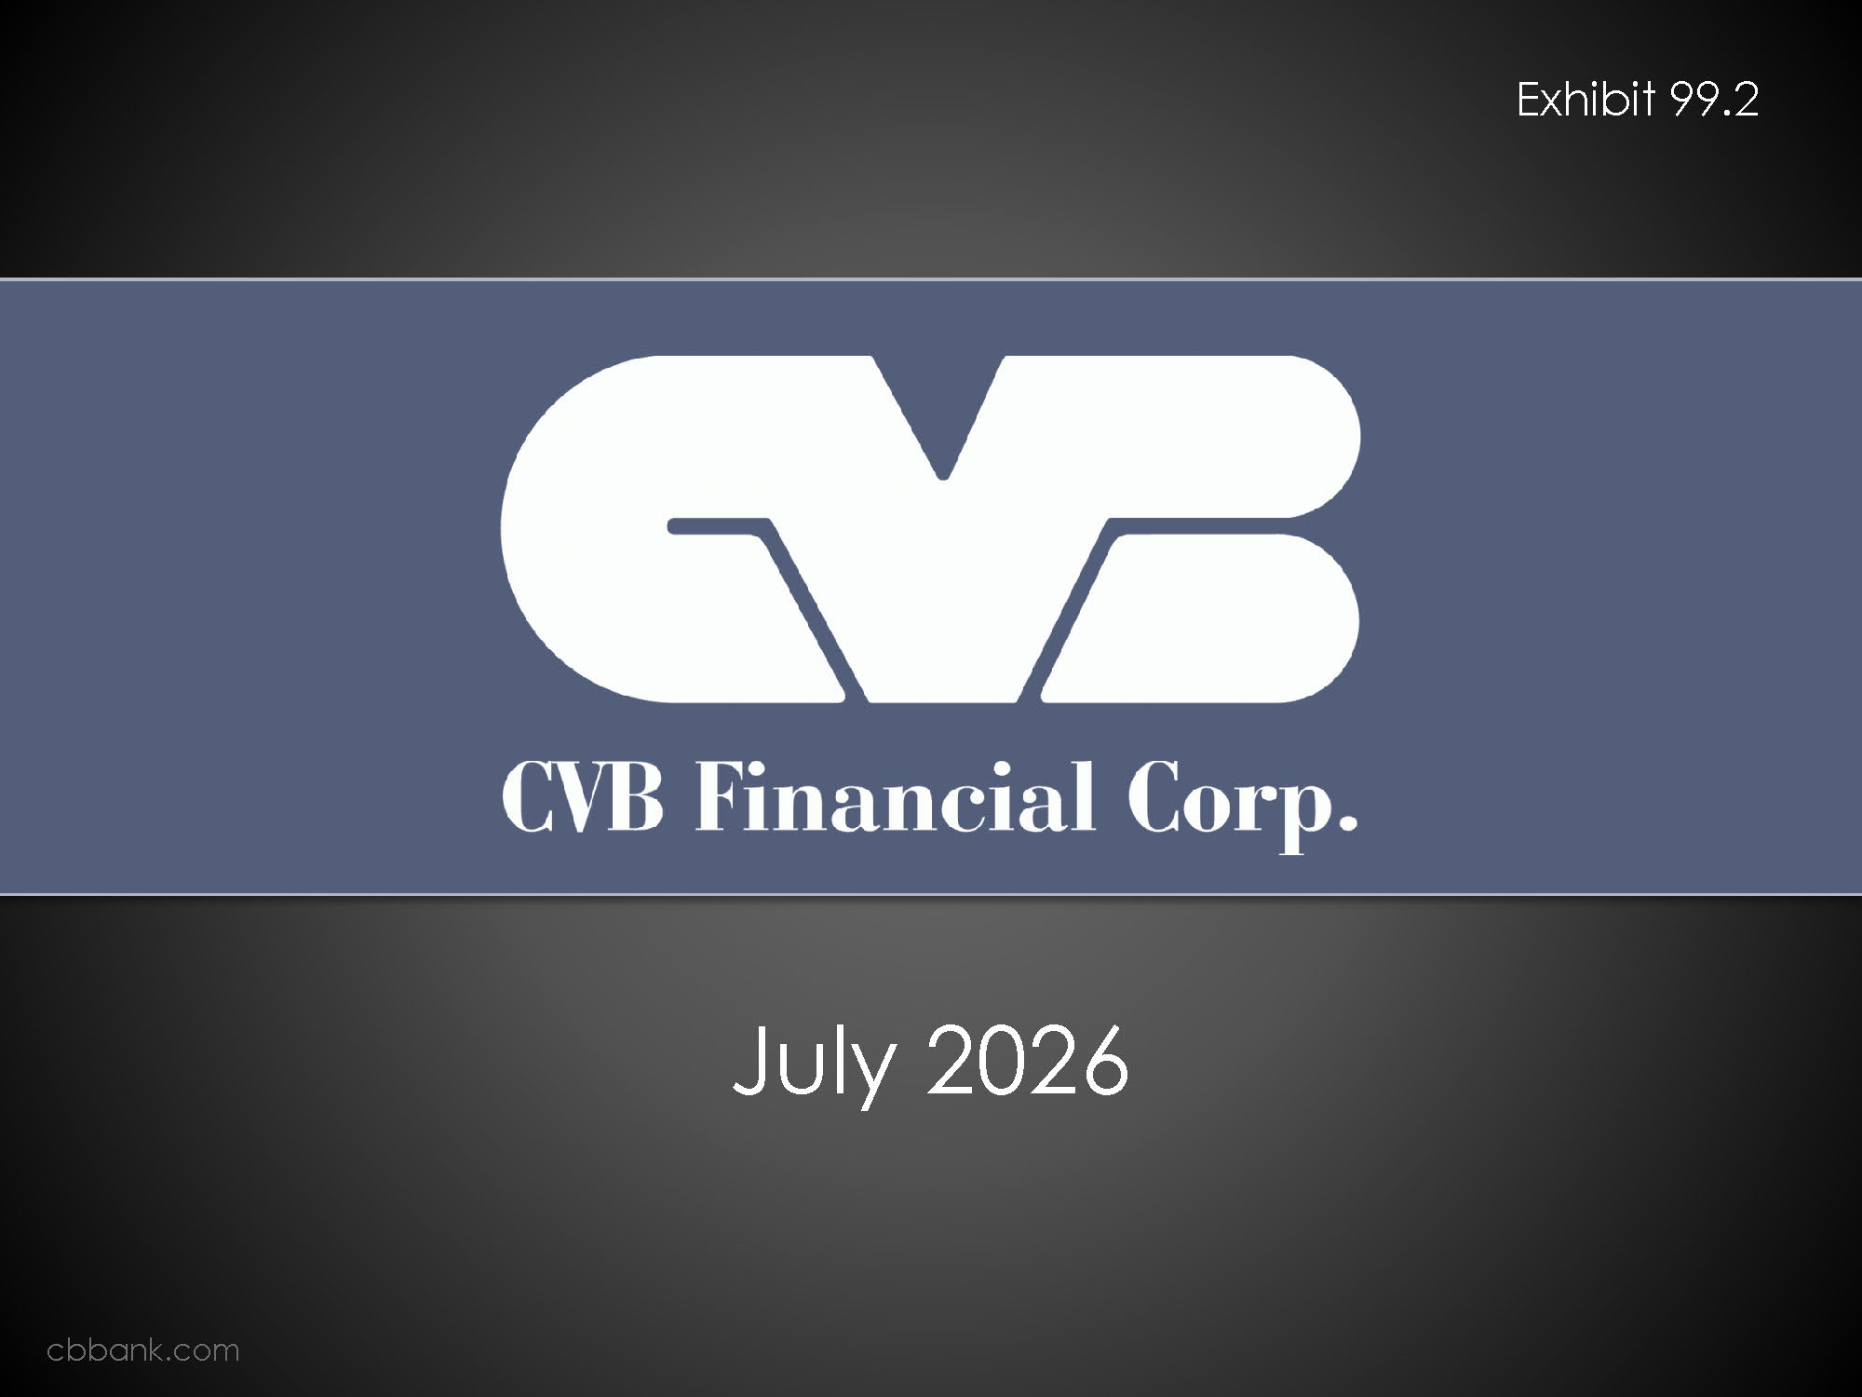
Exhibit 99.2 Logo CVB Financial Corp. July 2026 cbbank.com

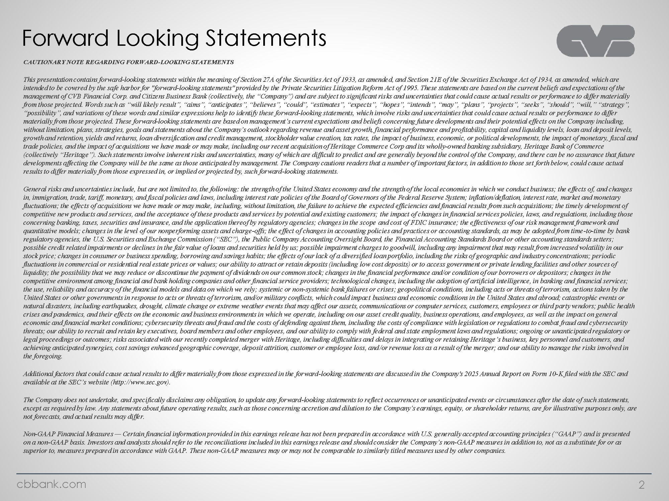
Company Logo Forward Looking Statements CAUTIONARY NOTE REGARDING FORWARD-LOOKING STATEMENTS This presentation contains forward-looking statements within the meaning of Section 27A of the Securities Act of 1933, as amended, and Section 21E of the Securities Exchange Act of 1934, as amended, which are intended to be covered by the safe harbor for "forward-looking statements" provided by the Private Securities Litigation Reform Act of 1995. These statements are based on the current beliefs and expectations of the management of CVB Financial Corp. and Citizens Business Bank (collectively, the “Company”) and are subject to significant risks and uncertainties that could cause actual results or performance to differ materially from those projected. Words such as “will likely result”, “aims”, “anticipates”, “believes”, “could”, “estimates”, “expects”, “hopes”, “intends”, “may”, “plans”, “projects”, “seeks”, “should”, “will,” “strategy”, “possibility”, and variations of these words and similar expressions help to identify these forward-looking statements, which involve risks and uncertainties that could cause actual results or performance to differ materially from those projected. These forward-looking statements are based on management’s current expectations and beliefs concerning future developments and their potential effects on the Company including, without limitation, plans, strategies, goals and statements about the Company’s outlook regarding revenue and asset growth, financial performance and profitability, capital and liquidity levels, loan and deposit levels, growth and retention, yields and returns, loan diversification and credit management, stockholder value creation, tax rates, the impact of business, economic, or political developments, the impact of monetary, fiscal and trade policies, and the impact of acquisitions we have made or may make, including our recent acquisition of Heritage Commerce Corp and its wholly-owned banking subsidiary, Heritage Bank of Commerce (collectively “Heritage”). Such statements involve inherent risks and uncertainties, many of which are difficult to predict and are generally beyond the control of the Company, and there can be no assurance that future developments affecting the Company will be the same as those anticipated by management. The Company cautions readers that a number of important factors, in addition to those set forth below, could cause actual results to differ materially from those expressed in, or implied or projected by, such forward-looking statements. General risks and uncertainties include, but are not limited to, the following: the strength of the United States economy and the strength of the local economies in which we conduct business; the effects of, and changes in, immigration, trade, tariff, monetary, and fiscal policies and laws, including interest rate policies of the Board of Governors of the Federal Reserve System; inflation/deflation, interest rate, market and monetary fluctuations; the effects of acquisitions we have made or may make, including, without limitation, the failure to achieve the expected efficiencies and financial results from such acquisitions; the timely development of competitive new products and services, and the acceptance of these products and services by potential and existing customers; the impact of changes in financial services policies, laws, and regulations, including those concerning banking, taxes, securities and insurance, and the application thereof by regulatory agencies; changes in the scope and cost of FDIC insurance; the effectiveness of our risk management framework and quantitative models; changes in the level of our nonperforming assets and charge-offs; the effect of changes in accounting policies and practices or accounting standards, as may be adopted from time-to-time by bank regulatory agencies, the U.S. Securities and Exchange Commission (“SEC”), the Public Company Accounting Oversight Board, the Financial Accounting Standards Board or other accounting standards setters; possible credit related impairments or declines in the fair value of loans and securities held by us; possible impairment charges to goodwill, including any impairment that may result from increased volatility in our stock price; changes in consumer or business spending, borrowing and savings habits; the effects of our lack of a diversified loan portfolio, including the risks of geographic and industry concentrations; periodic fluctuations in commercial or residential real estate prices or values; our ability to attract or retain deposits (including low cost deposits) or to access government or private lending facilities and other sources of liquidity; the possibility that we may reduce or discontinue the payment of dividends on our common stock; changes in the financial performance and/or condition of our borrowers or depositors; changes in the competitive environment among financial and bank holding companies and other financial service providers; technological changes, including the adoption of artificial intelligence, in banking and financial services; the use, reliability and accuracy of the financial models and data on which we rely; systemic or non-systemic bank failures or crises; geopolitical conditions, including acts or threats of terrorism, actions taken by the United States or other governments in response to acts or threats of terrorism, and/or military conflicts, which could impact business and economic conditions in the United States and abroad; catastrophic events or natural disasters, including earthquakes, drought, climate change or extreme weather events that may affect our assets, communications or computer services, customers, employees or third party vendors; public health crises and pandemics, and their effects on the economic and business environments in which we operate, including on our asset credit quality, business operations, and employees, as well as the impact on general economic and financial market conditions; cybersecurity threats and fraud and the costs of defending against them, including the costs of compliance with legislation or regulations to combat fraud and cybersecurity threats; our ability to recruit and retain key executives, board members and other employees, and our ability to comply with federal and state employment laws and regulations; ongoing or unanticipated regulatory or legal proceedings or outcomes; risks associated with our recently completed merger with Heritage, including difficulties and delays in integrating or retaining Heritage’s business, key personnel and customers, and achieving anticipated synergies, cost savings enhanced geographic coverage, deposit attrition, customer or employee loss, and/or revenue loss as a result of the merger; and our ability to manage the risks involved in the foregoing. Additional factors that could cause actual results to differ materially from those expressed in the forward-looking statements are discussed in the Company's 2025 Annual Report on Form 10-K filed with the SEC and available at the SEC’s website (http://www.sec.gov). The Company does not undertake, and specifically disclaims any obligation, to update any forward-looking statements to reflect occurrences or unanticipated events or circumstances after the date of such statements, except as required by law. Any statements about future operating results, such as those concerning accretion and dilution to the Company’s earnings, equity, or shareholder returns, are for illustrative purposes only, are not forecasts, and actual results may differ. Non-GAAP Financial Measures — Certain financial information provided in this earnings release has not been prepared in accordance with U.S. generally accepted accounting principles (“GAAP”) and is presented on a non-GAAP basis. Investors and analysts should refer to the reconciliations included in this earnings release and should consider the Company’s non-GAAP measures in addition to, not as a substitute for or as superior to, measures prepared in accordance with GAAP. These non-GAAP measures may or may not be comparable to similarly titled measures used by other companies. cbbank.com 2

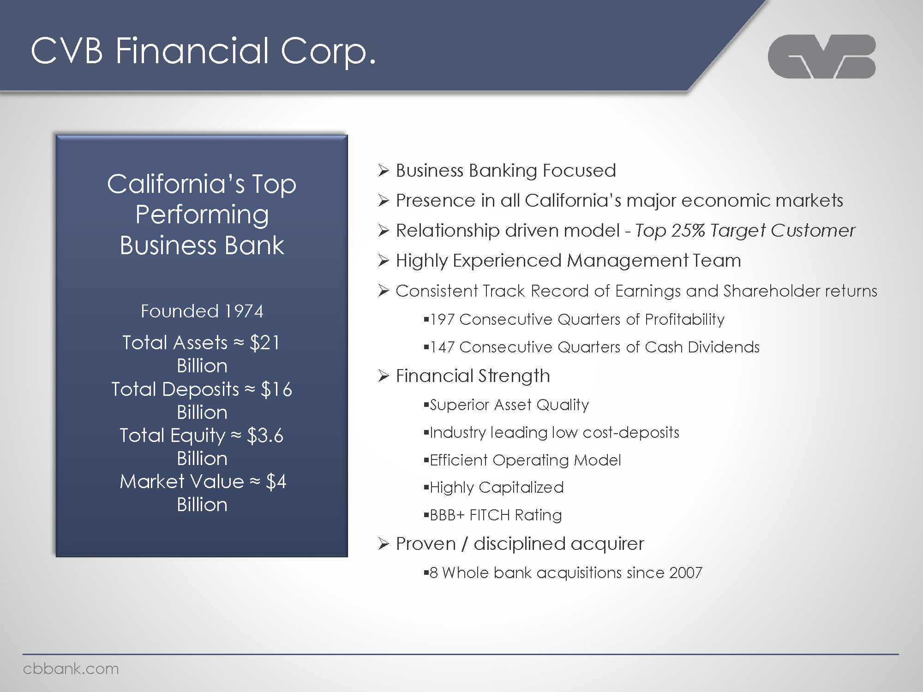
Logo CVB Financial Corp. California’s Top Performing Business Bank Founded 1974 Total Assets ≈ $21 Billion Total Deposits ≈ $16 Billion Total Equity ≈ $3.6 Billion Market Value ≈ $4 Billion Business Banking Focused Presence in all California’s major economic markets Relationship driven model - Top 25% Target Customer Highly Experienced Management Team Consistent Track Record of Earnings and Shareholder returns 197 Consecutive Quarters of Profitability 147 Consecutive Quarters of Cash Dividends Financial Strength Superior Asset Quality Industry leading low cost-deposits Efficient Operating Model Highly Capitalized BBB+ FITCH Rating Proven / disciplined acquirer 8 Whole bank acquisitions since 2007 cbbank.com

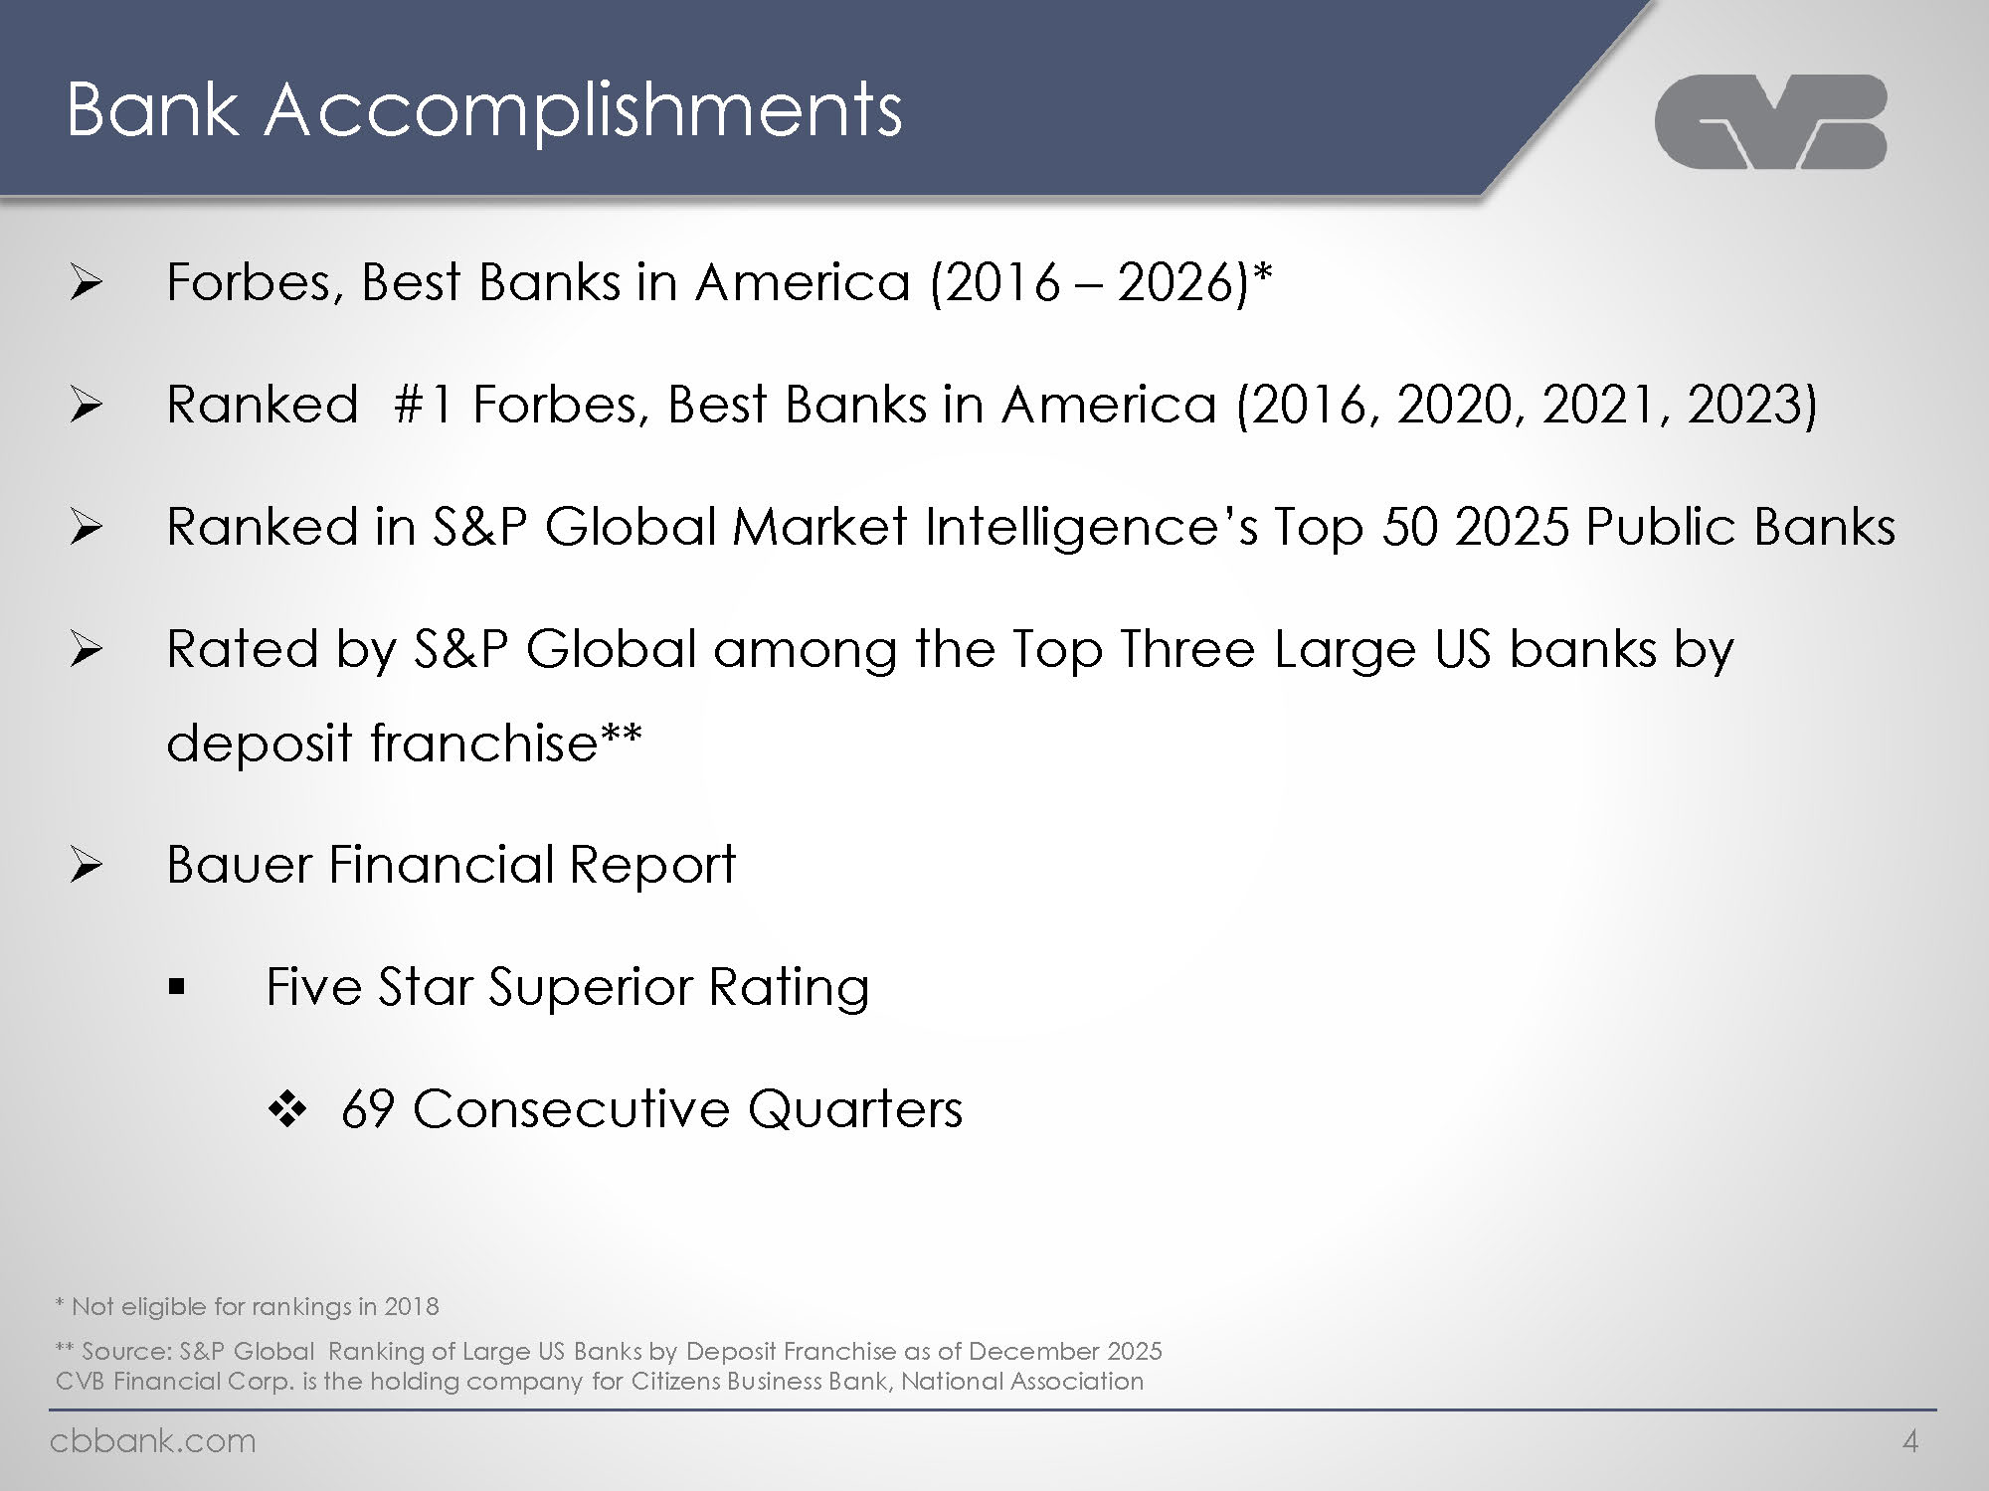
Company Logo Bank Accomplishments Forbes, Best Banks in America (2016 – 2026)* Ranked #1 Forbes, Best Banks in America (2016, 2020, 2021, 2023) Ranked in S&P Global Market Intelligence’s Top 50 2025 Public Banks Rated by S&P Global among the Top Three Large US banks by deposit franchise** Bauer Financial Report Five Star Superior Rating 69 Consecutive Quarters * Not eligible for rankings in 2018 ** Source: S&P Global Ranking of Large US Banks by Deposit Franchise as of December 2025 CVB Financial Corp. is the holding company for Citizens Business Bank, National Association cbbank.com 4

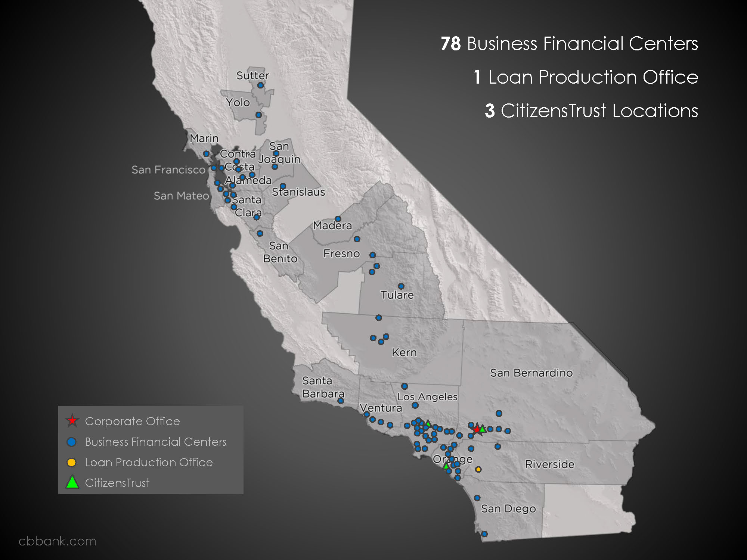
Image 78 Business Financial Centers 1 Loan Production Office 3 CitizensTrust Locations Corporate Office Business Financial Centers Loan Production Office CitizensTrust cbbank.com

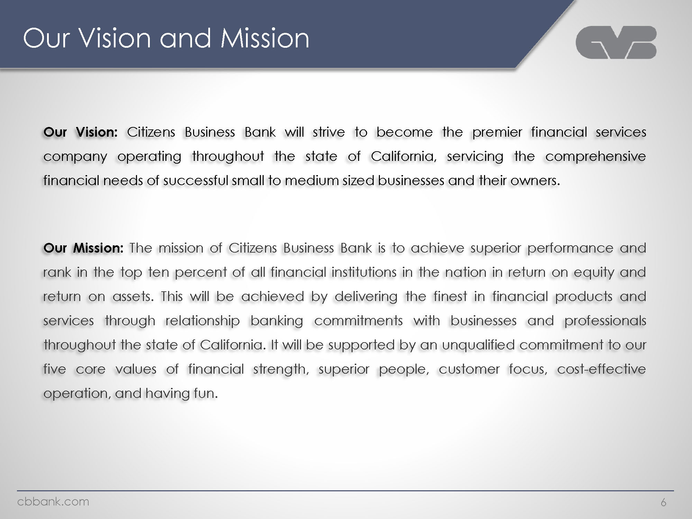
Company logo Our Vision and Mission Our Vision: Citizens Business Bank will strive to become the premier financial services company operating throughout the state of California, servicing the comprehensive financial needs of successful small to medium sized businesses and their owners. Our Mission: The mission of Citizens Business Bank is to achieve superior performance and rank in the top ten percent of all financial institutions in the nation in return on equity and return on assets. This will be achieved by delivering the finest in financial products and services through relationship banking commitments with businesses and professionals throughout the state of California. It will be supported by an unqualified commitment to our five core values of financial strength, superior people, customer focus, cost-effective operation, and having fun. cbbank.com 6

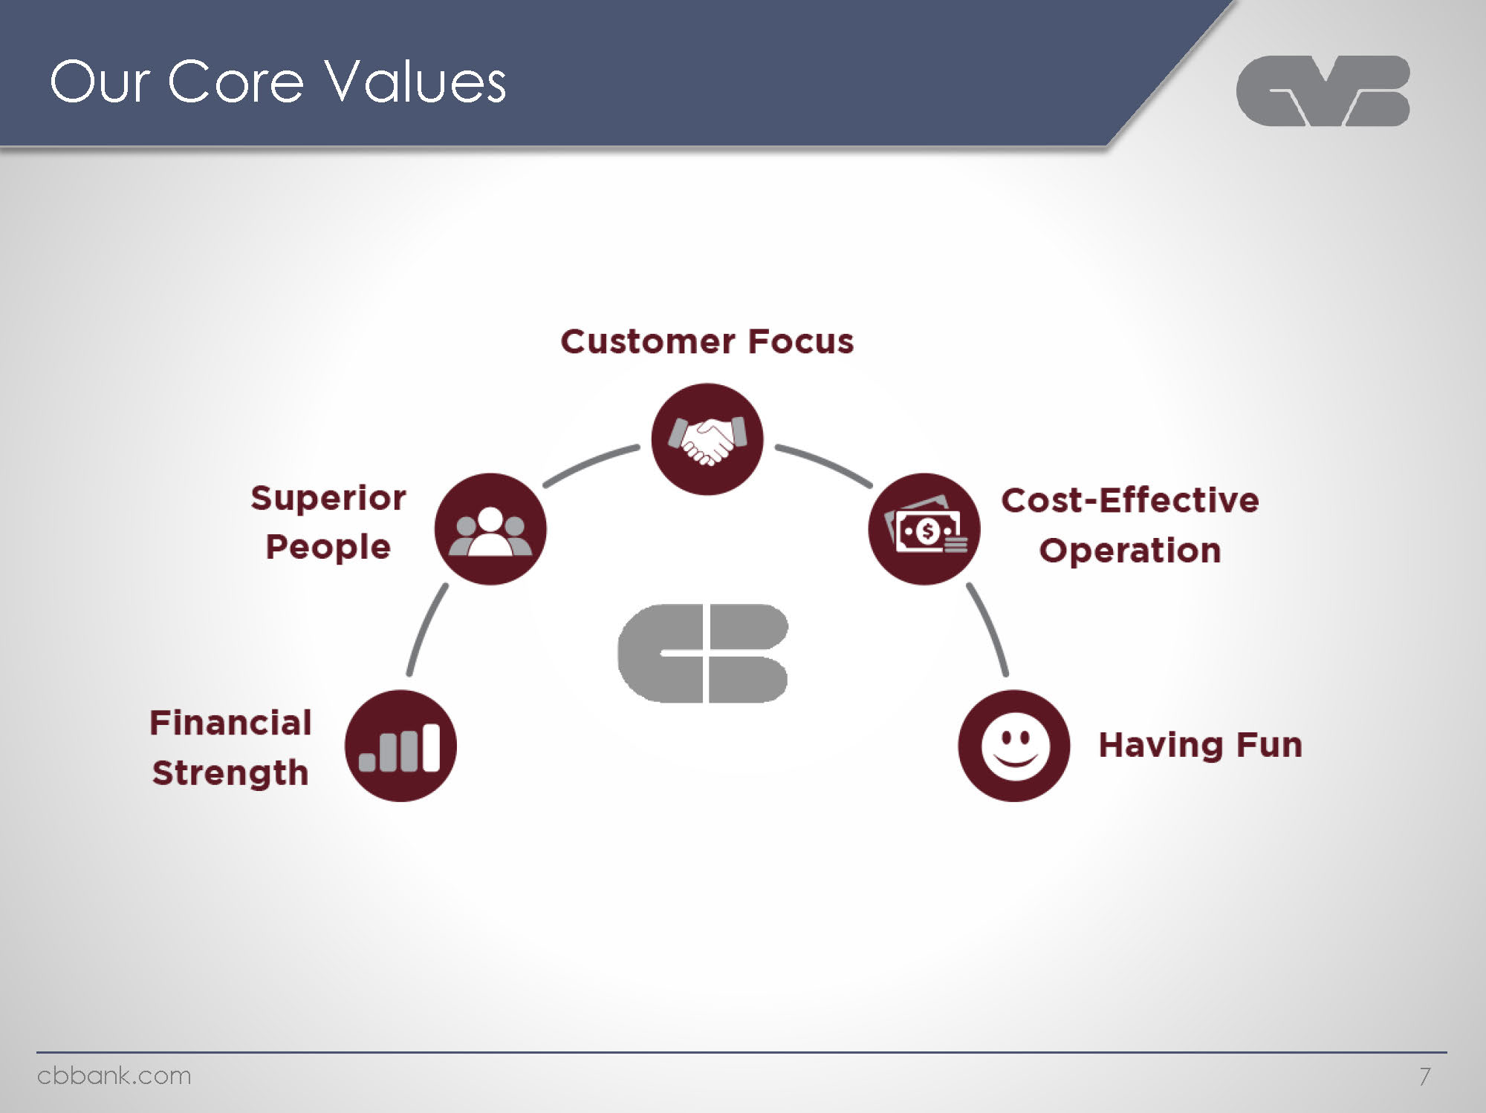
Company logo Our Core Values Customer Focus Superior People Cost-Effective Operation Financial Strength Having Fun cbbank.com 7

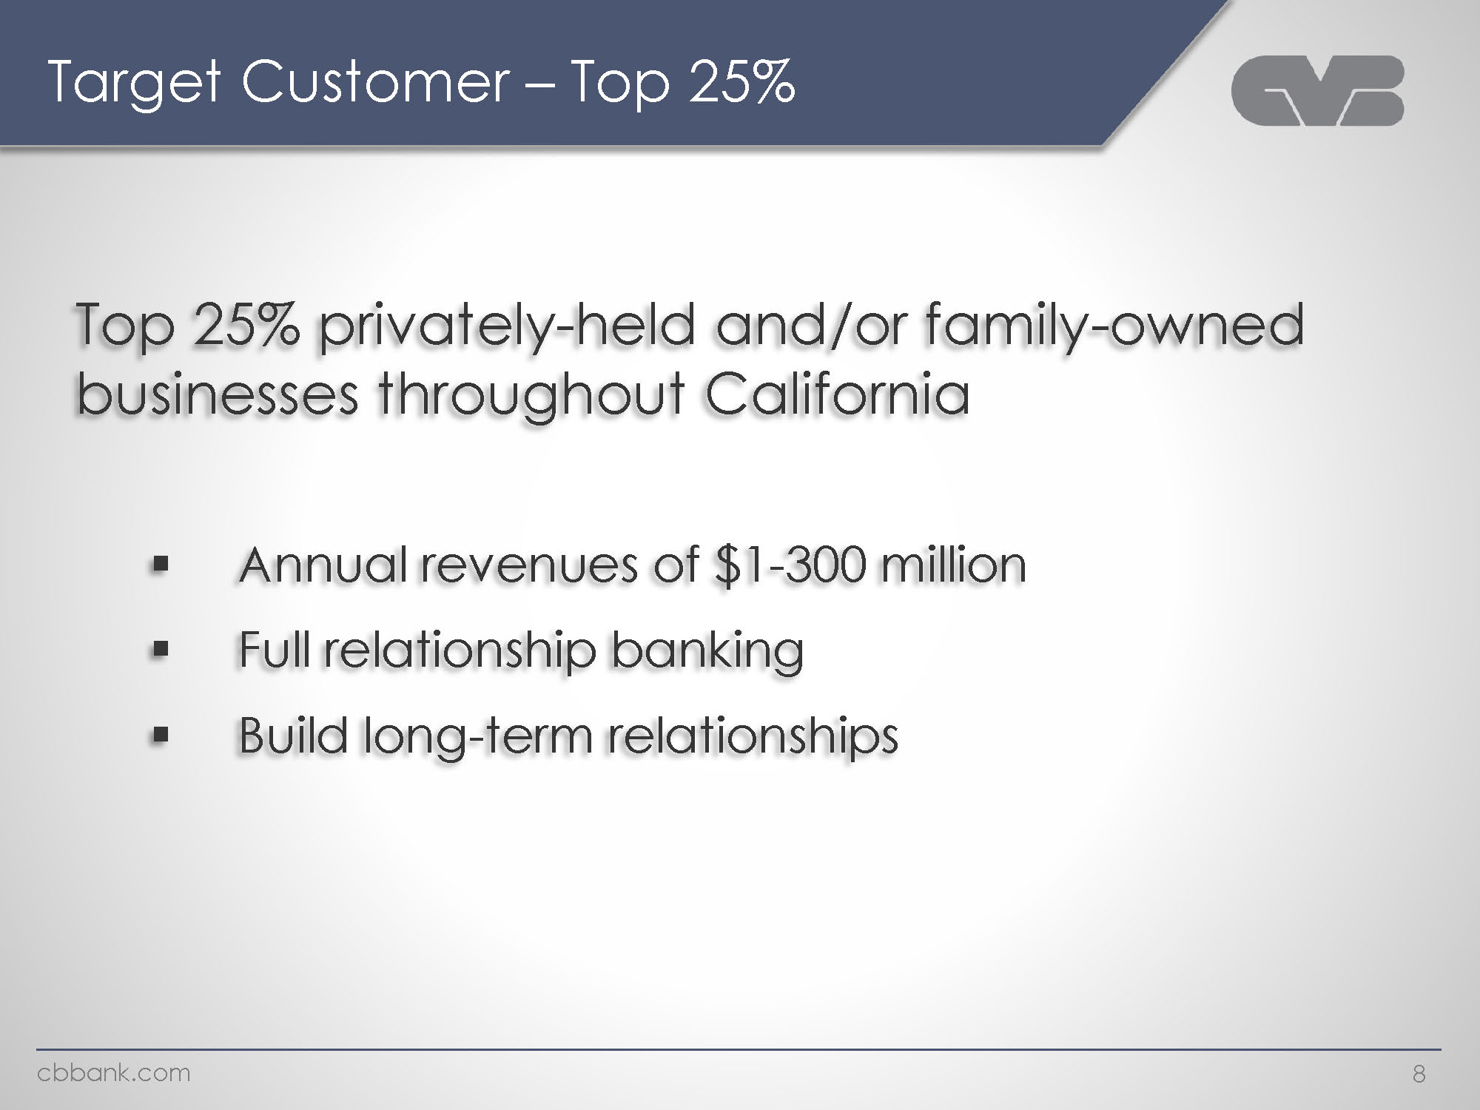
Company logo Target Customer – Top 25% Top 25% privately-held and/or family-owned businesses throughout California Annual revenues of $1-300 million Full relationship banking Build long-term relationships cbbank.com 8

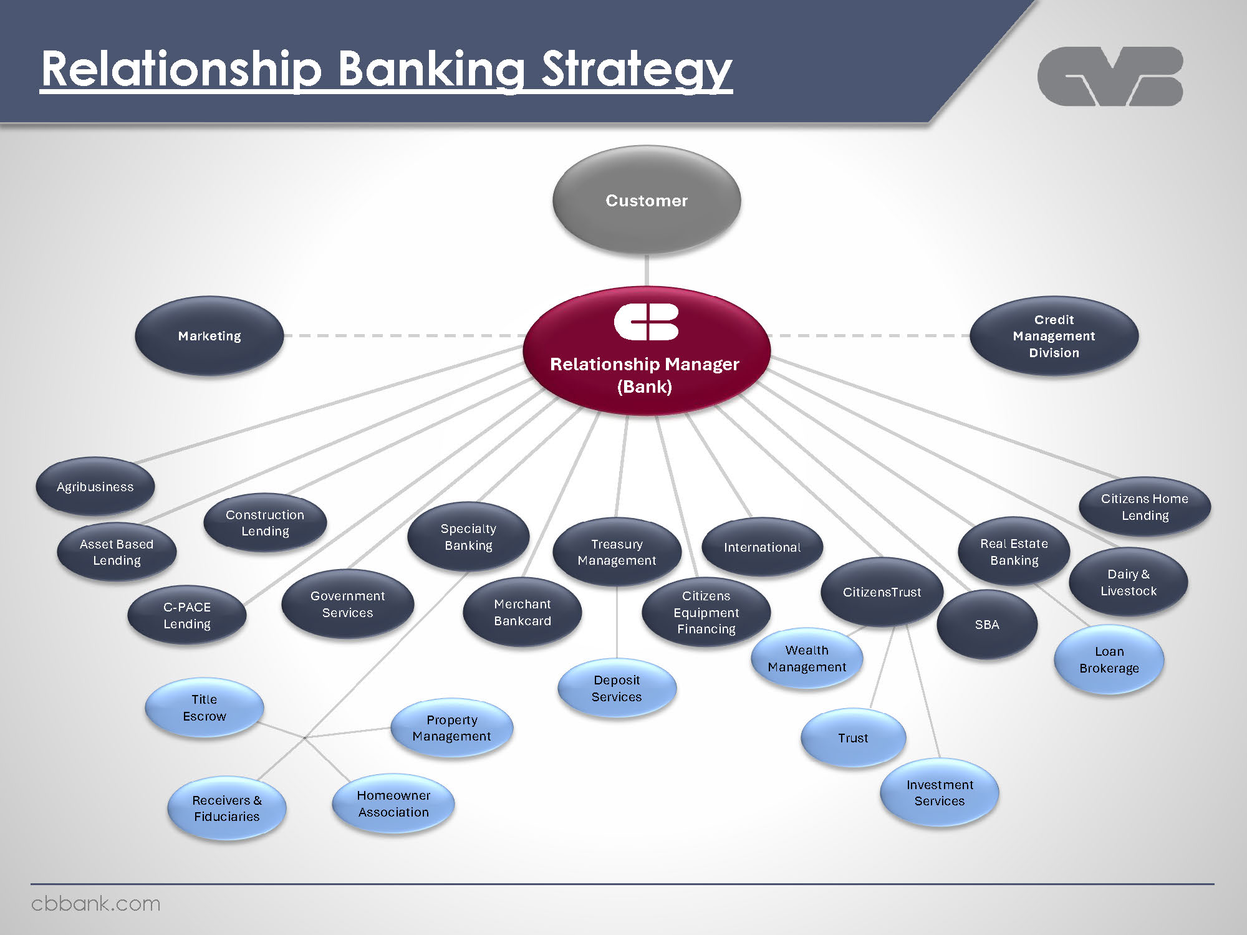
Company logo Relationship Banking Strategy Customer Marketing Relationship Manager (Bank) Credit Management Division Agribusiness Asset Based Lending C-PACE Lending Construction Lending Government Services Specialty Banking Merchant Bankcard Treasury Management Citizens Equipment Financing International CitizensTrust Real Estate Banking SBA Citizens Home Lending Dairy & Livestock Title Escrow Receivers & Fiduciaries Property Management Homeowner Association Deposit Services Wealth Management Trust Investment Services Loan Brokerage cbbank.com

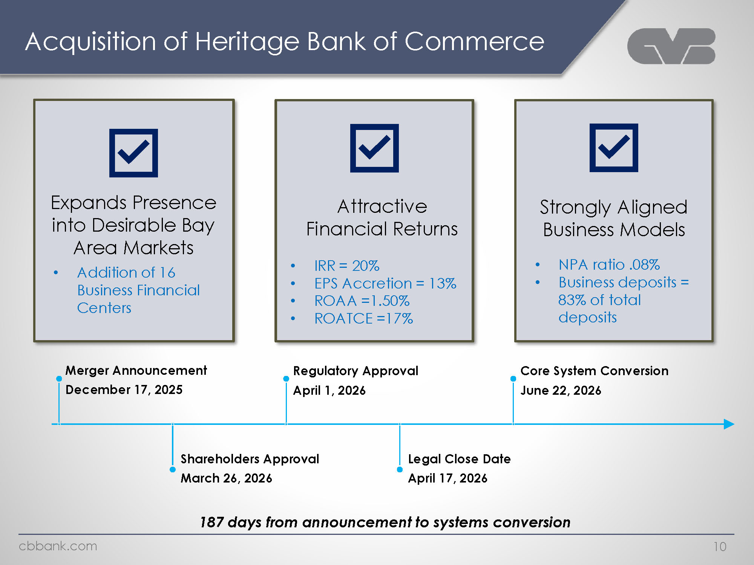
Company logo Acquisition of Heritage Bank of Commerce Expands Presence into Desirable Bay Area Markets Addition of 16 Business Financial Centers Attractive Financial Returns IRR = 20% EPS Accretion = 13% ROAA =1.50% ROATCE =17% Strongly Aligned Business Models NPA ratio .08% Business deposits = 83% of total deposits Merger Announcement December 17, 2025 Regulatory Approval April 1, 2026 Core System Conversion June 22, 2026 Shareholders Approval March 26, 2026 Legal Close Date April 17, 2026 187 days from announcement to systems conversion cbbank.com 10

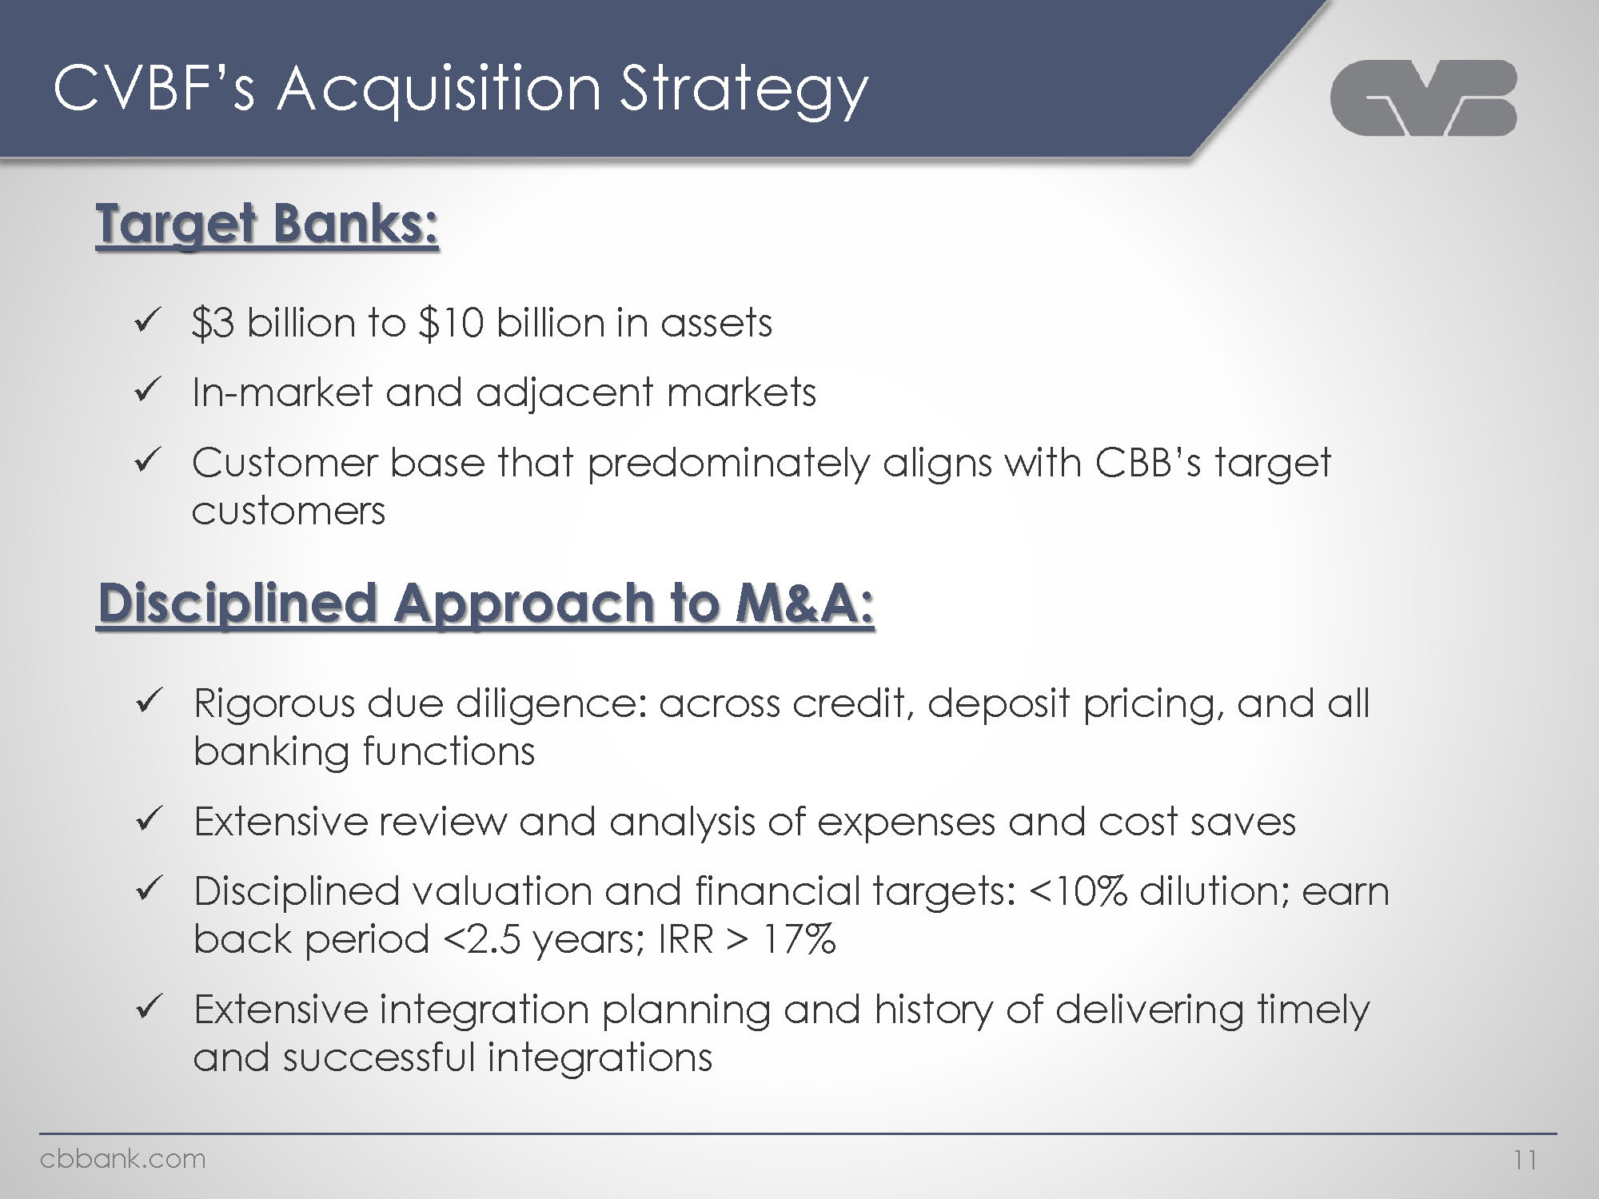
Logo CVBF’s Acquisition Strategy Target Banks: $3 billion to $10 billion in assets In-market and adjacent markets Customer base that predominately aligns with CBB’s target customers Disciplined Approach to M&A: Rigorous due diligence: across credit, deposit pricing, and all banking functions Extensive review and analysis of expenses and cost saves Disciplined valuation and financial targets: <10% dilution; earn back period <2.5 years; IRR > 17% Extensive integration planning and history of delivering timely and successful integrations Cbbank.com 11

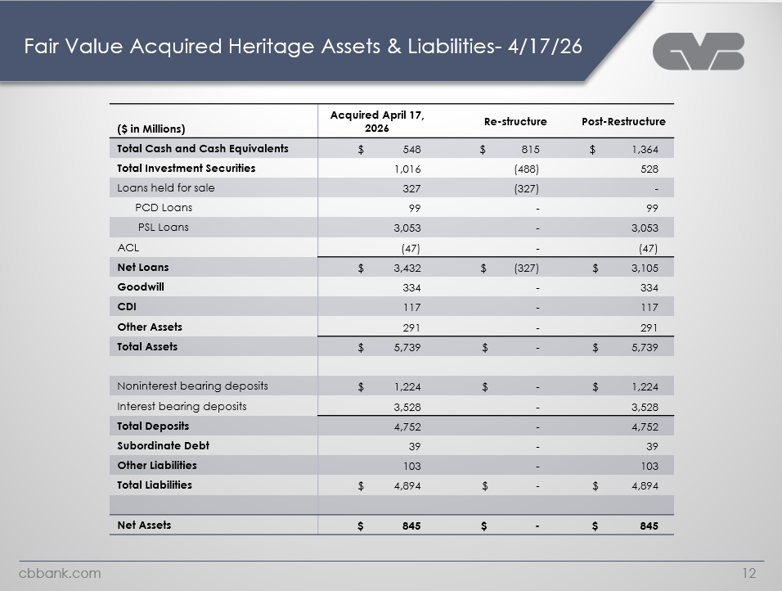
Logo Fair Value Acquired Heritage Assets & Liabilities- 4/17/26 ($ in Millions) Acquired April 17, 2026 Re-structure Post-Restructure Total Cash and Cash Equivalents $548 $815 $1,364 Total Investment Securities 1,016 (488) 528 Loans held for sale 327 (327) - PCD Loans 99 - 99 PSL Loans 3,053 - 3,053 ACL (47) - (47) Net Loans $ 3,432 $ (327) $ 3,105 Goodwill 334 - 334 CDI 117 - 117 Other Assets 291 - 291 Total Assets $5,739 $ - $ 5,739 Noninterest bearing deposits $ 1,224 $ - $ 1,224 Interest bearing deposits 3,528 - 3,528 Total Deposits 4,752 - 4,752 Subordinate Debt 39 - 39 Other Liabilities 103 - 103 Total Liabilities $ 4,894 $ - $ 4,894 Net Assets $ 845 $ - $ 845 Cbbank.com 12

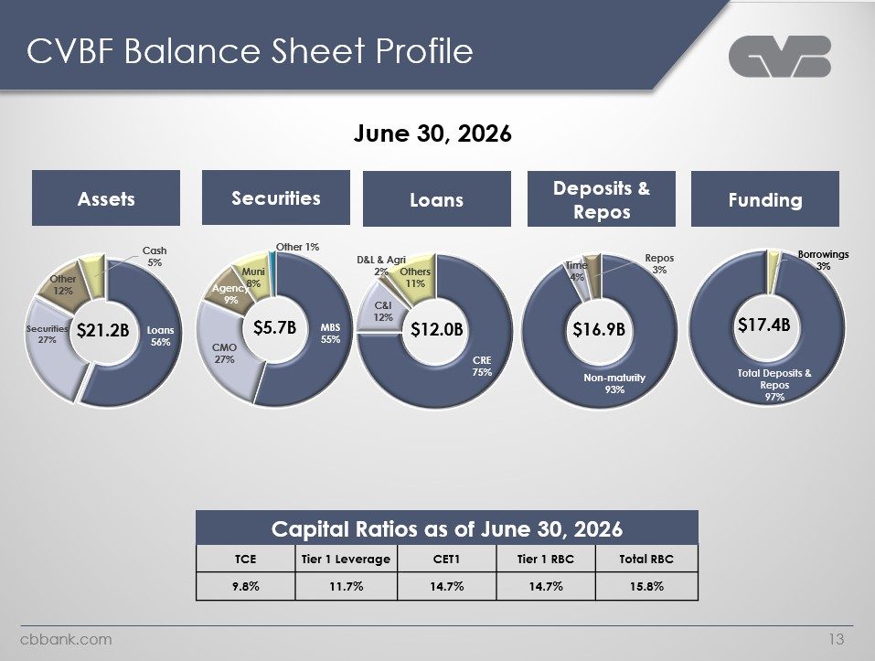
CVBF Balance Sheet Profile logo June 30, 2026 Assets $21.2B Loans: 56% Securities: 27% Other: 12% Cash: 5% Securities $5.7B MBS: 55% CMO: 27% Agency: 9% Muni: 8% Other: 1% Loans $12.0B CRE: 75% C&I: 12% Other: 11% D&L & Agri: 2% Deposits & Repos $16.9B Non-maturity: 93% Repos: 3% Time: 4% Funding $17.4B Total Deposits & Repos: 97% Borrowings: 3% Capital Ratios as of June 30, 2026 TCE Tier 1 Leverage CET1 Tier 1 RBC Total RBC 9.8% 11.7% 14.7% 14.7% 15.8% cbbank.com 13

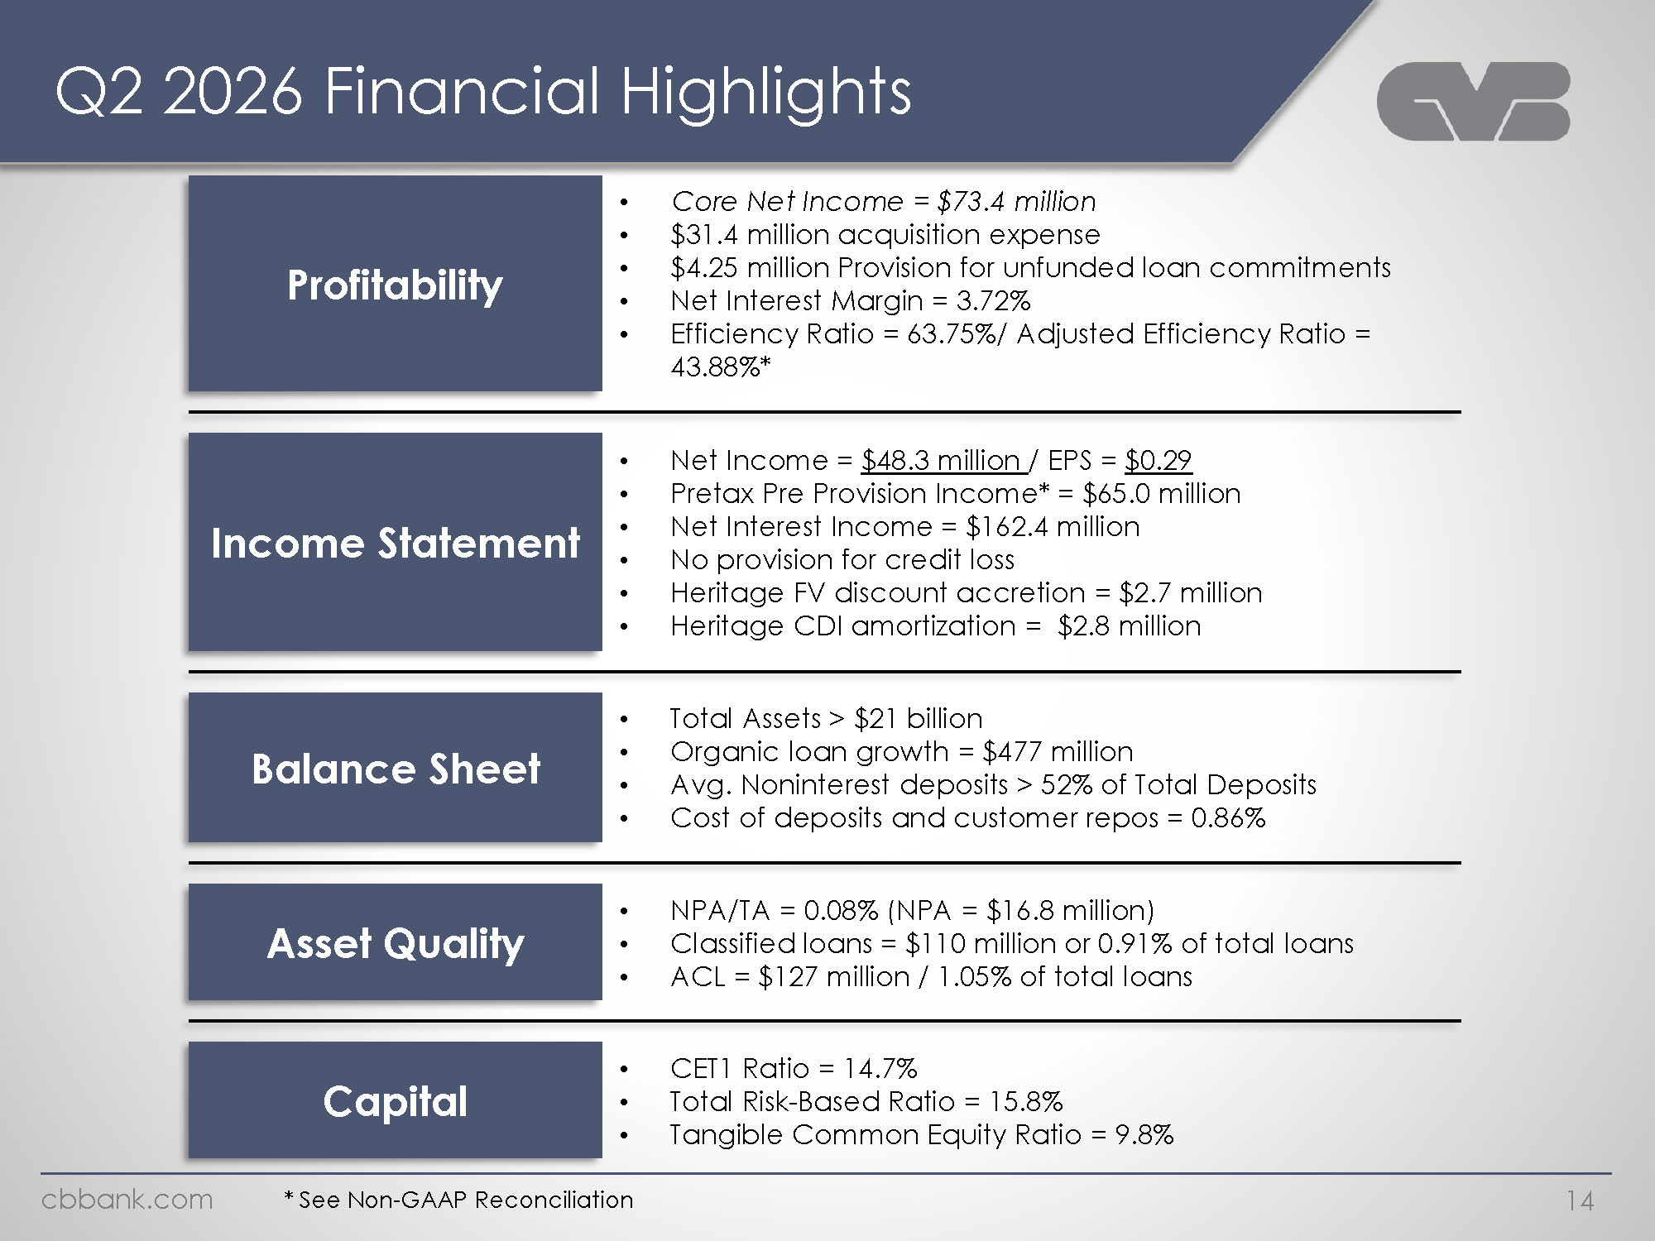
Q2 2026 Financial Highlights logo Profitability Core Net Income = $73.4 million $31.4 million acquisition expense $4.25 million Provision for unfunded loan commitments Net Interest Margin = 3.72% Efficiency Ratio = 63.75%/ Adjusted Efficiency Ratio = 43.88%* Income Statement Net Income = $48.3 million / EPS = $0.29 Pretax Pre Provision Income* = $65.0 million Net Interest Income = $162.4 million No provision for credit loss Heritage FV discount accretion = $2.7 million Heritage CDI amortization = $2.8 million Balance Sheet Total Assets > $21 billion Organic loan growth = $477 million Avg. Noninterest deposits > 52% of Total Deposits Cost of deposits and customer repos = 0.86% Asset Quality NPA/TA = 0.08% (NPA = $16.8 million) Classified loans = $110 million or 0.91% of total loans ACL = $127 million / 1.05% of total loans Capital CET1 Ratio = 14.7% Total Risk-Based Ratio = 15.8% Tangible Common Equity Ratio = 9.8% cbbank.com * See Non-GAAP Reconciliation 14

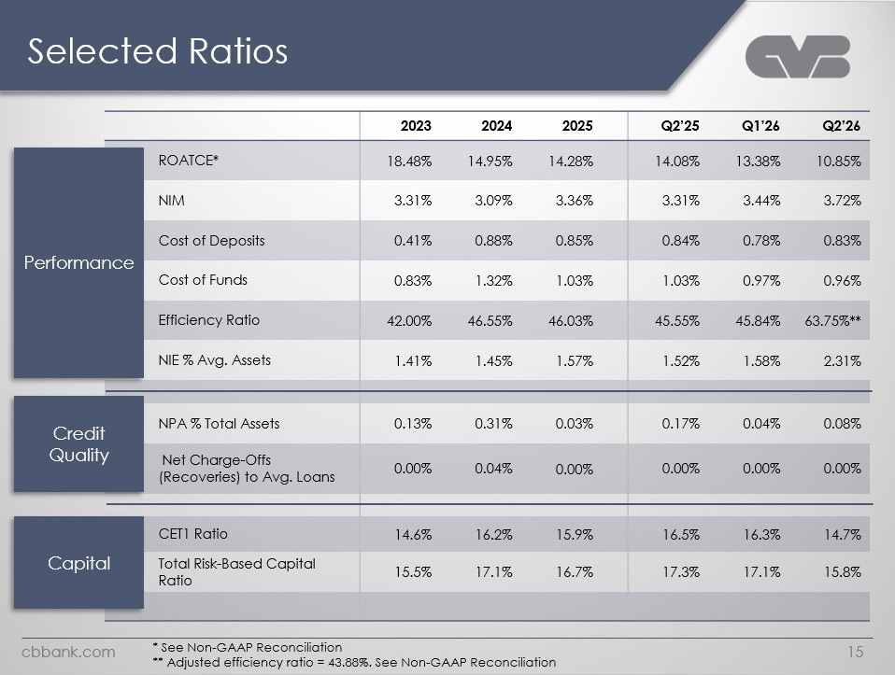
Selected Ratios Logo 2023 2024 2025 Q2’25 Q1’26 Q2’26 ROATCE *18.48% 14.95% 14.28% 14.08% 13.38% 10.85% NIM 3.31% 3.09% 3.36% 3.31% 3.44% 3.72% Cost of Deposits 0.41% 0.88% 0.85% 0.84% 0.78% 0.83% Cost of Funds 0.83% 1.32% 1.03% 1.03% 0.97% 0.96% Efficiency Ratio 42.00% 46.55% 46.03% 45.55% 45.84% 63.75% **NIE % Avg. Assets 1.41% 1.45%1.57% 1.52% 1.58% 2.31% Credit Quality NPA % Total Assets 0.13% 0.31% 0.03% 0.17% 0.04% 0.08% Net Charge-Offs (Recoveries) to Avg. Loans 0.00% 0.04% 0.00% 0.00% 0.00% 0.00% Capital CET1 Ratio14.6% 16.2% 15.9% 16.5% 16.3% 14.7% Total Risk-Based Capital Ratio15.5% 17.1% 16.7% 17.3% 17.1% 15.8% cbbank.com*See Non-GAAP Reconciliation** Adjusted efficiency ratio = 43.88%. See Non-GAAP Reconciliation 15

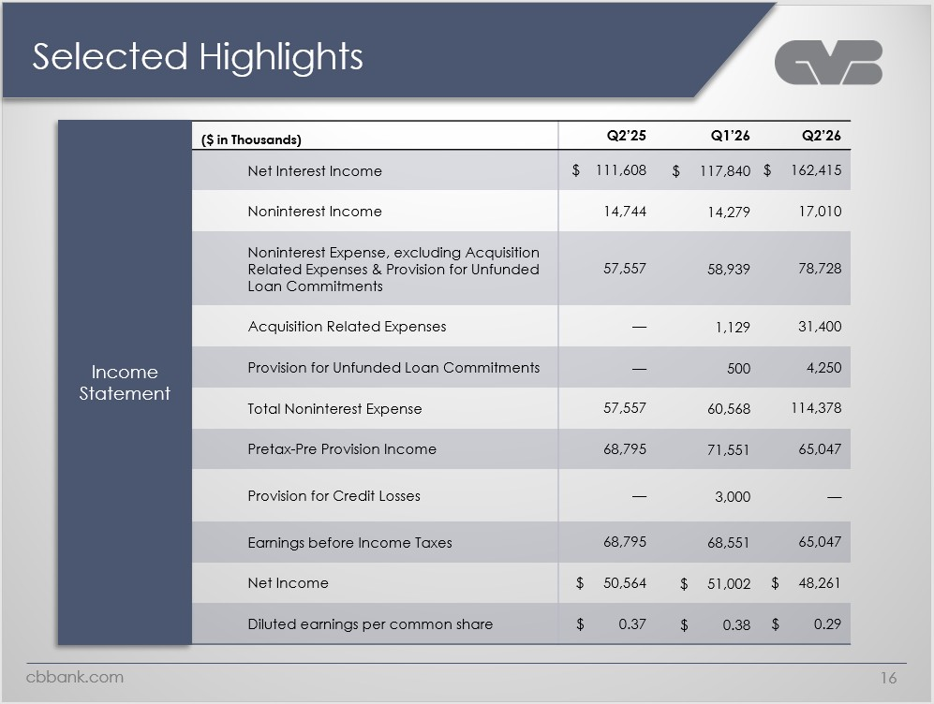
Selected Highlights Logo ($ in Thousands) Q2’25 Q1’26 Q2’26 Income Statement Net Interest Income $ 111,608 $ 117,840 $ 162,415 Noninterest Income 14,744 14,279 17,010 Noninterest Expense, excluding Acquisition Related Expenses & Provision for Unfunded Loan Commitments 57,557 58,939 78,728 Acquisition Related Expenses — 1,129 31,400 Provision for Unfunded Loan Commitments — 500 4,250 Total Noninterest Expense 57,557 60,568 114,378 Pretax-Pre Provision Income 68,795 71,551 65,047 Provision for Credit Losses — 3,000 — Earnings before Income Taxes 68,795 68,551 65,047 Net Income $ 50,564 $ 51,002 $ 8,261 Diluted earnings per common share $ 0.37 $ 0.38 $ 0.29Cbbank.com 16

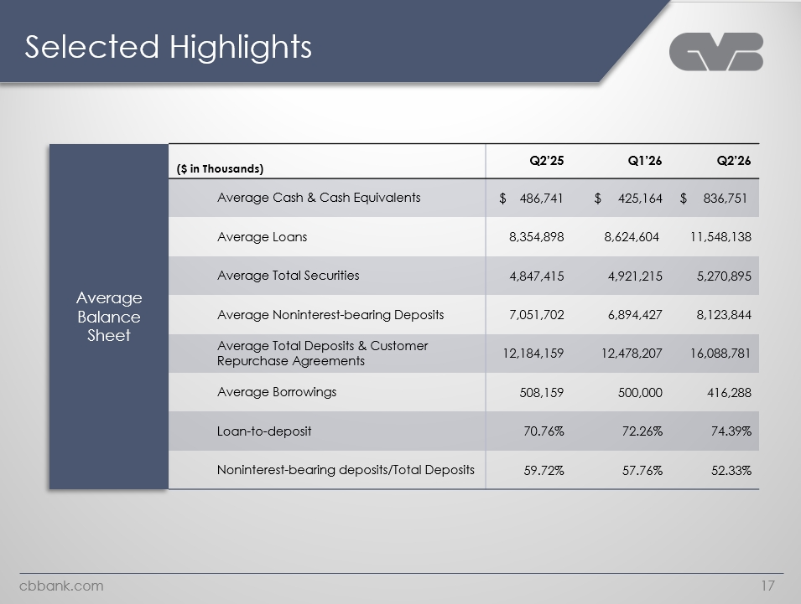
Logo Selected Highlights Average Balance Sheet ($ in Thousands) Q2’25 Q1’26 Q2’26 Average Cash & Cash Equivalents $ 486,741 $ 425,164 $ 836,751 Average Loans 8,354,898 8,624,604 11,548,138 Average Total Securities 4,847,415 4,921,215 5,270,895 Average Noninterest-bearing Deposits 7,051,702 6,894,427 8,123,844 Average Total Deposits & Customer Repurchase Agreements 12,184,159 12,478,207 16,088,781 Average Borrowings 508,159 500,000 416,288 Loan-to-deposit 70.76% 72.26% 74.39% Noninterest-bearing deposits/Total Deposits 59.72% 57.76% 52.33% Cbbank.com 17

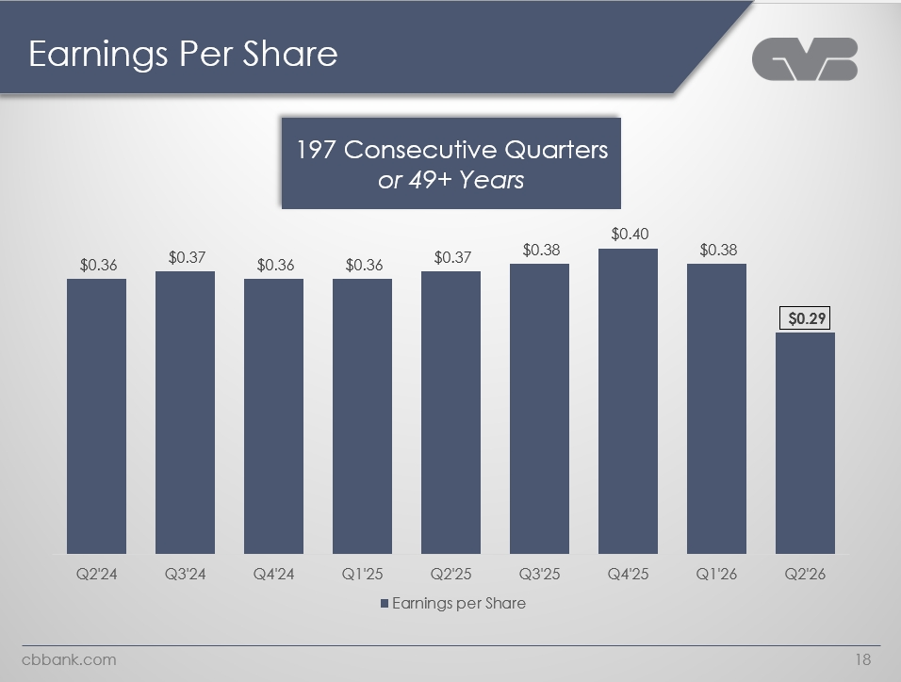
Logo Earnings Per Share 197 Consecutive Quarters or 49+ Years $0.36 $0.36 $0.36 $0.36 $0.36 $0.38 $0.40 $0.38 $0.29 Q2’24 Q3’24 Q4’24 Q1’25 Q2’25 Q3’25 Q4’25 Q1’26 Q2’26 earnings per share cbbank.com 18

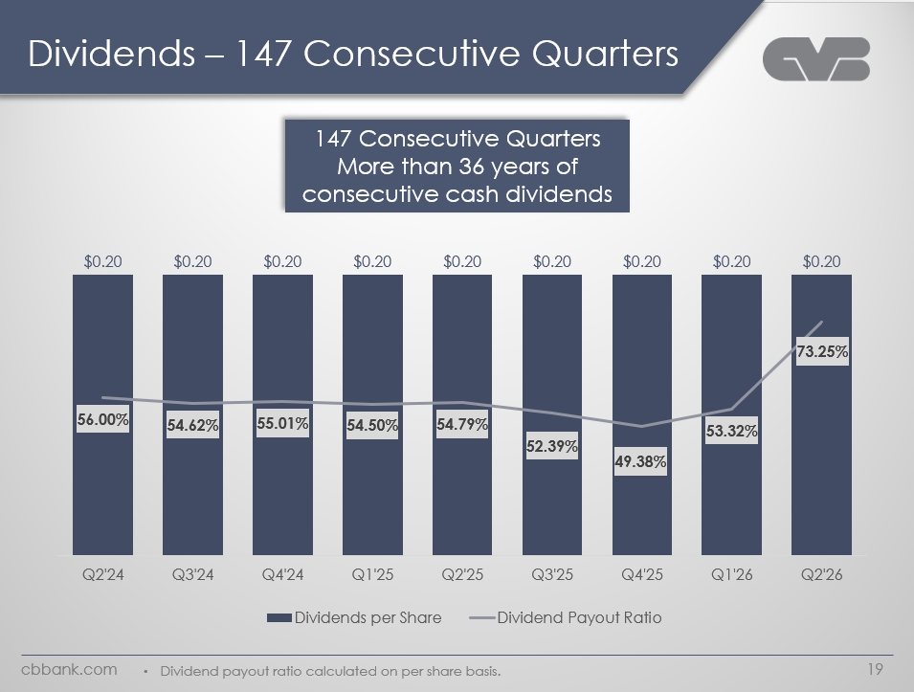
Logo Dividends – 147 Consecutive Quarters 147 Consecutive Quarters More than 36 years of consecutive cash dividends $0.20 $0.20 $0.20 $0.20 $0.20 $0.20 $0.20 $0.20 $0.20 56.00% 54.62%55.01% 54.50% 54.79% 52.39% 49.38% 53.32% 73.25% Q2'24 Q3'24 Q4'24 Q1'25 Q2'25 Q3'25 Q4'25 Q1'26 Q2'26 Dividends per Share Dividend Payout Ratio Dividend payout ratio calculated on per share basis. Cbbank.com 19

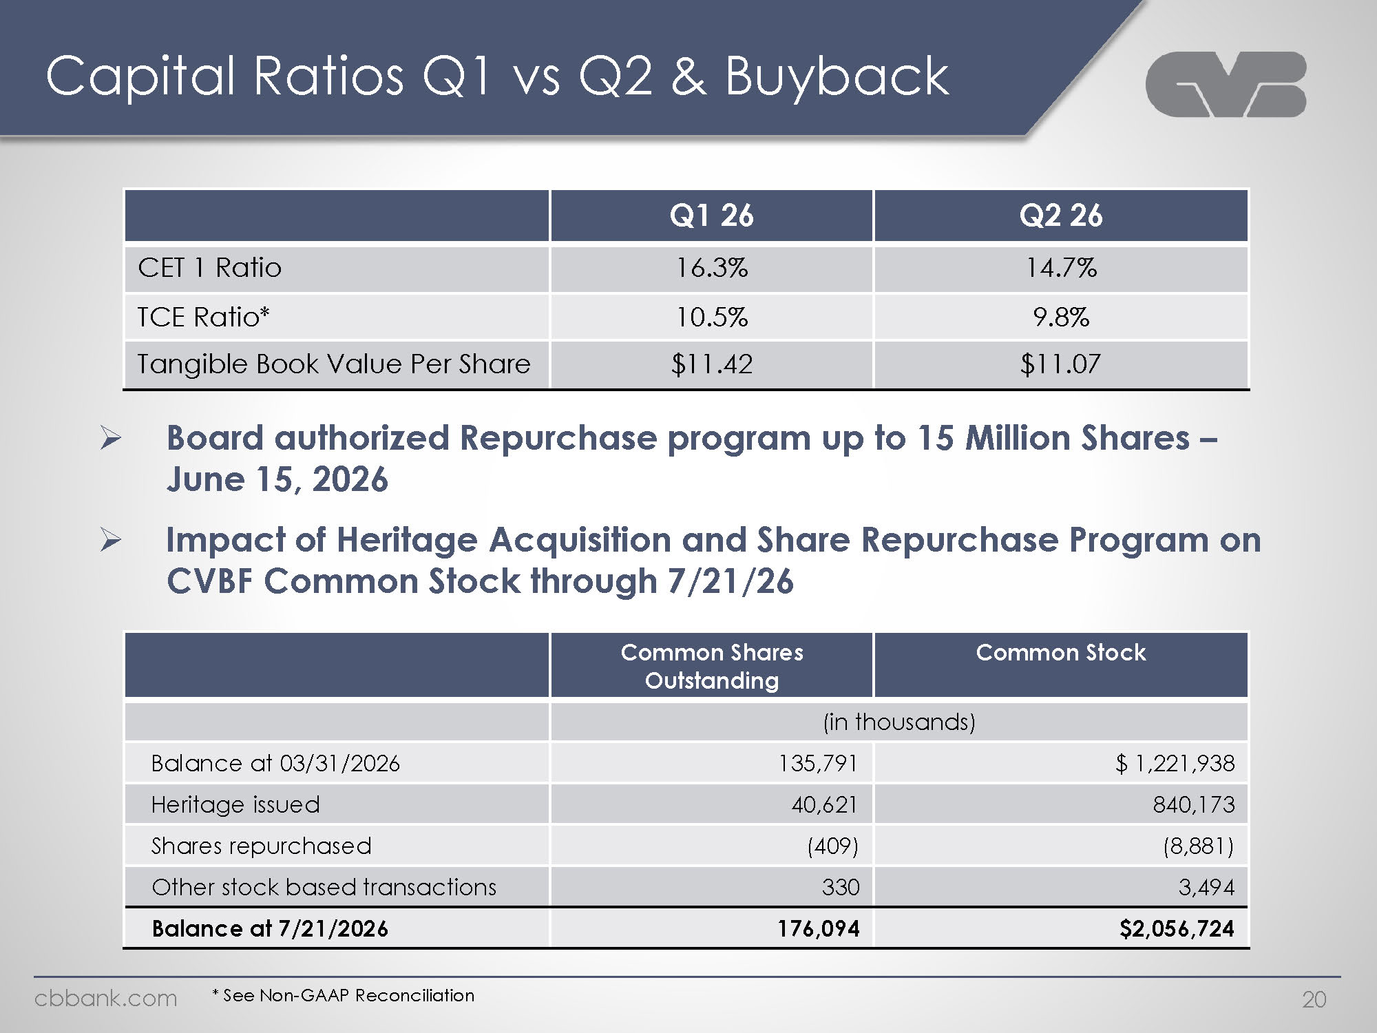
Logo Capital Ratios Q1 vs Q2 & Buyback Q1 26 Q2 26 CET 1 Ratio 16.3% 14.7% TCE Ratio* 10.5% 9.8% Tangible Book Value Per Share $11.42 $11.07 Board authorized Repurchase program up to 15 Million Shares – June 15, 2026 Impact of Heritage Acquisition and Share Repurchase Program on CVBF Common Stock through 7/21/26 Common Shares Outstanding Common Stock (in thousands) Balance at 03/31/2026 135,791 $ 1,221,938 Heritage issued 40,621 840,173 Shares repurchased (409) (8,881) Other stock based transactions 330 3,494 Balance at 7/21/2026 176,094 $2,056,724 * See Non-GAAP Reconciliation cbbank.com 20

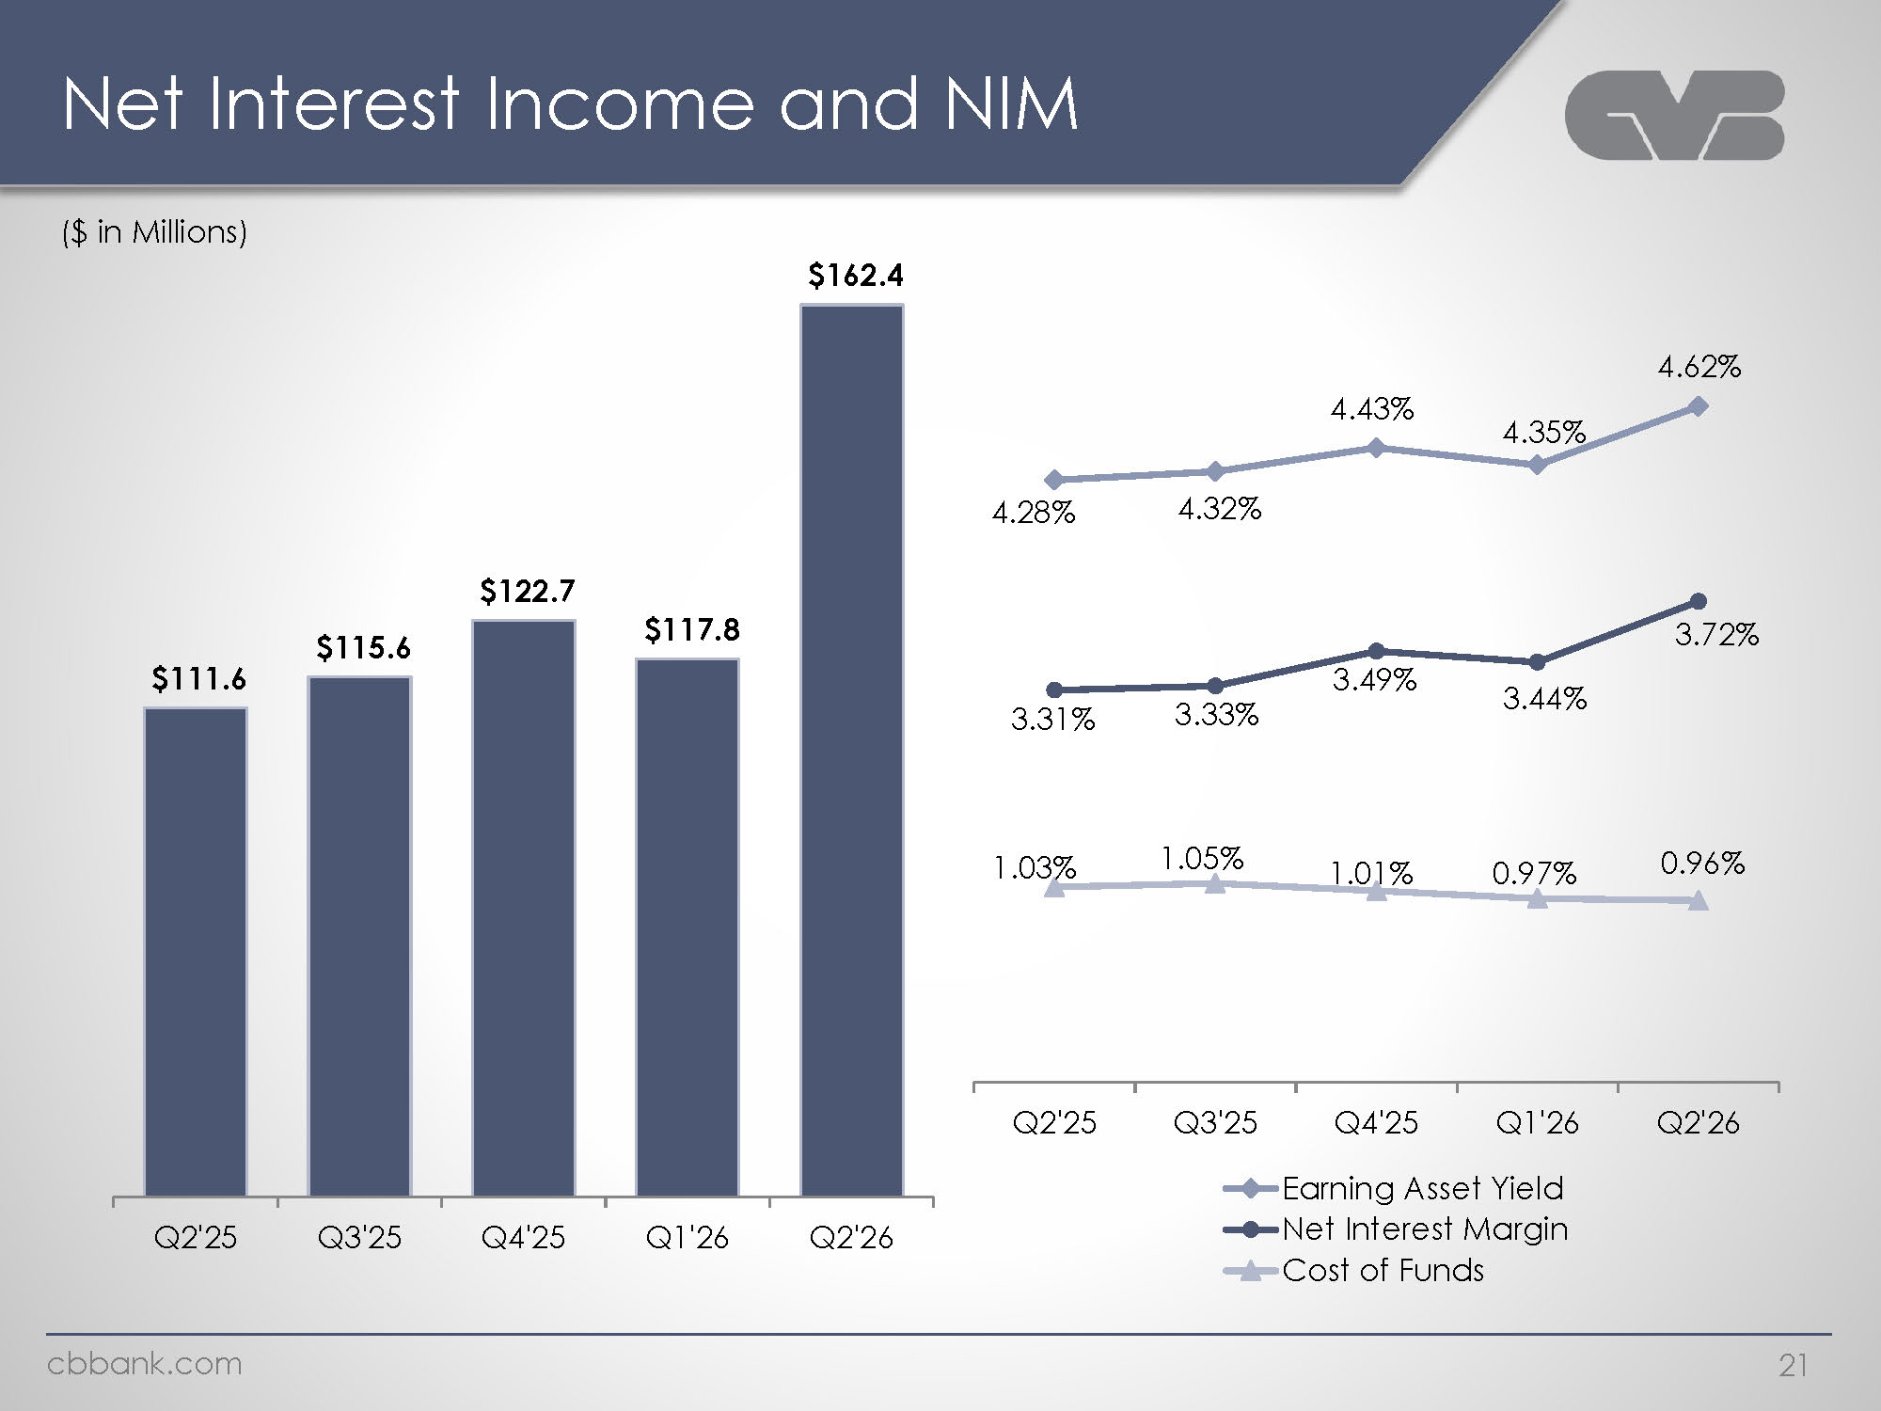
Logo Net Interest Income and NIM ($ in Millions) $111.6 $115.6 $122.7 $117.8 $162.4 Q2'25 Q3'25 Q4'25 Q1'26 Q2'26 4.28% 4.32% 4.43% 4.35% 4.62% 3.31% 3.33% 3.49% 3.44% 3.72% 1.03% 1.05% 1.01% 0.97% 0.96% Q2'25 Q3'25 Q4'25 Q1'26 Q2'26 Earning Asset Yield Net Interest Margin Cost of Funds cbbank.com 21

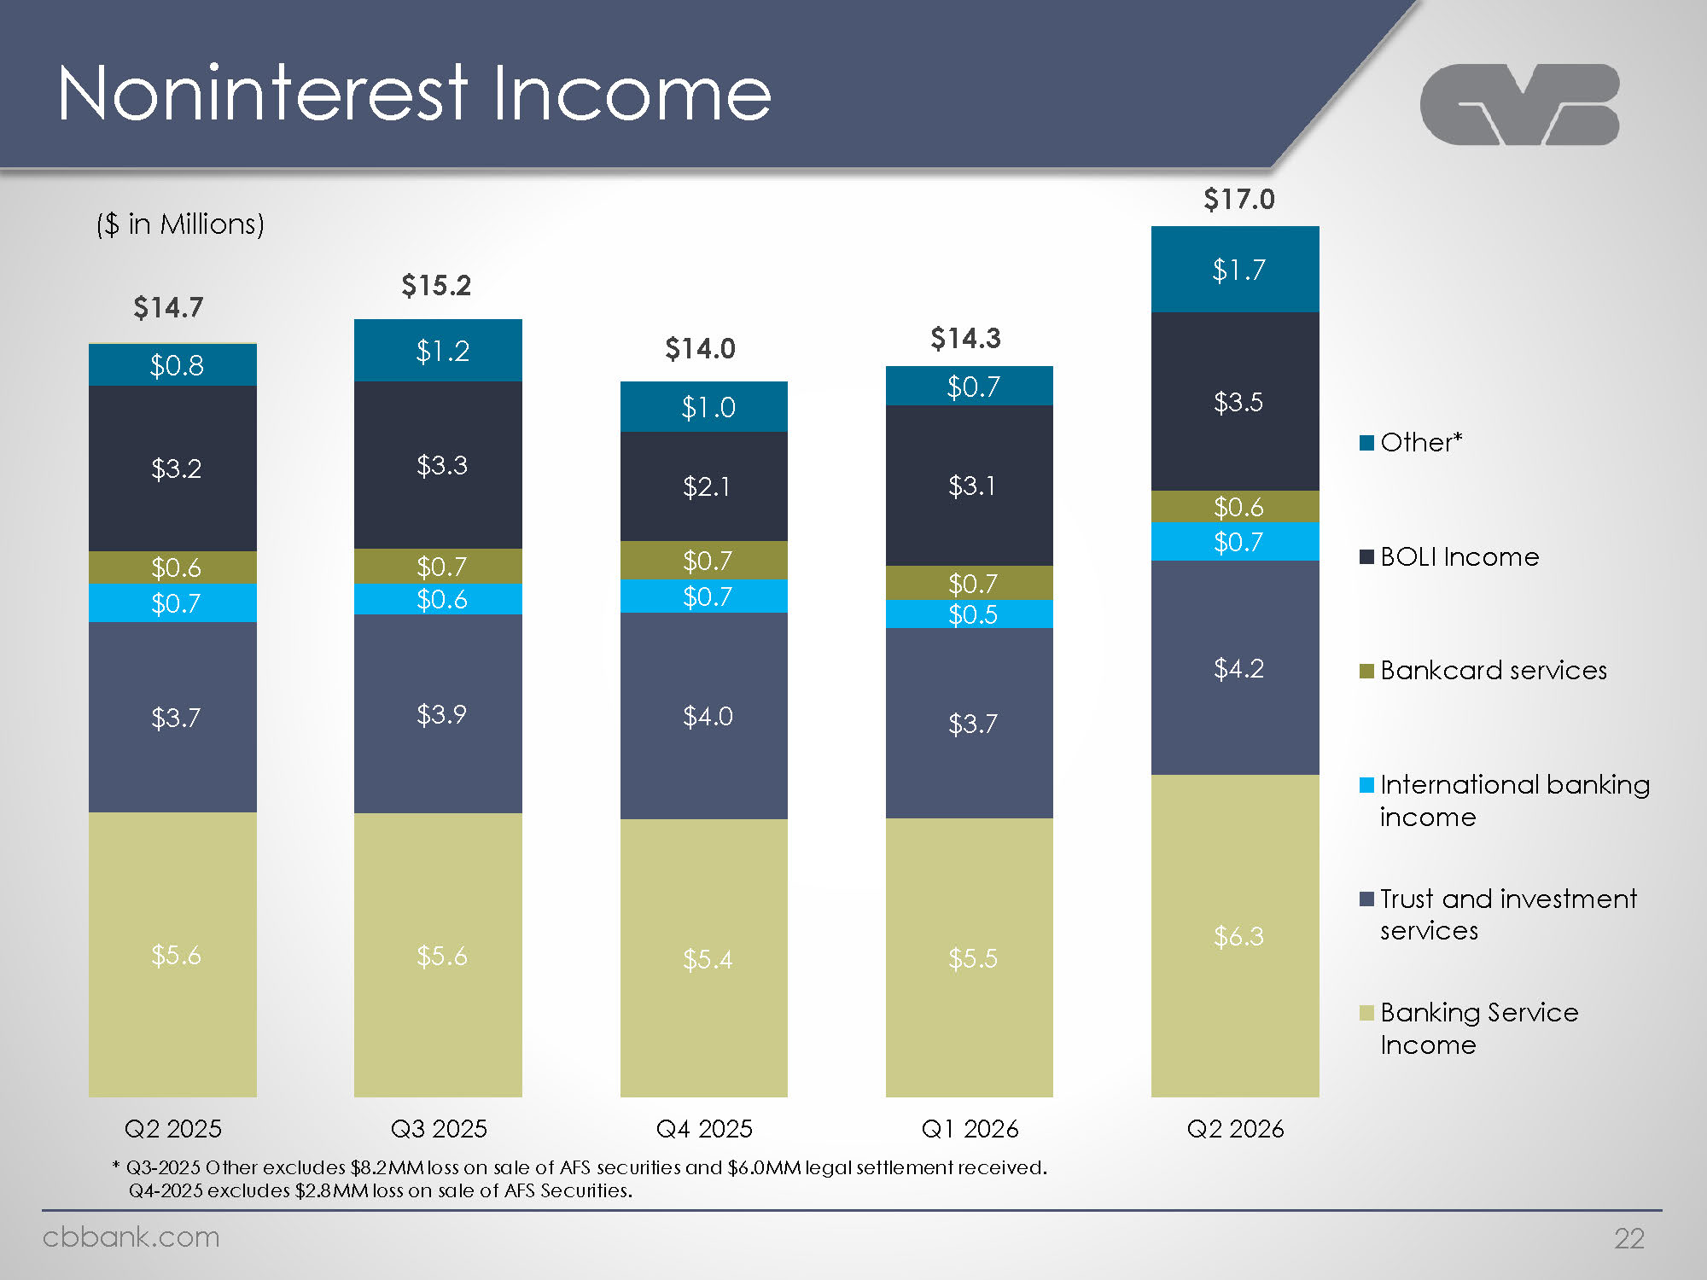
Logo Noninterest Income ($ in Millions) $14.7 $0.8 $3.2 $0.6 $0.7 $3.7 $5.6 $15.2 $1.2 $3.3 $0.7 $0.6 $3.9 $5.6 $14.0 $1.0 $2.1 $0.7 $0.7 $4.0 $5.4 $14.3 $0.7 $3.1 $0.7 $0.5 $3.7 $5.5 $17.0 $1.7 $3.5 $0.6 $0.7 $4.2 $6.3 Q2 2025Q3 2025 Q4 2025 Q1 2026 Q2 2026 Other* BOLI Income Bankcard services International banking income Trust and investment services Banking Service Income * Q3-2025 Other excludes $8.2MM loss on sale of AFS securities and $6.0MM legal settlement received. Q4-2025 excludes $2.8MM loss on sale of AFS Securities. Cbbank.com 22

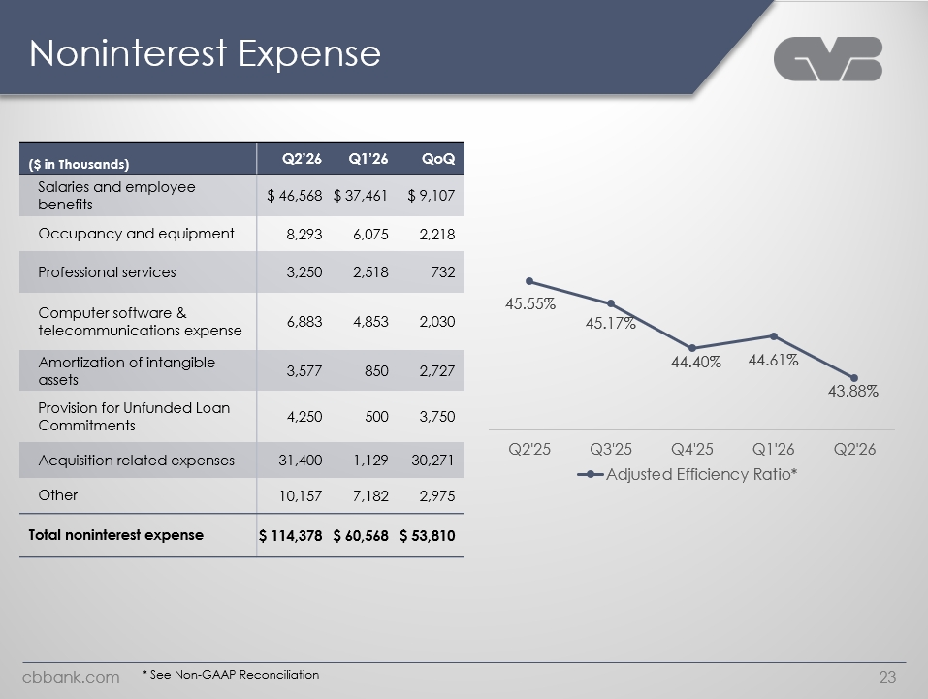
Logo ($ in Thousands) Q2’26 Q1’26 QoQ Salaries and employee benefits $ 46,568 $ 37,461 $ 9,107 Occupancy and equipment 8,293 6,075 2,218 Professional services 3,250 2,518 732 Computer software & telecommunications expense 6,883 4,853 2,030 Amortization of intangible assets 3,577 850 2,727 Provision for Unfunded Loan Commitments 4,250 500 3,750 Acquisition related expenses 31,400 1,129 30,271 Other 10,157 7,182 2,975 Total noninterest expense $ 114,378 $ 60,568 $ 53,810 45.55% 45.17% 44.40% 44.61% 43.88% Q2'25 Q3'25 Q4'25 Q1'26 Q2'26 * See Non-GAAP Reconciliation Cbbank.com 23

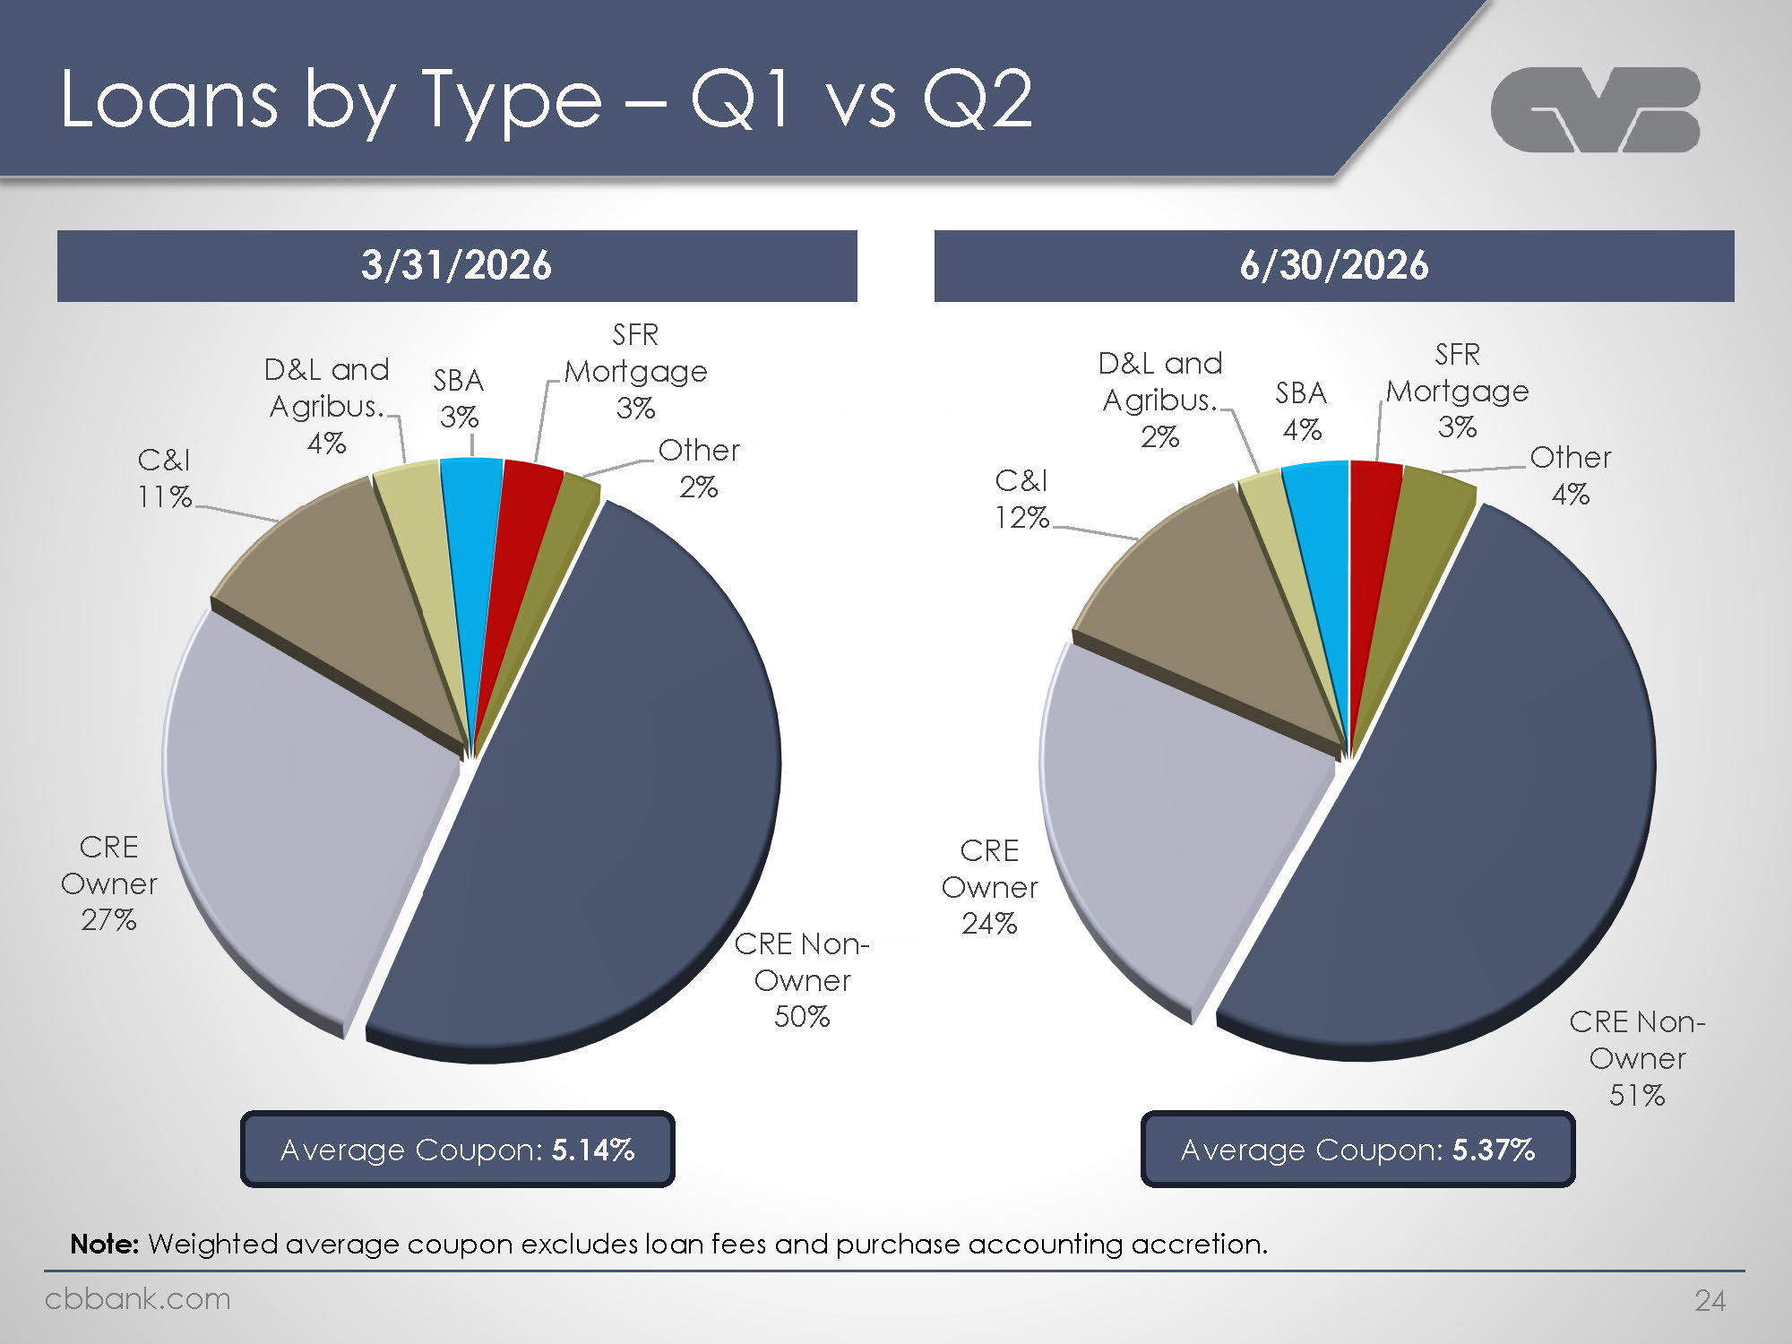
Logo Loans by Type – Q1 vs Q2 3/31/2026 C&I 11% D&L and Agribus.4% D&L and Agribus. 4% SFR Mortgage Other 2% CRE Owner CRE Non-Owner 50% Average Coupon: 5.14% 6/30/2026 C&I 12% D&L and Agribus. 2% SBA 4% SFR Mortgage Other 4% CRE Owner CRE Non-Owner Average Coupon: 5.37% Note: Weighted average coupon excludes loan fees and purchase accounting accretion. Cbbank.com 24

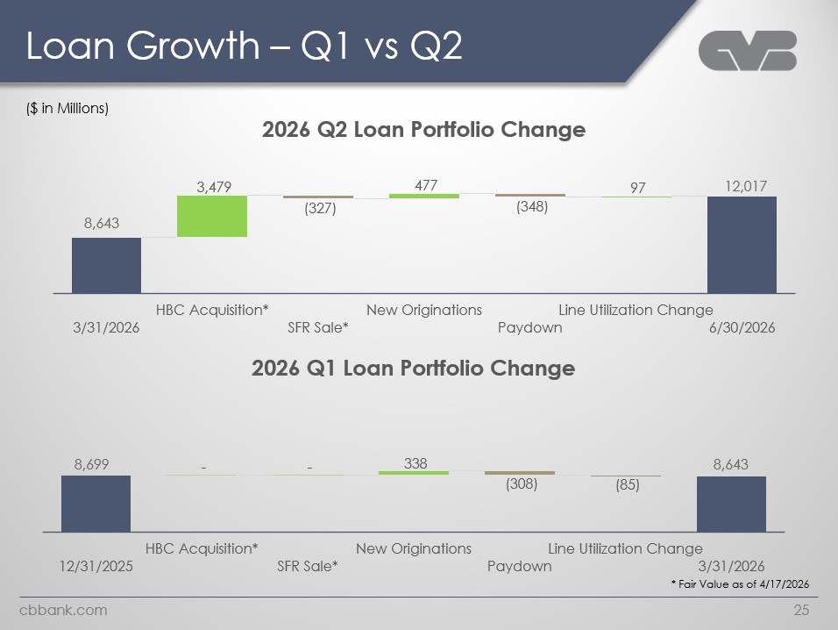
Logo Loan Growth – Q1 vs Q2 ($ in Millions) 2026 Q2 Loan Portfolio Change 8,643 3,479 (327) 477 (348) 97 12,017 3/31/2026 HBC Acquisition* SFR Sale* New Originations Paydown Line Utilization Change 6/30/2026 2026 Q1 Loan Portfolio Change 8,699 - - 338 (308) (85) 8,643 12/31/2025 HBC Acquisition* SFR Sale* New Originations Paydown Line Utilization Change 3/31/2026 * Fair Value as of 4/17/2026 cbbank.com 25

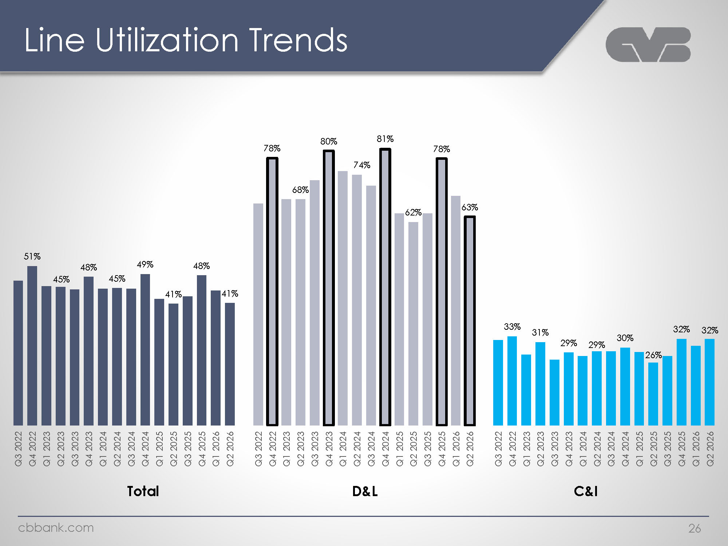
Logo Line Utilization Trends 51% 45% 48% 45% 49% 41% 48% 41% Q3 2022 Q4 2022 Q1 2023 Q2 2023 Q3 2023 Q4 2023 Q1 2024 Q2 2024 Q3 2024 Q4 2024 Q1 2025 Q2 2025 Q3 2025 Q4 2025 Q1 2026 Q2 2026 78% 68% 80% 74% 81% 62% 78% 63% Q3 2022 Q4 2022 Q1 2023 Q2 2023 Q3 2023 Q4 2023 Q1 2024 Q2 2024 Q3 2024 Q4 2024 Q1 2025 Q2 2025 Q3 2025 Q4 2025 Q1 2026 Q2 2026 33% 31% 29% 29% 29% 30% 30% 26% 32% 32% 32% Q3 2022 Q4 2022 Q1 2023 Q2 2023 Q3 2023 Q4 2023 Q1 2024 Q2 2024 Q3 2024 Q4 2024 Q1 2025 Q2 2025 Q3 2025 Q4 2025 Q1 2026 Q2 2026 Total D&L C&I Cbbank.com 26

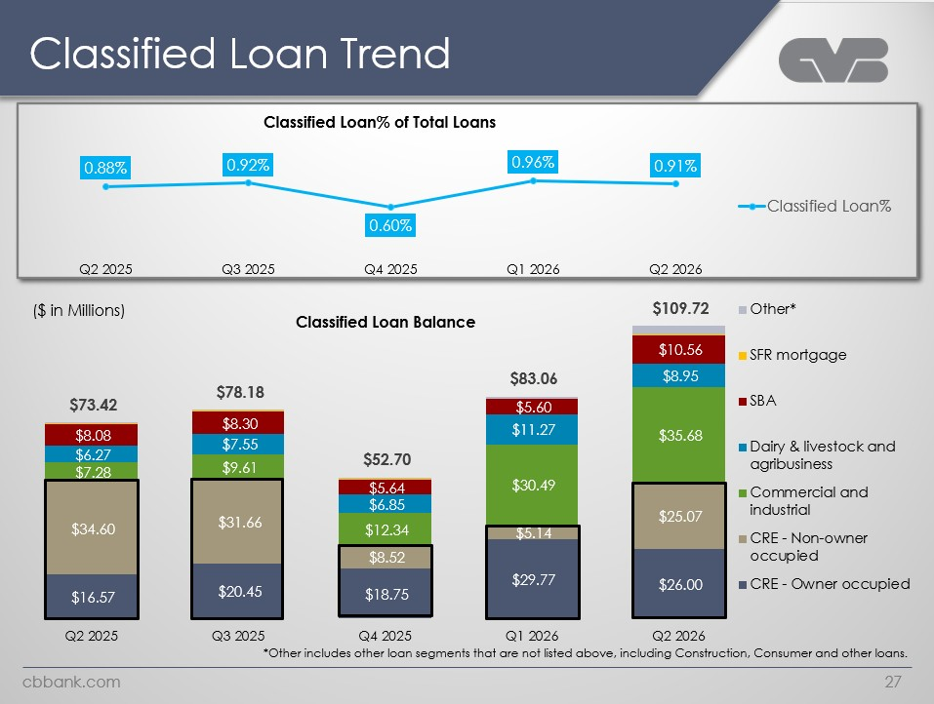
Logo Classified Loan Trend Classified Loan% of Total Loans 0.88% 0.92% 0.60% 0.96% 0.91% Classified Loan% Q2 2025 Q3 2025 Q4 2025 Q1 2026 Q2 2026 ($ in Millions) Classified Loan Balance $73.42 $8.08 $6.27 $7.28 $34.60 $16.57 $78.18 $8.30 $7.55 $9.61 $31.66 $20.45 $52.70 $5.64 $6.85 $12.34 $8.52 $18.75 $83.06 $5.60 $11.27 $30.49 $5.14 $29.77 $109.72 $10.56 $8.95 $35.68 $25.07 $26.00 =Other* SFR mortgage SBA Dairy & livestock and agribusiness Commercial and industrial CRE - Non-owner occupied CRE - Owner occupied Q2 2025 Q3 2025 Q4 2025 Q1 2026 Q2 2026 *Other includes other loan segments that are not listed above, including Construction, Consumer and other loans. cbbank.com 27

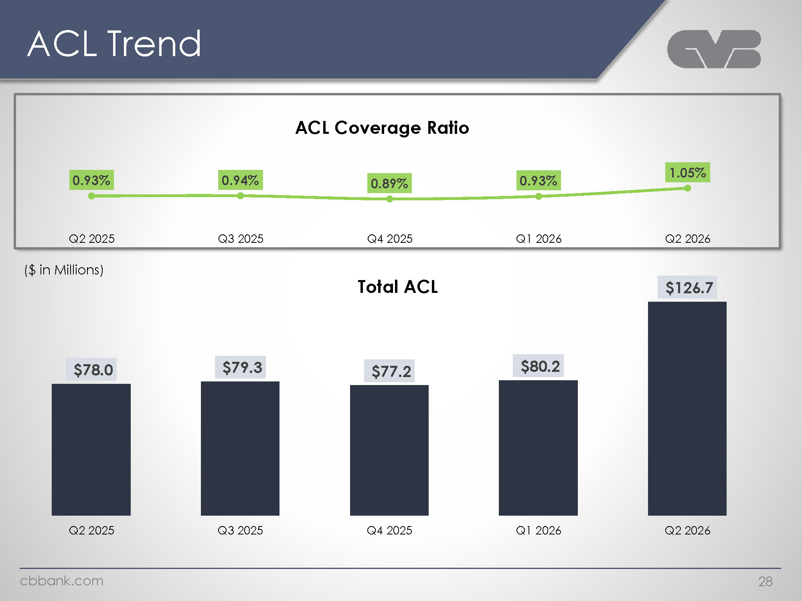
Logo ACL Trend ACL Coverage Ratio 0.93% 0.94% 0.89% 0.93% 1.05% Q2 2025 Q3 2025 Q4 2025 Q1 2026 Q2 2026 Total ACL ($ in Millions) $78 $79.3 $77.2 $80.2 $126.7 Q2 2025 Q3 2025 Q4 2025 Q1 2026 Q2 2026 Cbbank.com 28

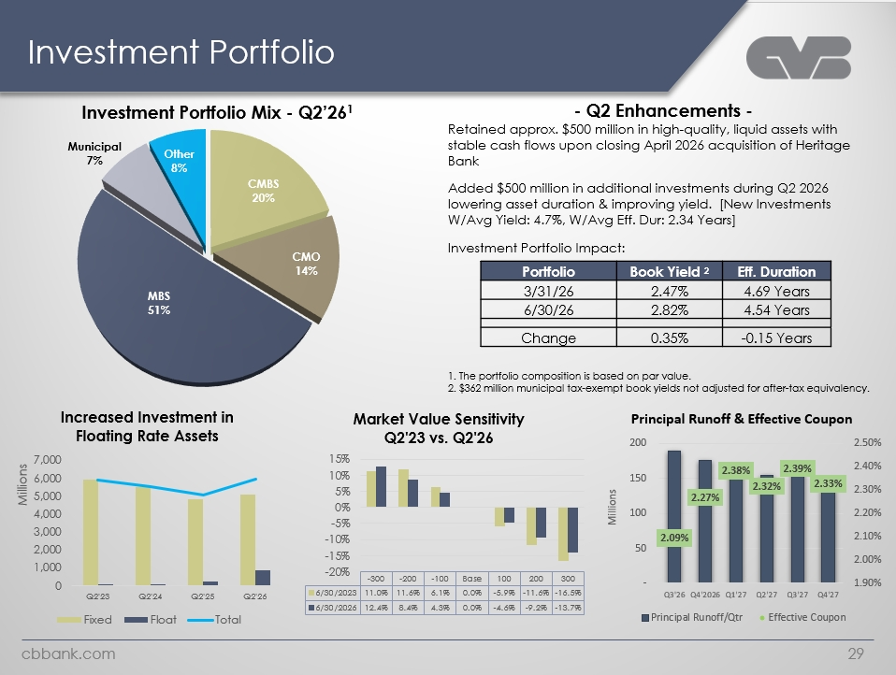
Logo Investment Portfolio Investment Portfolio Mix - Q2’261 Municipal 7% Other 8% CMBS 20% CMO 14% MBS 51% - Q2 Enhancements - Retained approx. $500 million in high-quality, liquid assets with stable cash flows upon closing April 2026 acquisition of Heritage Bank Added $500 million in additional investments during Q2 2026 lowering asset duration & improving yield. [New Investments W/Avg Yield: 4.7%, W/Avg Eff. Dur: 2.34 Years]Investment Portfolio Impact: Portfolio Book Yield 2 Eff. Duration 3/31/26 2.47% 4.69 Years 6/30/26 2.82% 4.54 Years Change 0.35% -0.15 Years 1. The portfolio composition is based on par value. 2. $362 million municipal tax-exempt book yields not adjusted for after-tax equivalency Increased Investment in Floating Rate Assets Millions 7,000 6,000 5,000 4,000 3,000 2,000 1,000 0 Q2'23 Q2'24 Q2'25 Q2'26 Fixed Float Total Market Value Sensitivity Q2'23 vs. Q2'26 15% 10% 5% 0% -5% -10% -15% -20% -300 -200 -100 Base 100 200 300 6/30/2023 11.0% 11.6% 6.1% 0.0% -5.9% -11.6% -16.5% 6/30/2026 12.4% 8.4% 4.3% 0.0% -4.6% -9.2% -13.7% Principal Runoff & Effective Coupon Millions 200 150 100 52 – 2.09% 2.27% 2.38% 2.32% 2.39% 2.33% 2.50% 2.40% 2.30% 2.20% 2.10% 2.00% 1.90% Q3'26 Q4'2026 Q1'27 Q2'27 Q3'27 Q4'27 Cbbank.com 29

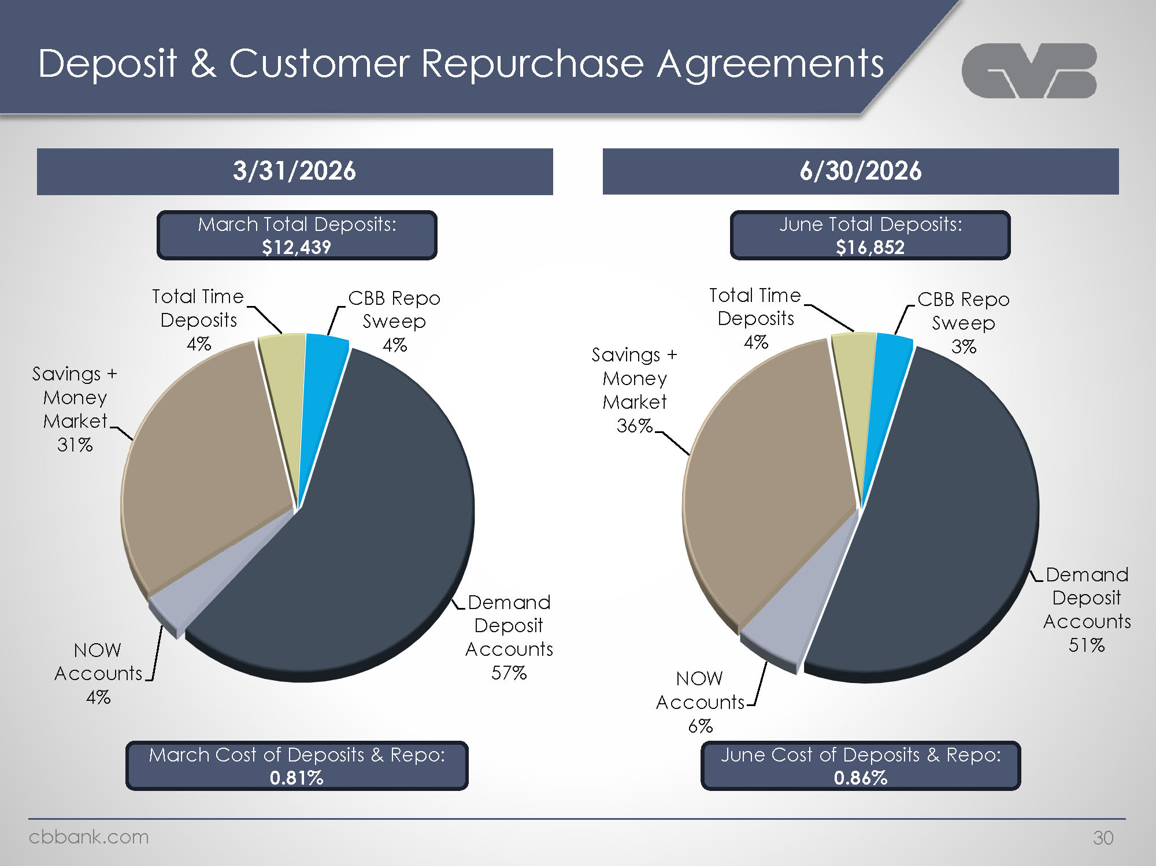
Logo Deposit & Customer Repurchase Agreements 3/31/2026 March Total Deposits: $12,439 Total Time Deposits 4% CBB Repo Sweep 4% Savings + Money Market 31% NOW Accounts 4% Demand Deposit Accounts 57% 6/30/2026 June Total Deposits: $16,852 Total Time Deposits 4% Savings + Money Market 36% NOW Accounts 6% CBB Repo Sweep 3% Demand Deposit Accounts 51% June Cost of Deposits & Repo: 0.86% March Cost of Deposits & Repo: 0.81% cbbank.com 30

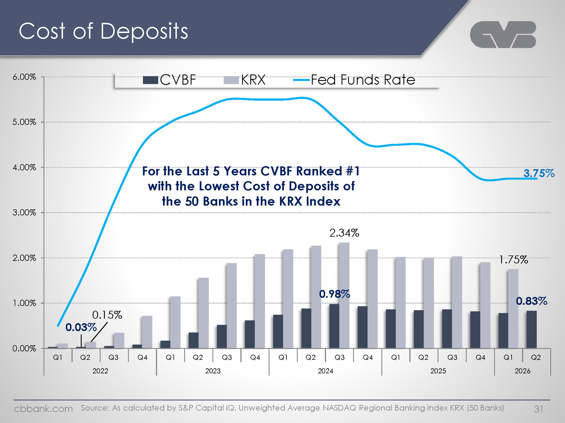
Logo Cost of Deposits CVBF KRX Fed Funds Rate 6.00% 5.00% 4.00% 3.00% 2.00% 1.00% 0.00% For the Last 5 Years CVBF Ranked #1 with the Lowest Cost of Deposits of the 50 Banks in the KRX Index 3.75% 0.03% 0.15% 2.34% 0.98% 1.75% 0.83% Q1 Q2 Q3 Q4 Q1 Q2 Q3 Q4 Q1 Q2 Q3 Q4 Q1 Q2 Q3 Q4 Q1Q2 2022 2023 2024 2025 2026 Source: As calculated by S&P Capital IQ. Unweighted Average NASDAQ Regional Banking Index KRX (50 Banks) 31 cbbank.com

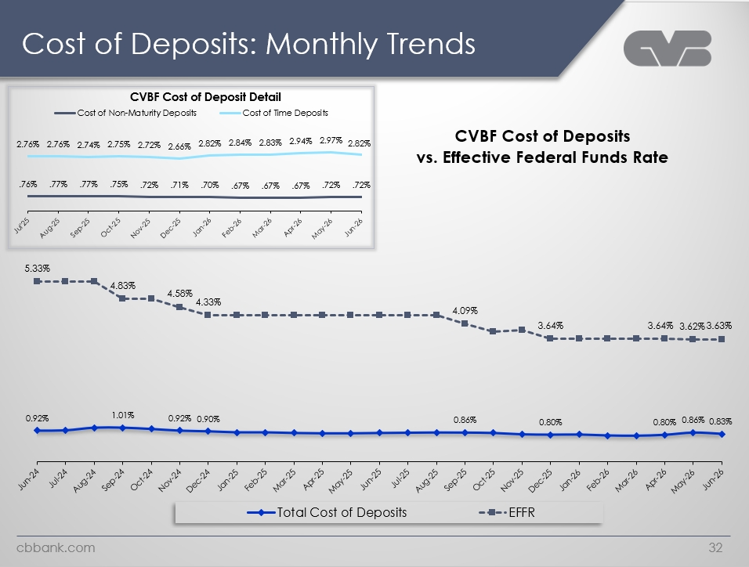
Logo Cost of Deposits: Monthly Trends CVBF Cost of Deposit Detail Cost of Non-Maturity Deposits Cost of Time Deposits 2.76% 2.76% 2.74% 2.75% 2.72% 2.66% 2.82% 2.84% 2.83% 2.94% 2.97% 2.82% .76% .77% .77% .75% .72% .71% .70% .67% .67% .67% .72% .72% Jul25 Aug-25 Sep-25 Oct-25 Nov-25 Dec-25 Jan-26 feb-26 Mar-26 Apr-26 May-26 Jun-26 CVBF Cost of Deposits vs. Effective Federal Funds Rate 5.33% 4.83% 4.58% 4.33% 4.09% 3.64% 3.64% 3.62% 3.63% 0.92% 1.01% 0.92% 0.90% 0.86% 0.80% 0.80% 0.86% 0.83% Jun-24 Jul-24 Aug-24 Sep-24 Oct-24 Nov-24 Dec-24 Jan-25 Feb-25 Mar-25 Apr-25 May-25 Jun-25 Jul-25 Aug-25 Sep-25 Oct-25 Nov-25 Dec-25 Jan-26 feb-26 Mar-26 Apr-26 May-26 Jun-26 Total Cost of Deposits EFFR cbback.com 32

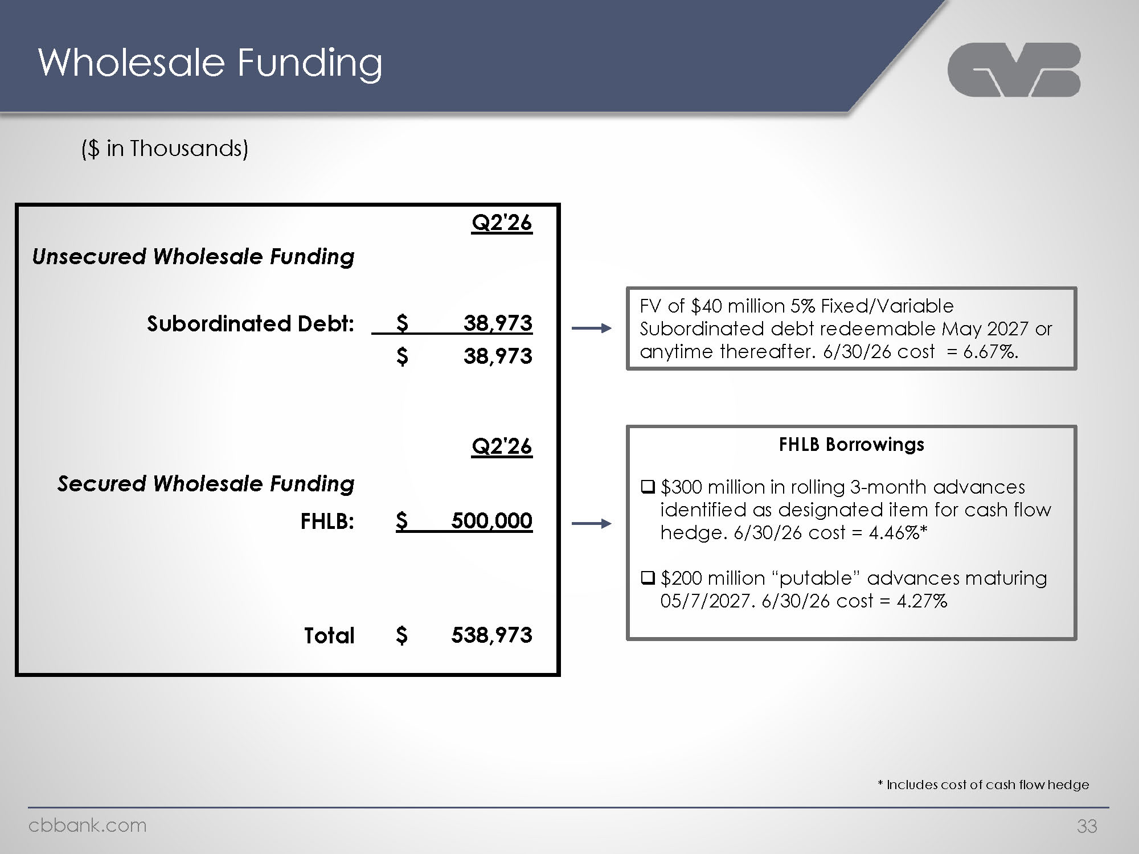
Logo Wholesale Funding ($ in Thousands) Unsecured Wholesale Funding Q2'26 Subordinated Debt: $ 38,973 $ 38,973 Secured Wholesale Funding FHLB: Q2'26 $ 500,000 Total $ 538,973 FV of $40 million 5% Fixed/Variable Subordinated debt redeemable May 2027 or anytime thereafter. 6/30/26 cost = 6.67%. FHLB Borrowings $300 million in rolling 3-month advances identified as designated item for cash flow hedge. 6/30/26 cost = 4.46%* $200 million “putable” advances maturing 05/7/2027. 6/30/26 cost = 4.27% * Includes cost of cash flow hedge cbbank.com 33

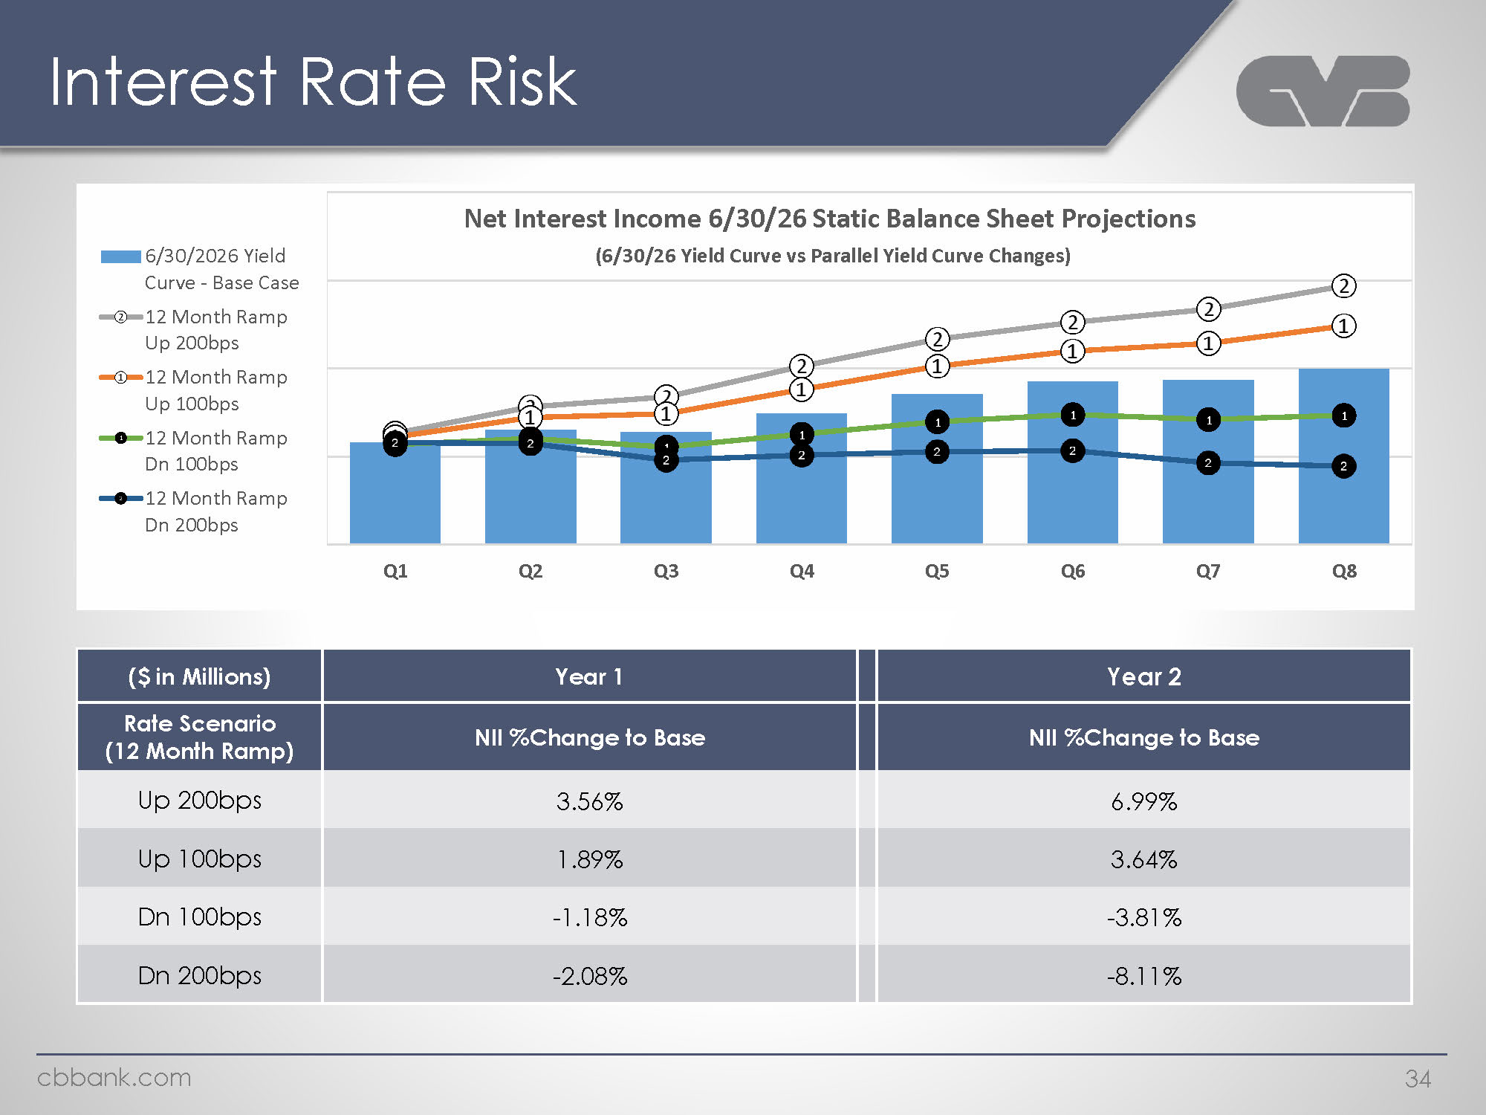
Logo Interest Rate Risk Net Interest Income 6/30/26 Static Balance Sheet Projections (6/30/26 Yield Curve vs Parallel Yield Curve Changes) 16/30/2026 Yield Curve - Base Case -2-12 Month Ramp Up 200bps --12 Month Ramp Up 100bps 12 Month Ramp Dn 100bps 12 Month Ramp Dn 200bps (21) 8 (1) (2) (2) (1) 8 Q1 Q2 Q3 Q4 Q5 Q6 Q7 Q8 ($ in Millions) Year 1 Year 2Rate Scenario (12 Month Ramp) NII %Change to Base NII %Change to Base Up 200bps 3.56% 6.99% Up 100bps 1.89% 3.64% Dn 100bps -1.18% -3.81% Dn 200bps -2.08% -8.11% cbbank.com 34

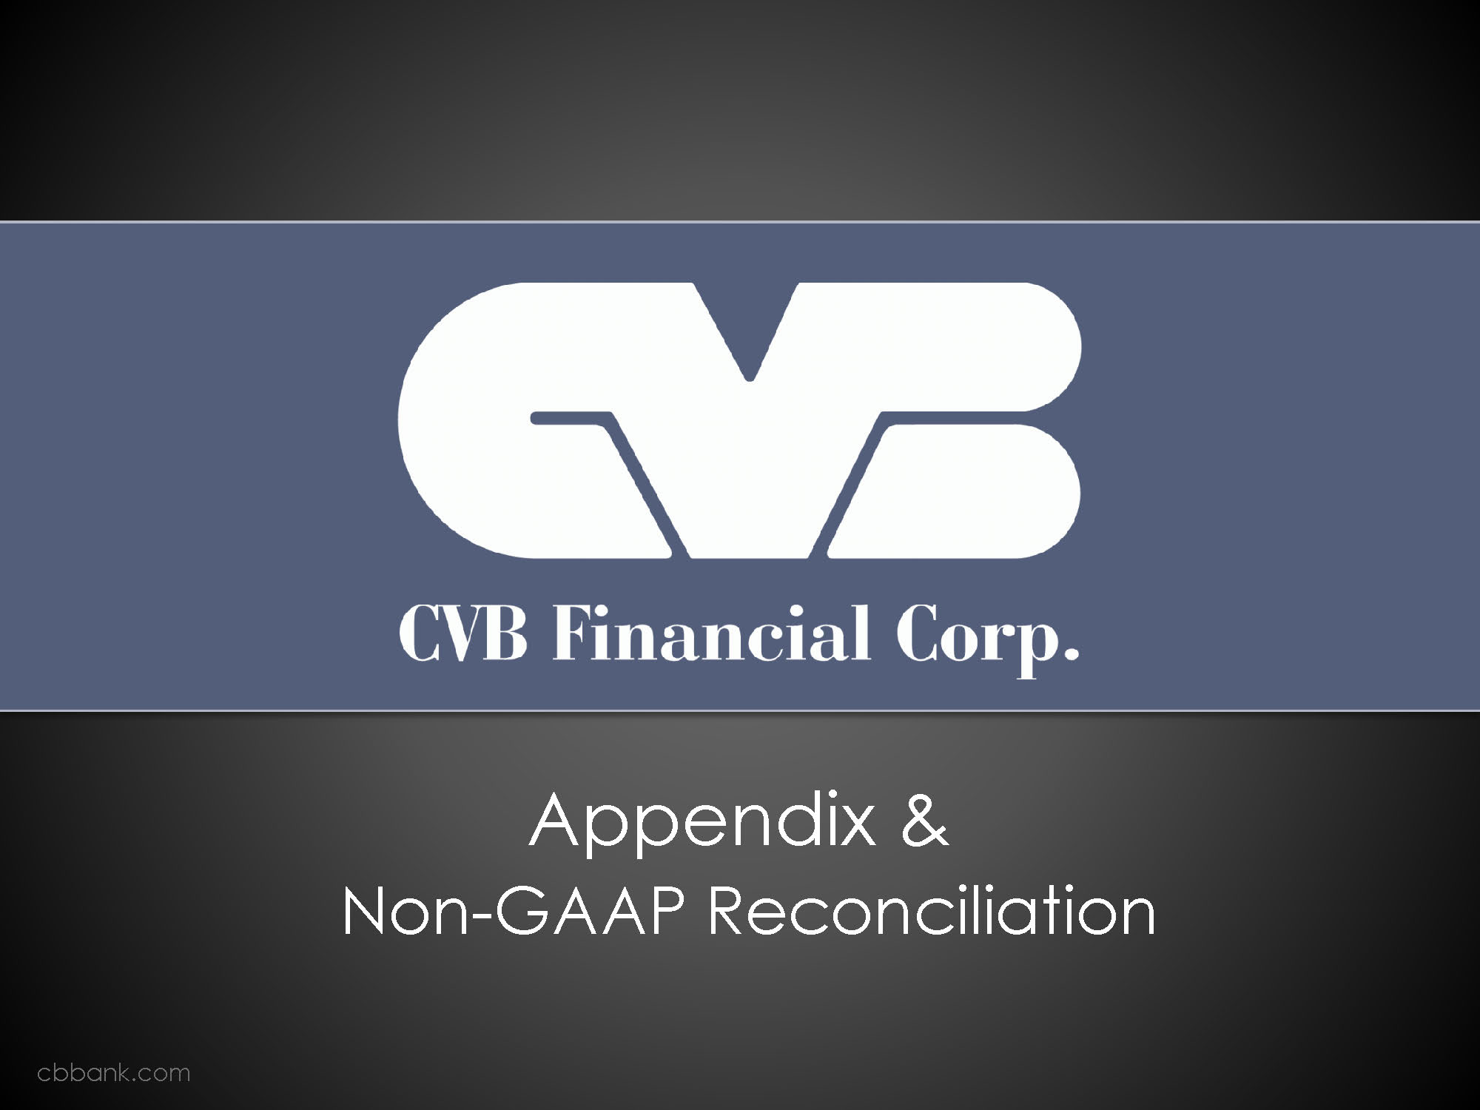
CVB Financial Corp. Appendix & Non-GAAP Reconciliation cbbank.com

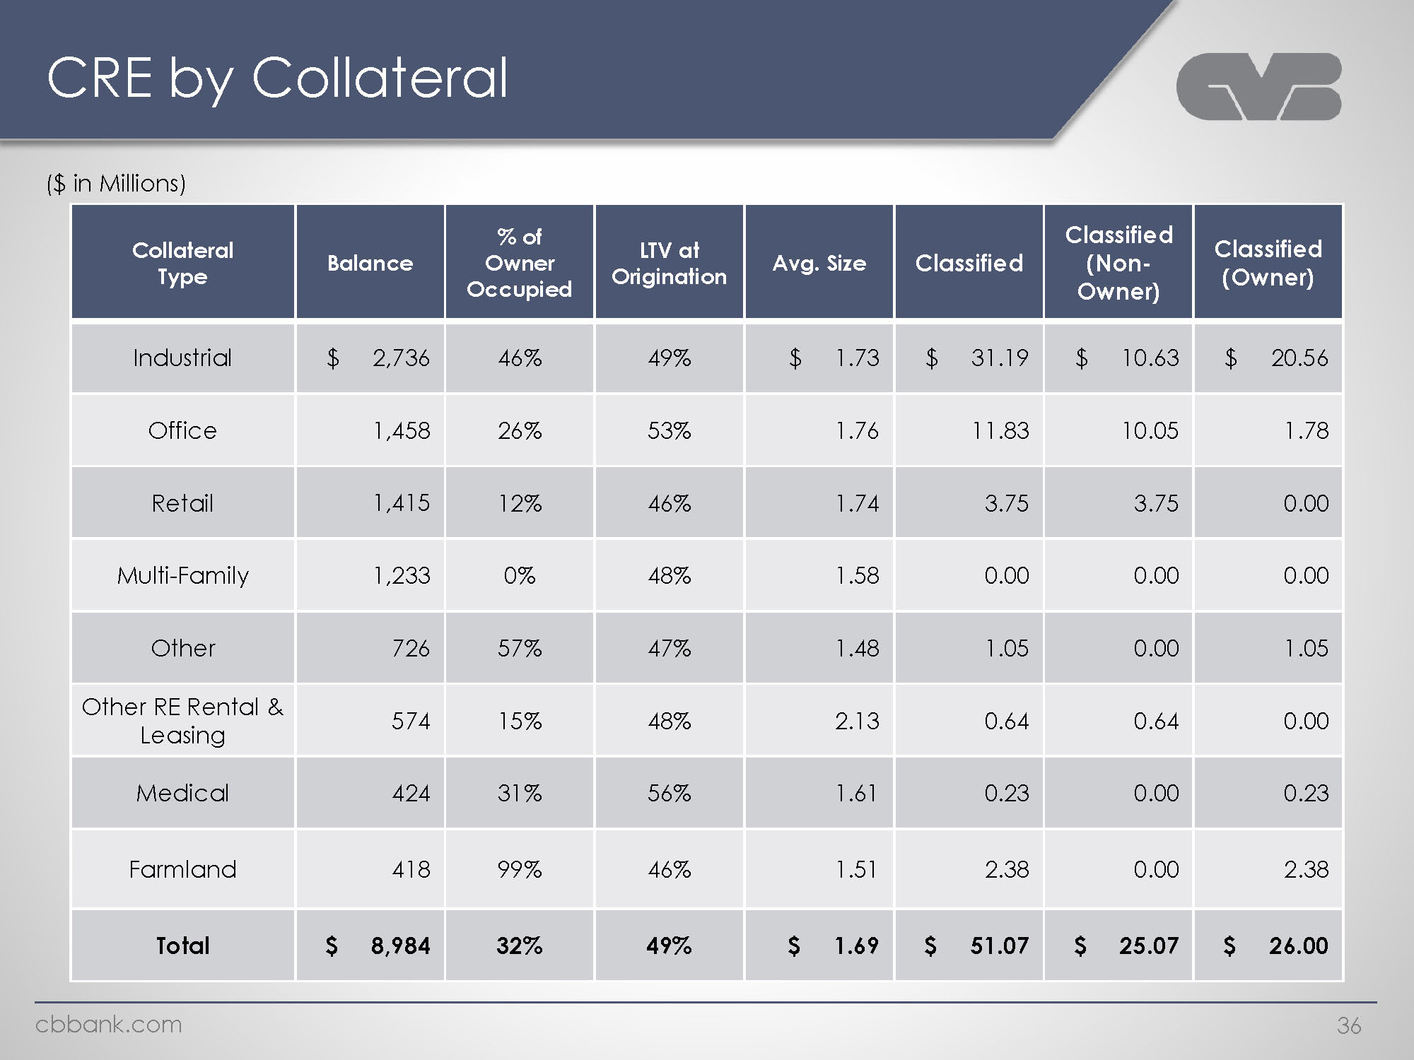
logo CRE by Collateral ($ in Millions) Collateral Type Balance % of Owner Occupied LTV at Origination Avg. Size Classified Classified (Non- Owner) Classified (Owner) Industrial Office Retail Multi-Family Other Other RE Rental & Leasing Medical Farmland Total $ 2,736 1,458 1,415 1,233 726 574 424 418 $ 8,984 46% 26% 12% 0% 57% 15% 31% 31% 32% 49% 53% 46% 48% 47% 48% 56% 46% 49% $ 1.73 1.76 1.74 1.58 1.48 2.13 1.61 1.51 $ 1.69 $ 31.19 11.83 3.75 0.00 1.05 0.64 0.23 2.38 $ 51.07 $ 10.63 10.05 3.75 0.00 0.00 0.64 0.00 0.00 $ 25.07 $ 20.56 1.78 0.00 0.00 1.05 0.00 0.23 2.38 $ 26.00 cbbank.com 36

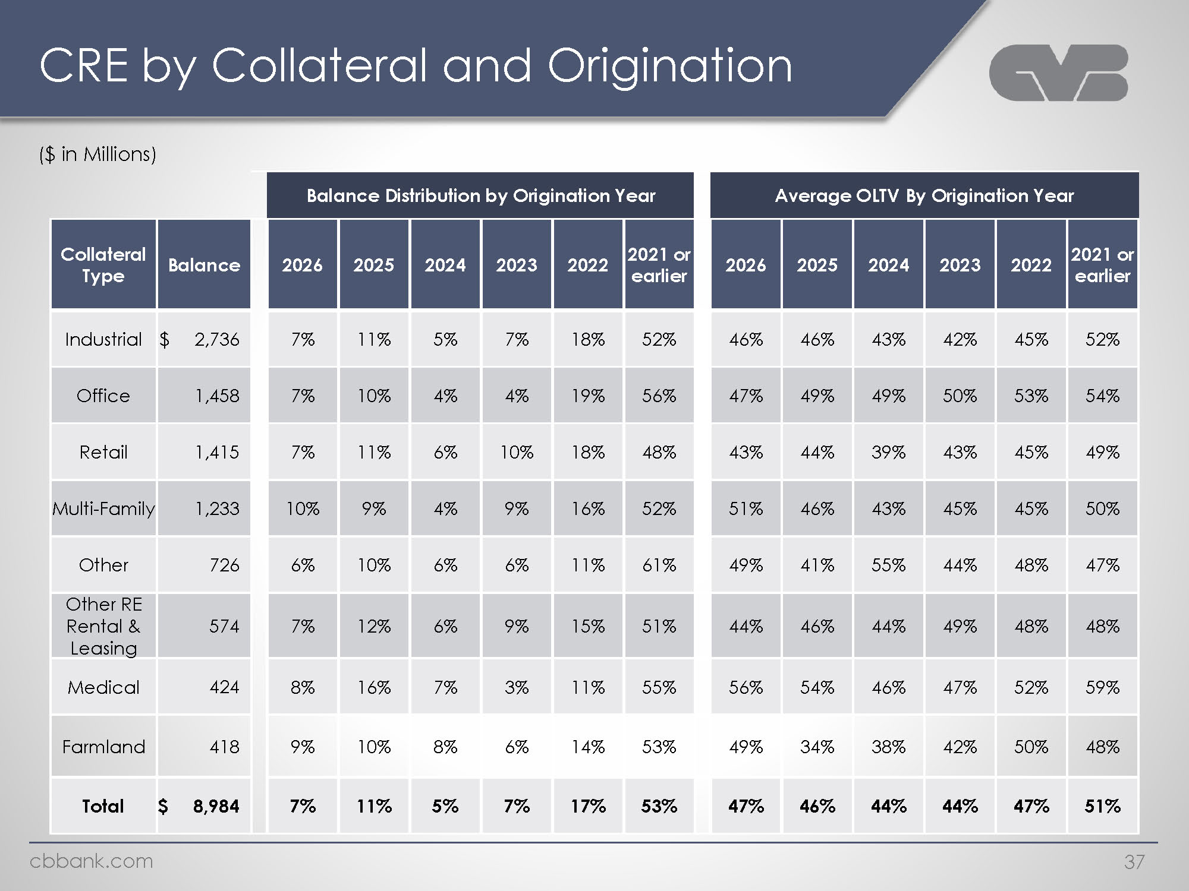
Logo CRE by Collateral and Origination ($ in Millions) Balance Distribution by Origination Year Average OLTV By Origination Year Collateral Type Balance 2026 2025 2024 2023 2022 2021 or earlier 2026 2025 2024 2023 2022 2021 or earlier Industrial $ 2,736 7% 11% 5% 7% 18% 52% 46% 46% 43% 42% 45% 52% Office 1,458 7% 10% 4% 4% 19% 56% 47% 49% 49% 50% 53% 54% Retail 1,415 7% 11% 6% 10% 18% 48% 43% 44% 39% 43% 45% 49% Multi-Family 1,233 10% 9% 4% 9% 16% 52% 51% 46% 43% 45% 45% 50% Other 726 6% 10% 6% 6% 11% 61% 49% 41% 55% 44% 48% 47% Other RE Rental & Leasing 574 7% 12% 6% 9% 15% 51% 44% 46% 44% 49% 48% 48% Medical 424 8% 16% 7% 3% 11% 55% 56% 54% 46% 47% 52% 59% Farmland 418 9% 10% 8% 6% 14% 53% 49% 34% 38% 42% 50% 48% Total $ 8,984 7% 11% 5% 7% 17% 53% 47% 46% 44% 44% 47% 51% Cbbank.com 37

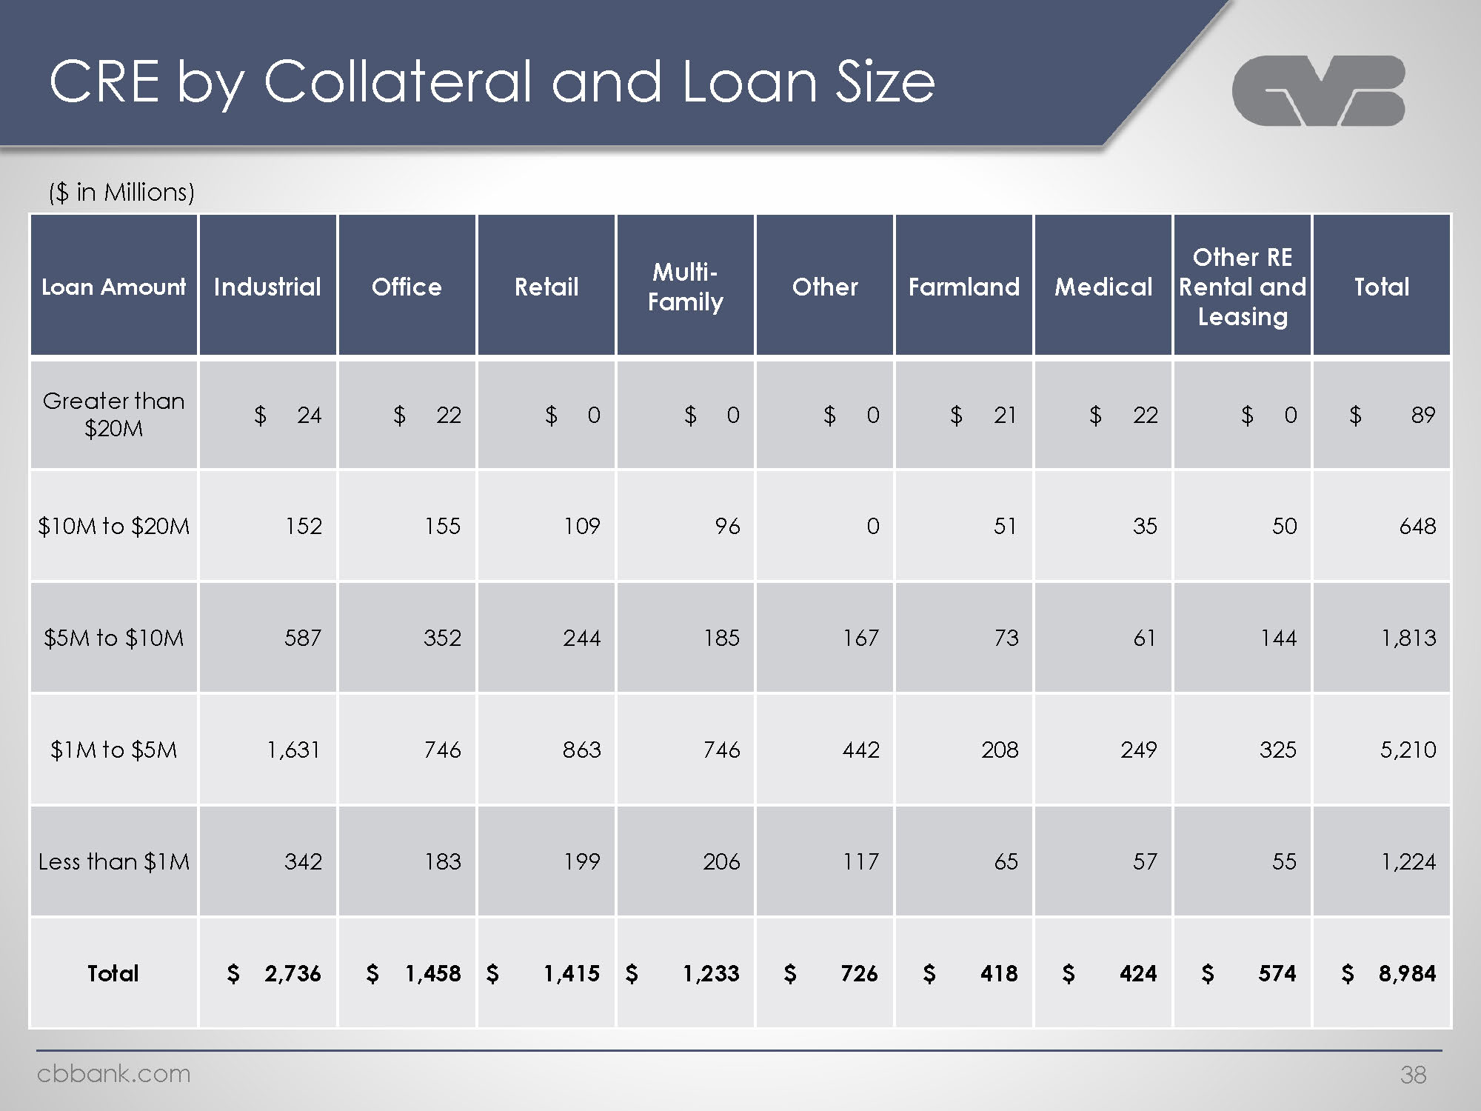
Logo CRE by Collateral and Loan Size ($ in Millions) Loan Amount Industrial Office Retail Multi-Family Other Farmland Medical Other RE Rental and Leasing Total Greater than $20M $24 $22 $ 0 $ 0 $ 0 $ 21 $ 22 $ 0 $ 89 $10M to $20M 152 155 109 96 0 51 35 50 648 $5M to $10M 587 352 244 185 167 73 61 144 1,813 $1M to $5M 1,631 746 863 746 442 208 249 325 5,210 Less than $1M 342 183 199 206 117 65 57 55 1,224Total $ 2,736 $ 1,458 $ 1,415 $ 1,233 $ 726 $ 418 $ 424 $ 574 $ 8,984

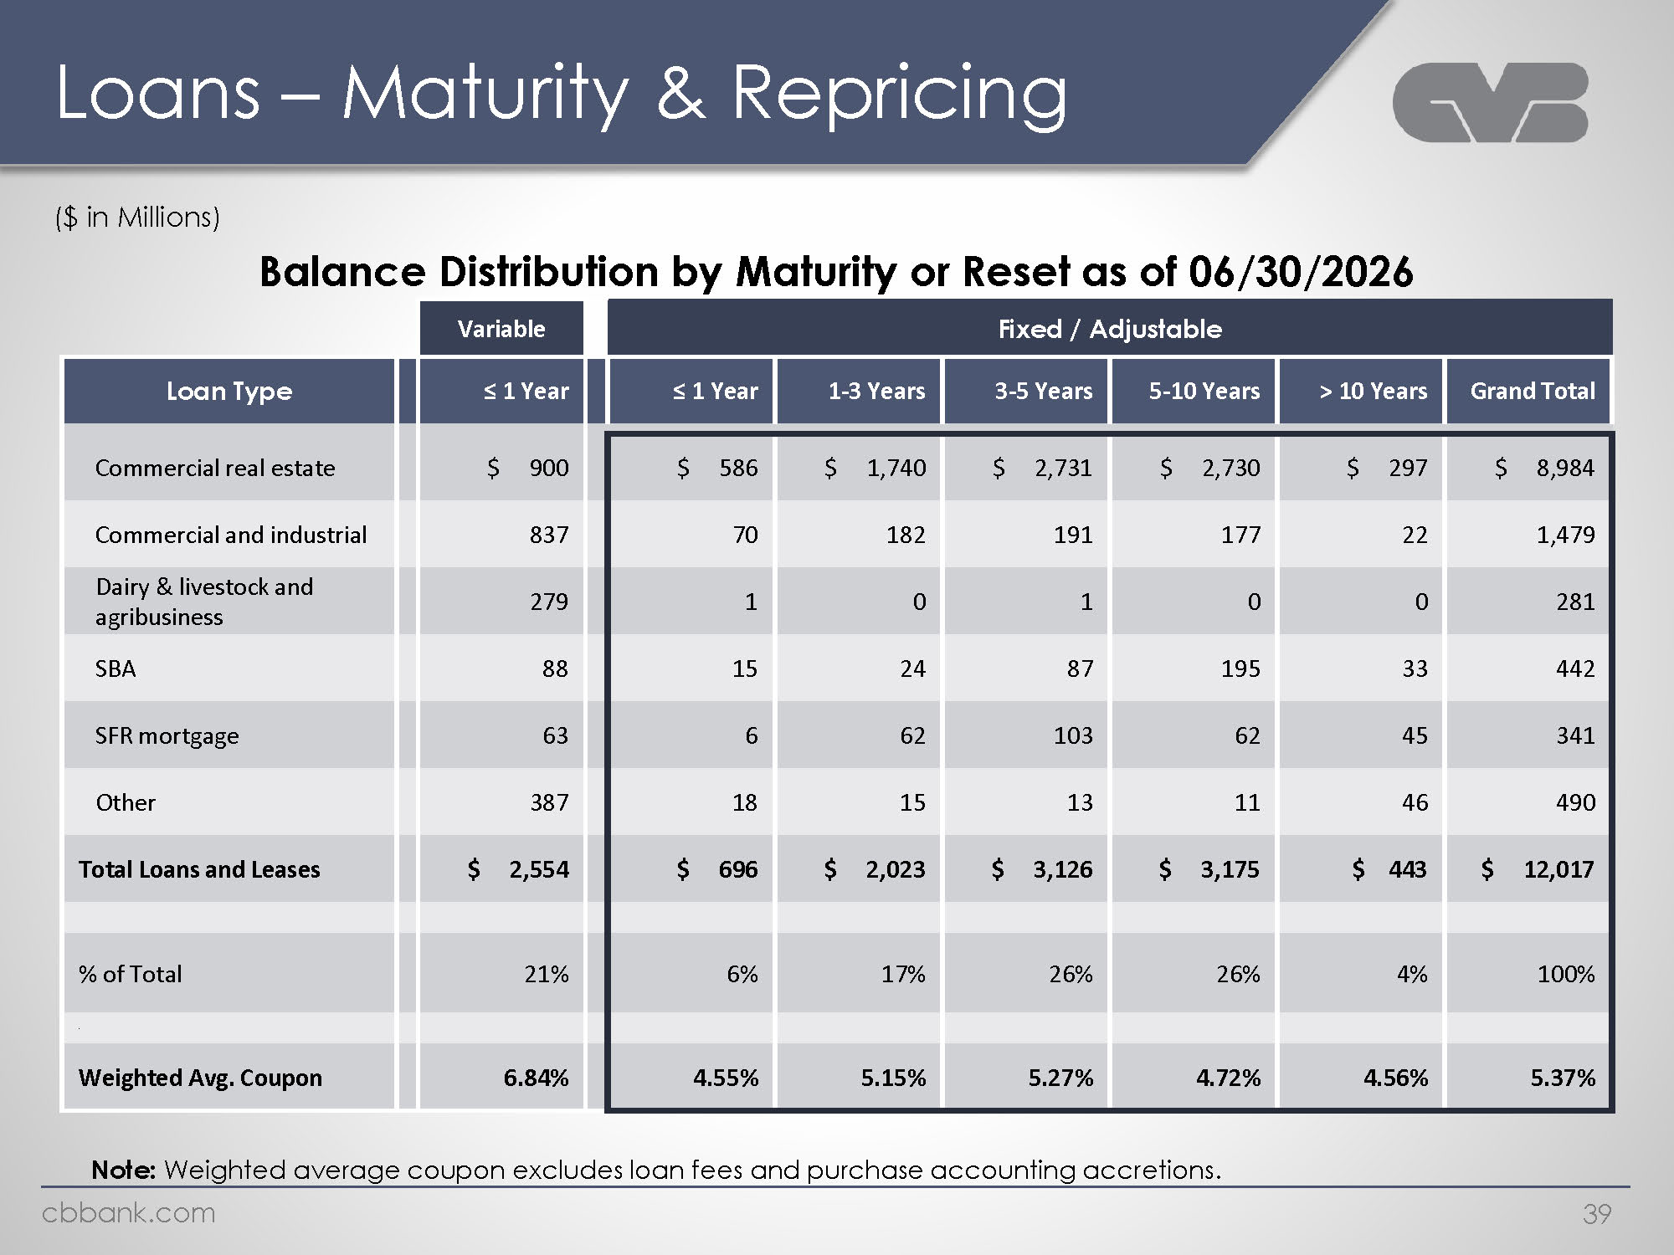
Logo Loans – Maturity & Repricing ($ in Millions) Balance Distribution by Maturity or Reset as of 06/30/2026 Variable Fixed / Adjustable Loan Type ≤ 1 Year ≤ 1 Year 1-3 Years 3-5 Years 5-10 Years > 10 Years Grand Total Commercial real estate $ 900 $ 586 $ 1,740 $ 2,731 $ 2,730 $ 297 $ 8,984 Commercial and industrial 837 70 182 191 177 22 1,479 Dairy & livestock and agribusiness 279 1 0 1 0 0 281 SBA 88 15 24 87 195 33 442 SFR mortgage 63 6 62 103 62 45 341 Other 387 18 15 13 11 46 490 Total Loans and Leases $ 2,554 $ 696 $ 2,023 $ 3,126 $ 3,175 $ 443 $ 12,017 % of Total 21% 6% 17% 26% 26% 4% 100% Weighted Avg. Coupon 6.84% 4.55% 5.15% 5.27% 4.72% 4.56% 5.37% Note: Weighted average coupon excludes loan fees and purchase accounting accretions. Cbbank.com 39

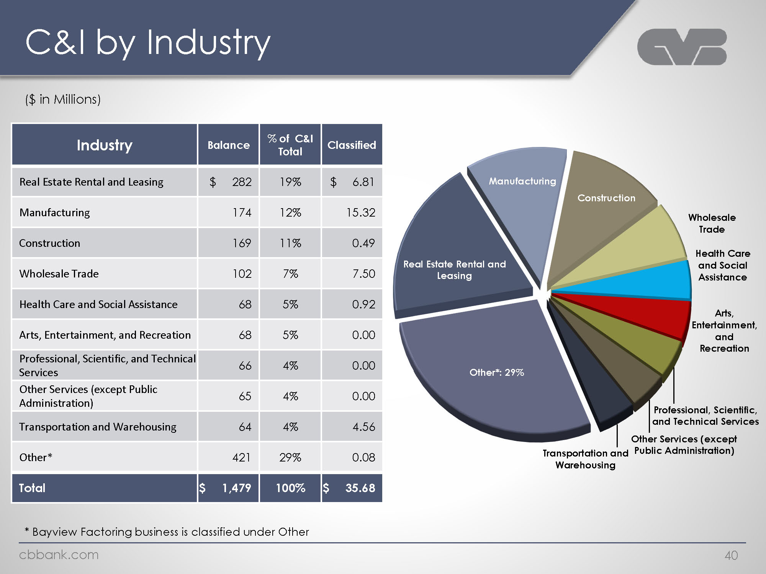
Logo C&I by Industry ($ in Millions) Industry Balance % of C&I Total Classified Real Estate Rental and Leasing $ 282 19% $ 6.81 Manufacturing 174 12% 15.32 Construction 169 11% 0.49 Wholesale Trade 102 7% 7.50 Health Care and Social Assistance 68 5% 0.92 Arts, Entertainment, and Recreation 68 5% 0.00 Professional, Scientific, and Technical Services 66 4% 0.00 Other Services (except Public Administration) 65 4% 0.00 Transportation and Warehousing 64 4% 4.56 Other* 421 29% 0.08 Total $ 1,479 100% $ 35.68 Manufacturing Construction Real Estate Rental and Leasing Other*: 29% Wholesale Trade Health Care and Social Assistance Arts, Entertainment, and Recreation Professional, Scientific, and Technical Services Other Services (except Public Administration) Transportation and Warehousing * Bayview Factoring business is classified under Other Cbbank.com 40

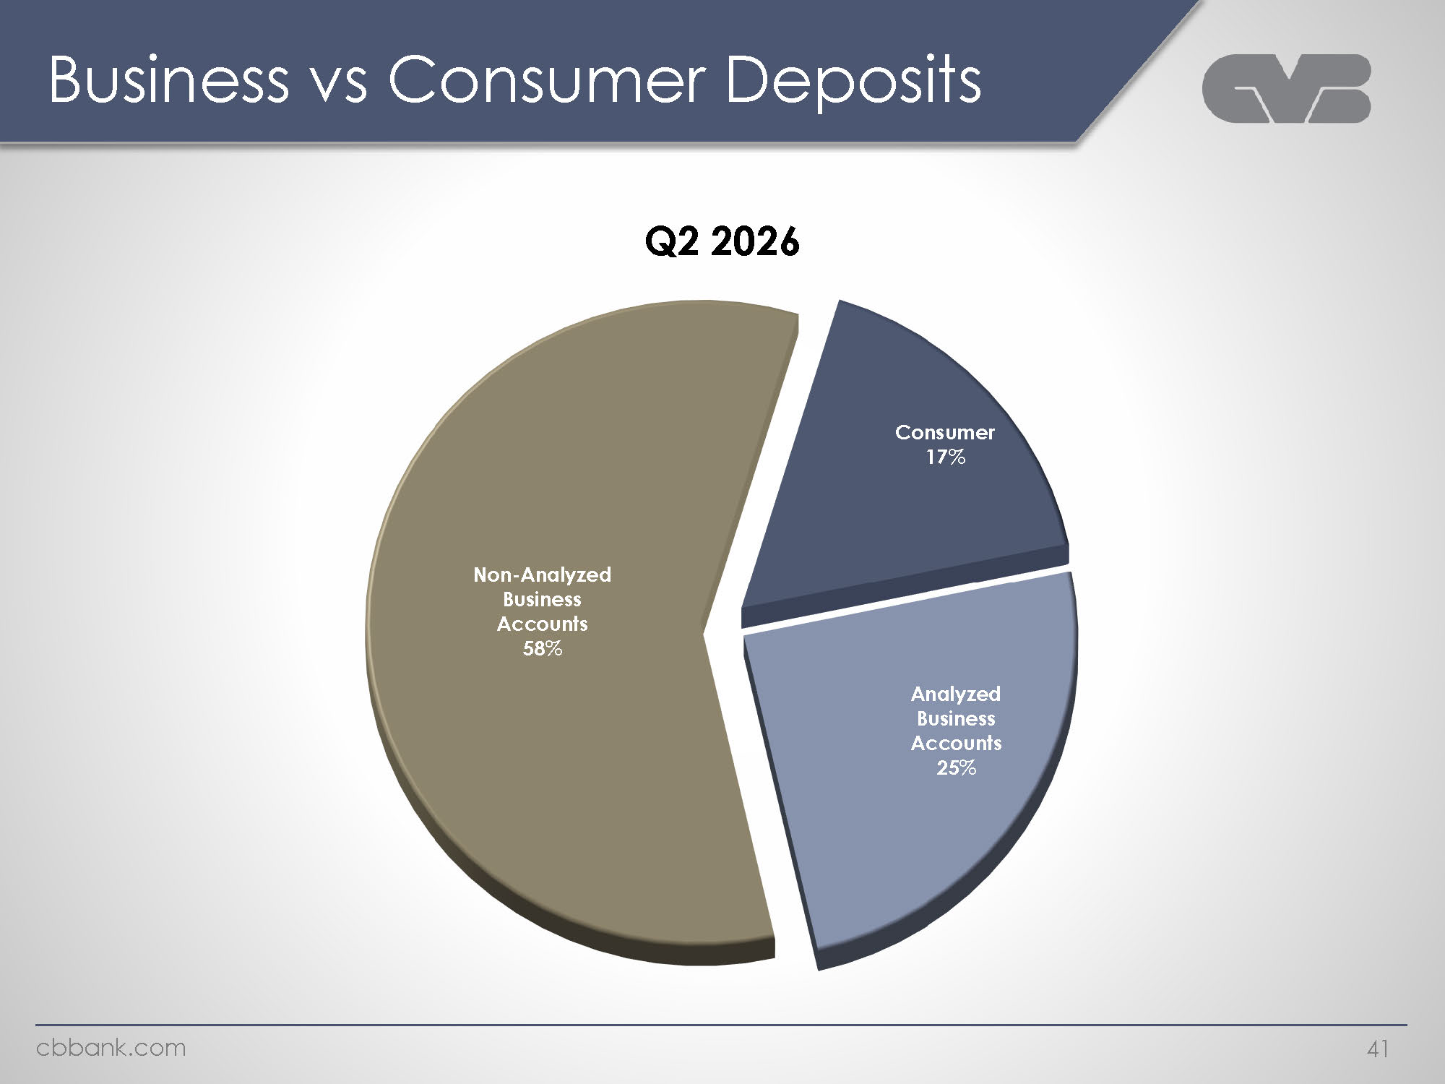
Logo Business vs Consumer Deposits Q2 2026 Non-Analyzed Business Accounts 58% Consumer 17% Analyzed Business Accounts 25% cbbank.com 41

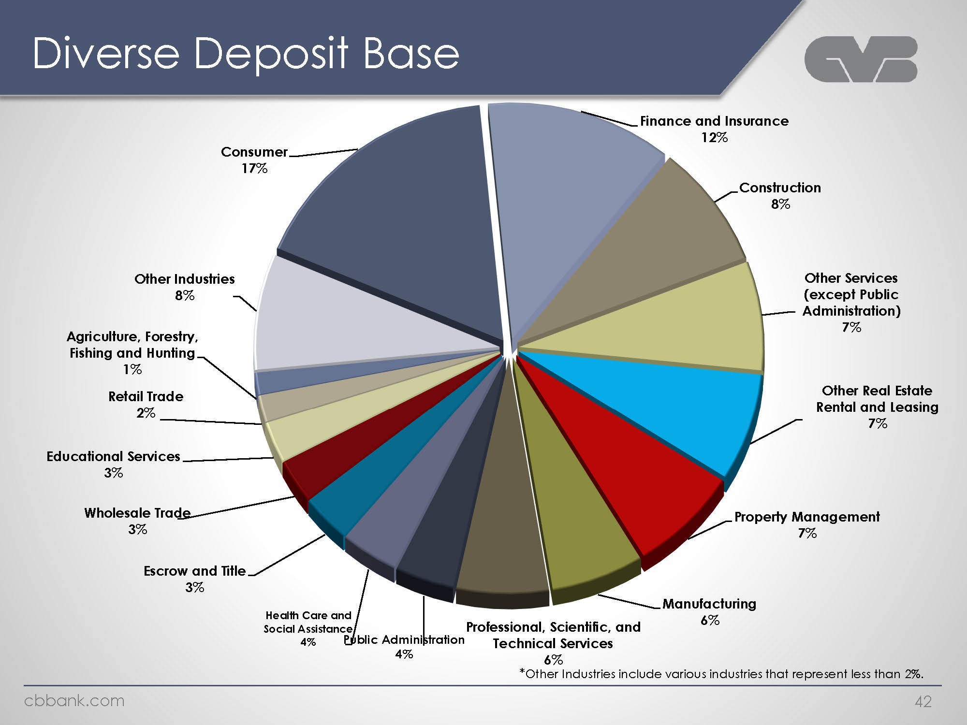
Logo Diverse Deposit Base Consumer 17% Other Industries 8% Agriculture, Forestry, Fishing and Hunting 1% Retail Trade 2% Educational Services 3% Wholesale Trade 3% Escrow and Title 3% Health Care and Social Assistance 4% Public Administration 4% Professional, Scientific, and Technical Services 6% Manufacturing 6% Property Management 7% Other Real Estate Rental and Leasing 7% Other Services (except Public Administration) 7% Construction 8% Finance and Insurance 12% *Other Industries include various industries that represent less than 2%.cbbank.com 42

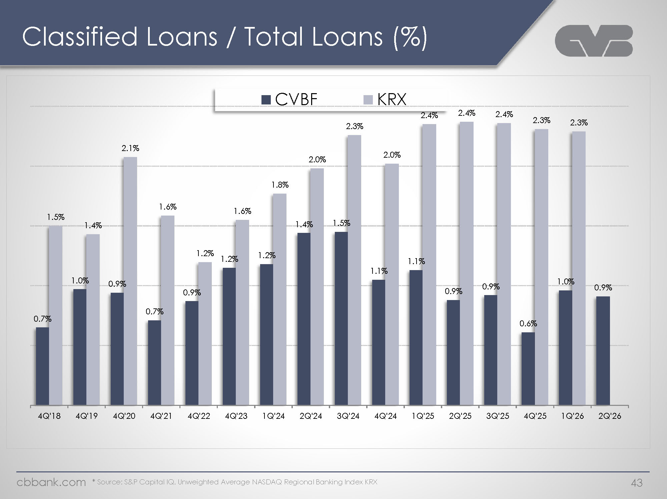
Logo Classified Loans / Total Loans (%) CVBF KRX 0.7% 1.5% 1.0% 1.4% 0.9% 2.1% 0.7% 1.6% 0.9% 1.2% 1.2% 1.6% 1.2% 1.8% 1.4% 2.0% 1.5% 2.3% 1.1% 2.0% 1.1% 2.4% 0.9% 2.4% 0.9% 0.6% 2.3% 1.0% 2.3% 0.9% 4Q'18 4Q'19 4Q'20 4Q'21 4Q'22 4Q'23 1Q'24 2Q'24 3Q'24 4Q'24 1Q'25 2Q'25 3Q'25 4Q'25 1Q'26 2Q'26 * Source: S&P Capital IQ. Unweighted Average NASDAQ Regional Banking Index KRX Cbbank.com 43

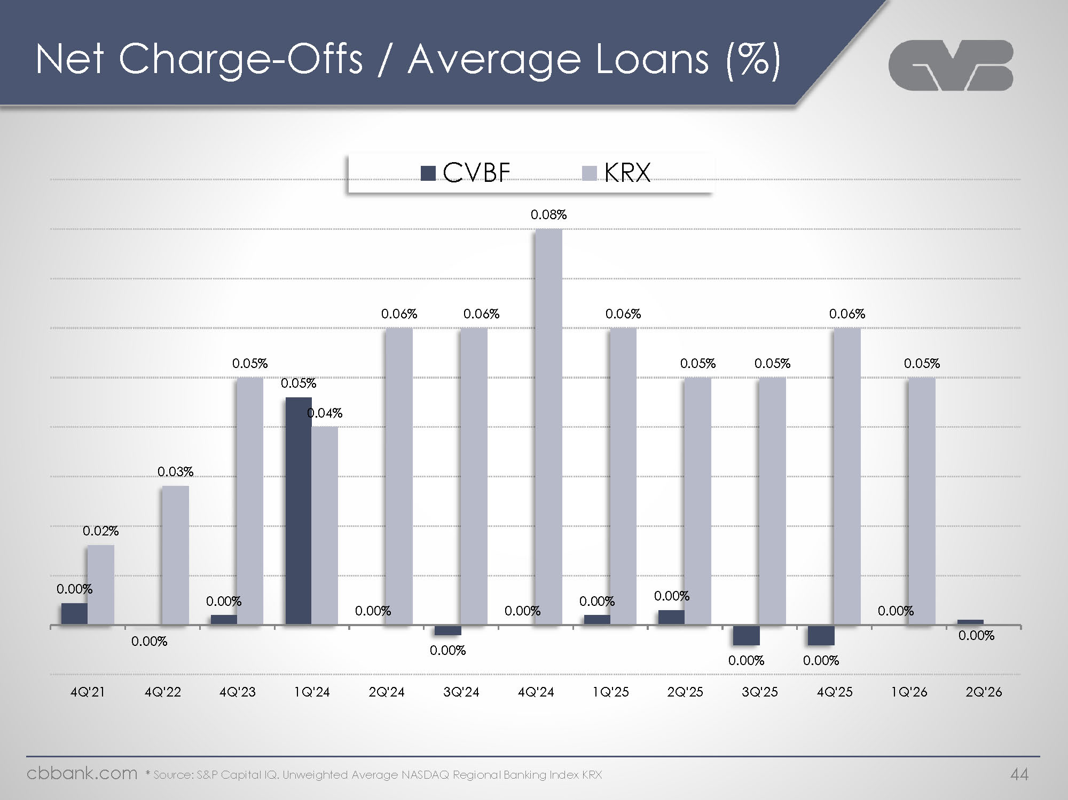
Logo Net Charge-Offs / Average Loans (%) 0.00% 0.02% 0.00% 0.03% 0.00% 0.05% 0.05% 0.04% 0.00% 0.06% 0.00% 0.06% 0.00% 0.08% 0.00% 0.00% 0.06% 0.00% 0.05% 0.00% 0.05% 0.00% 0.05% 0.00% 0.06% 0.00% 0.05% 0.00% 4Q'21 4Q'22 4Q'23 1Q'24 2Q'24 3Q'24 4Q'24 1Q'25 2Q'25 3Q'25 4Q'25 1Q'26 2Q'26 * Source: S&P Capital IQ. Unweighted Average NASDAQ Regional Banking Index KRX Cbbank.com 44

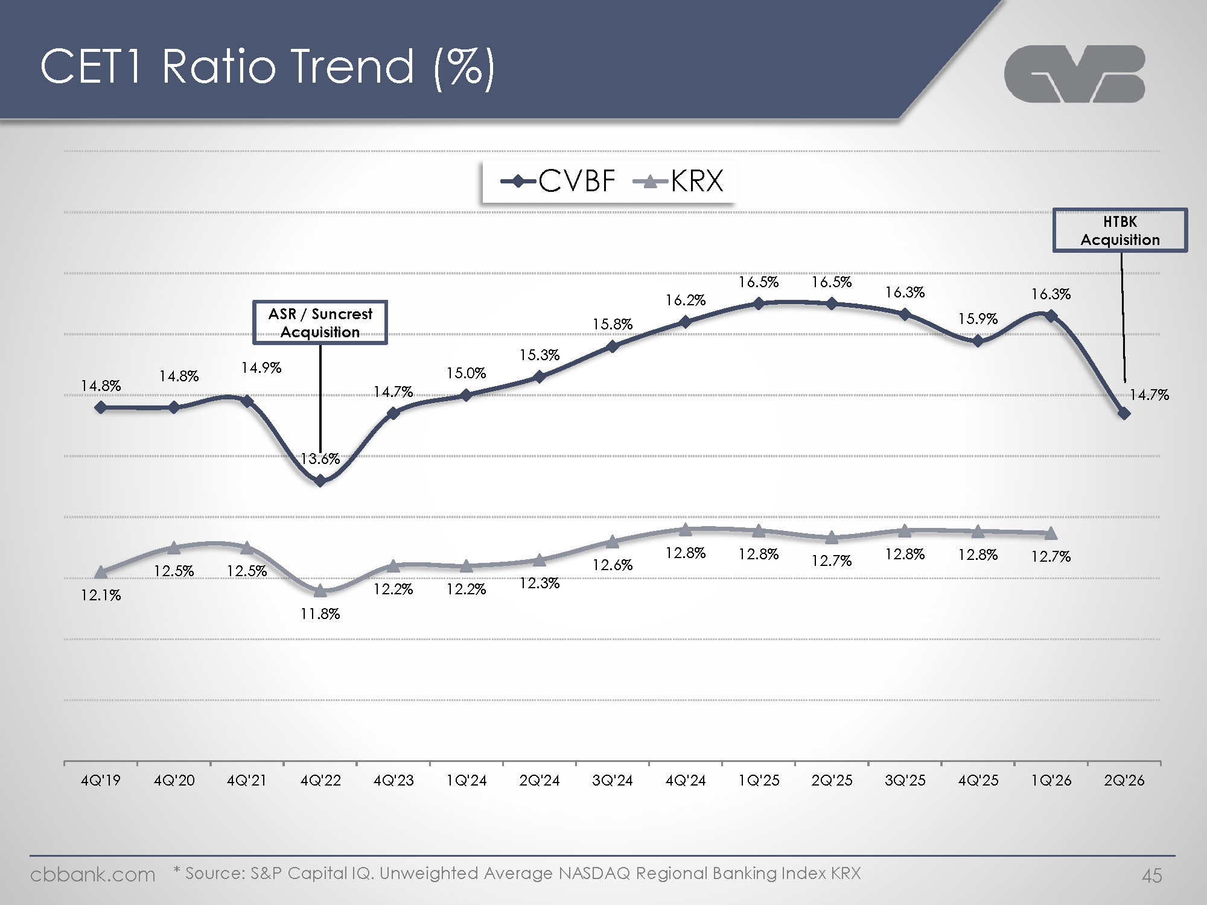
Logo CET1 Ratio Trend (%) CVBF KRX 14.8% 14.% 14.9% 13.6% ASR / Suncrest Acquisition 14.7% 15.0% 15.3% 15.8% 16.2% 16.5% 16.5% 16.3% 15.9% 16.3% 14.7% HTBK Acquisition 12.1% 12.5% 12.5% 11.8% 12.2% 12.2% 12.3% 12.6% 12.8% 12.7% 12.7% 12.8% 12.8% 12.8% 12.7% 4Q’19 4Q’20 4Q’21 4Q’22 4Q’23 1Q’24 3Q’24 4Q’24 1Q’25 2Q’25 3Q’25 4Q’25 1Q’26 2Q’26 * Source: S&P Capital IQ. Unweighted Average NASDAQ Regional Banking Index KRX cbbank.com 45

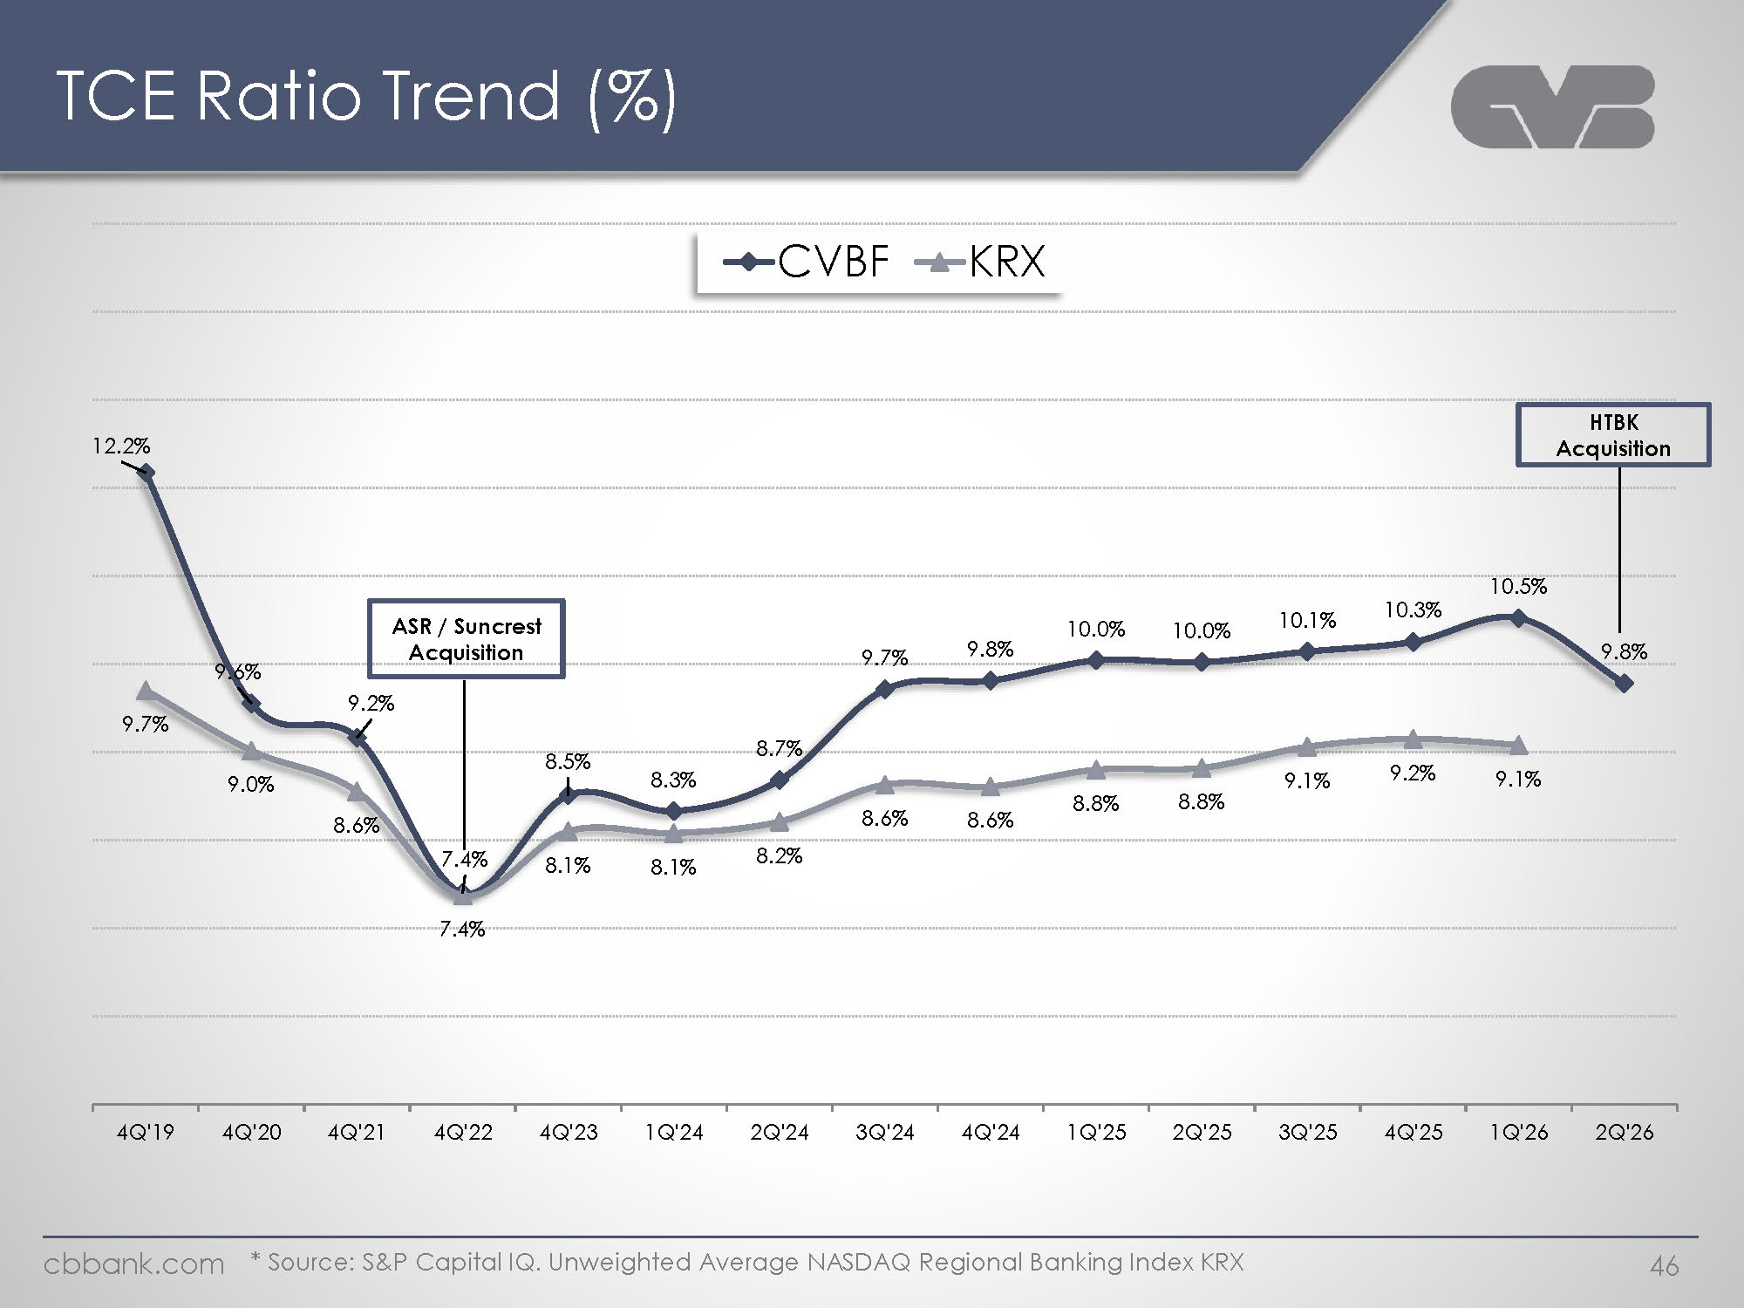
Logo TCE Ratio Trend (%) CVBF KRX 12.2% 9.6% 9.2% 7.4% ASR / Suncrest Acquisition 8.5% 8.3% 8.7% 9.7% 9.8% 10.0% 10.0% 10.1% 10.3% 10.5% 9.8% HTBK Acquisition 9.7% 9.0% 8.6% 7.4% 8.1% 8.1% 8.2% 8.6% 8.6% 8.8% 9.1% 9.2% 9.1% 4Q'19 4Q'20 4Q'21 4Q'22 4Q'23 1Q'24 2Q'24 3Q'24 4Q'24 1Q'25 2Q'25 3Q'25 4Q'25 1Q'26 2Q'26 * Source: S&P Capital IQ. Unweighted Average NASDAQ Regional Banking Index KRX Cbbank.com 46

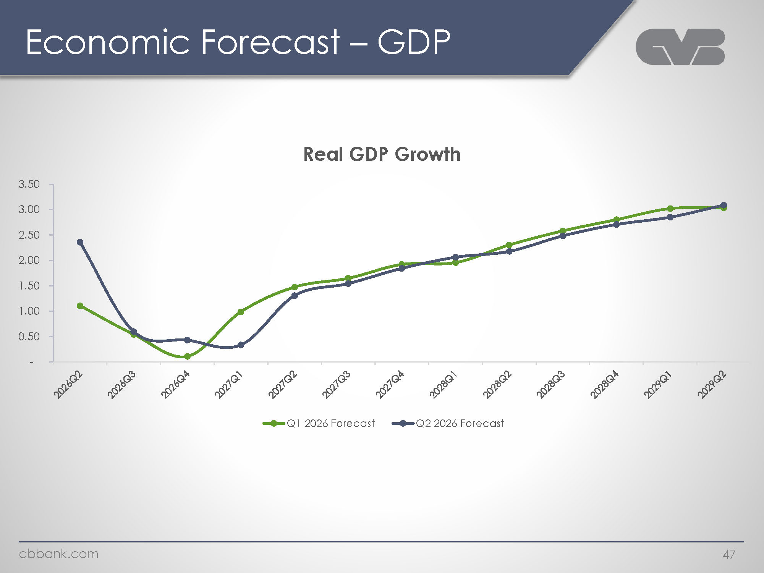
Logo Economic Forecast – GDP Real GDP Growth 3.50 3.00 2.50 2.00 1.50 1.00 0.50 – 2026Q2 2026Q3 2026Q4 2027Q1 2027Q2 2027Q3 2027Q4 2028Q1 2028Q2 2028Q3 2028Q4 2029Q1 2029Q2 Q1 2026 Forecast Q2 2026 Forecast Cbbank.com 47

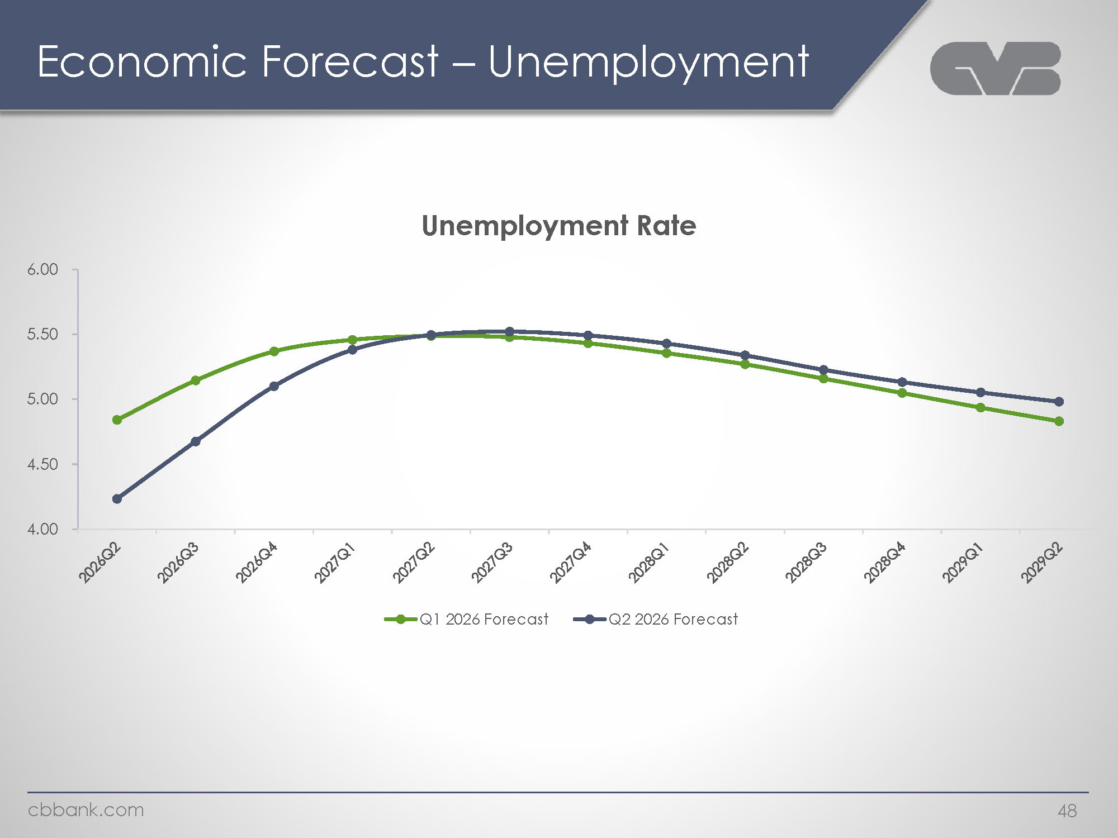
Logo Economic Forecast – Unemployment Unemployment Rate 6.00 5.50 5.00 4.50 4.00 2026Q2 2026Q3 2026Q4 2027Q1 2027Q2 2027Q3 2027Q4 2028Q1 2028Q2 2028Q3 2028Q4 2029Q1 2029Q2 Q1 2026 Forecast Forecast Q2 2026 Forecast Cbbank.com 48

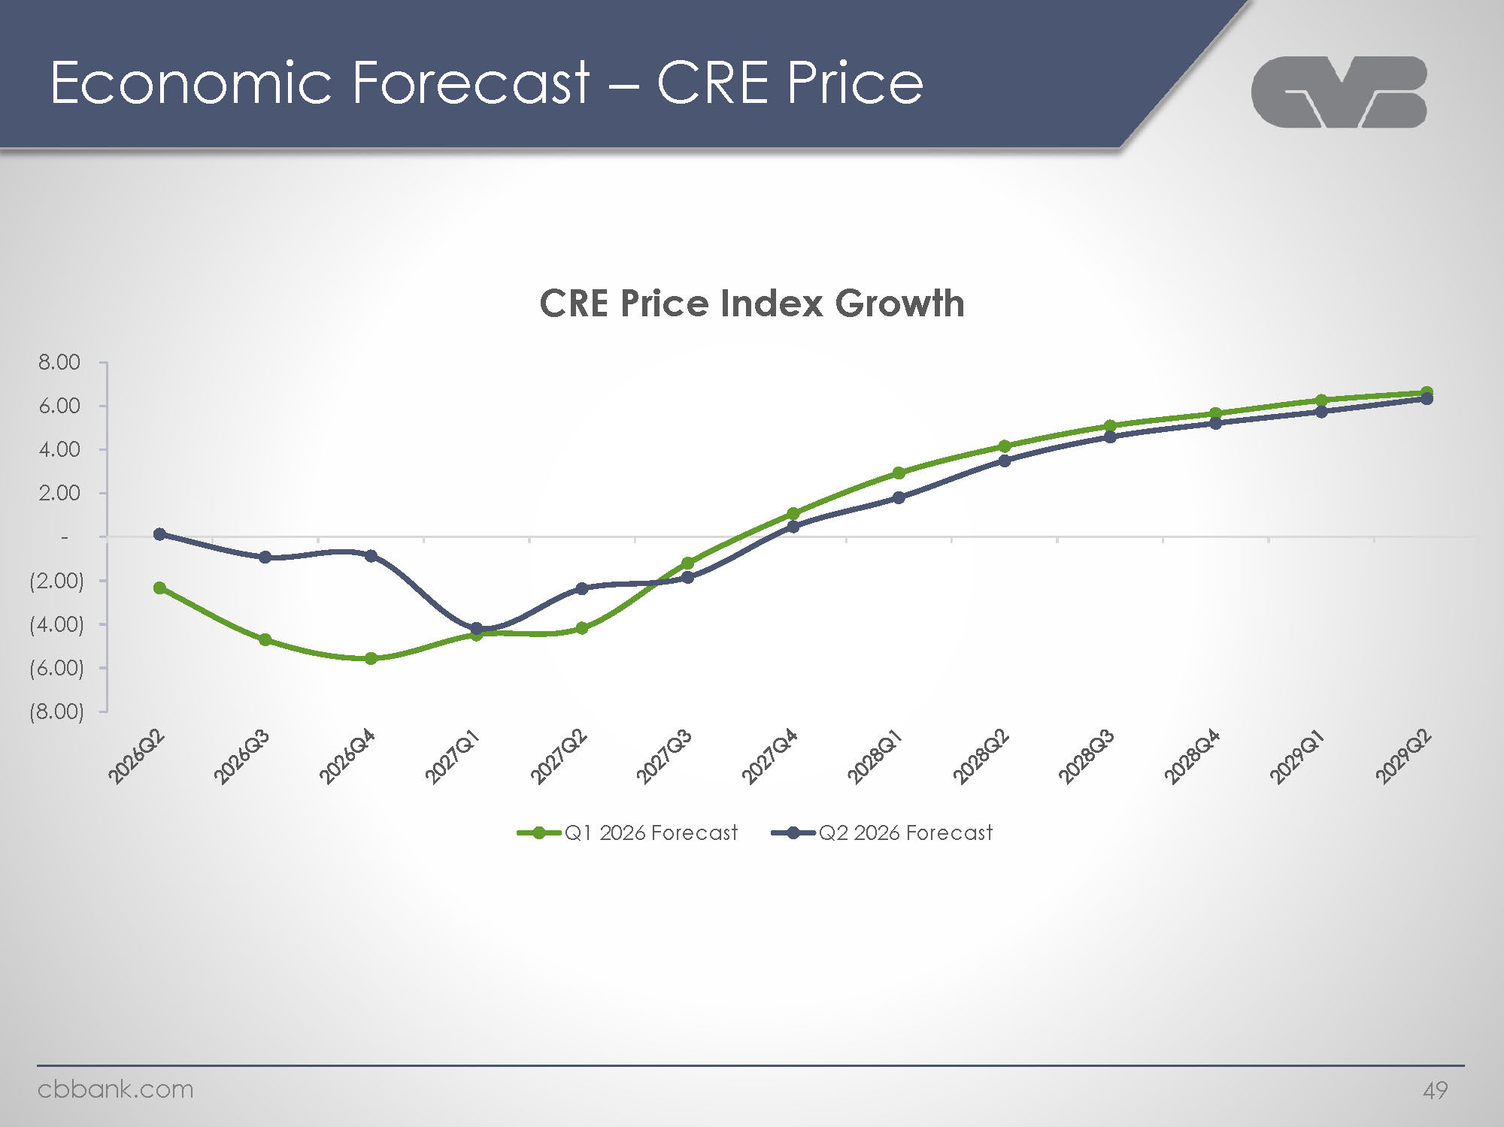
Logo Economic Forecast – CRE Price CRE Price Index Growth 8.00 6.00 4.00 2.00 (2.00) (4.00) (6.00) (8.00) 2026Q2 2026Q3 2026Q4 2027Q1 2027Q2 2027Q3 2027Q4 2028Q1 2028Q2 2028Q3 2028Q4 2029Q1 2029Q2 Q1 2026 Forecast Forecast Q2 2026 Forecast Cbbank.com 49

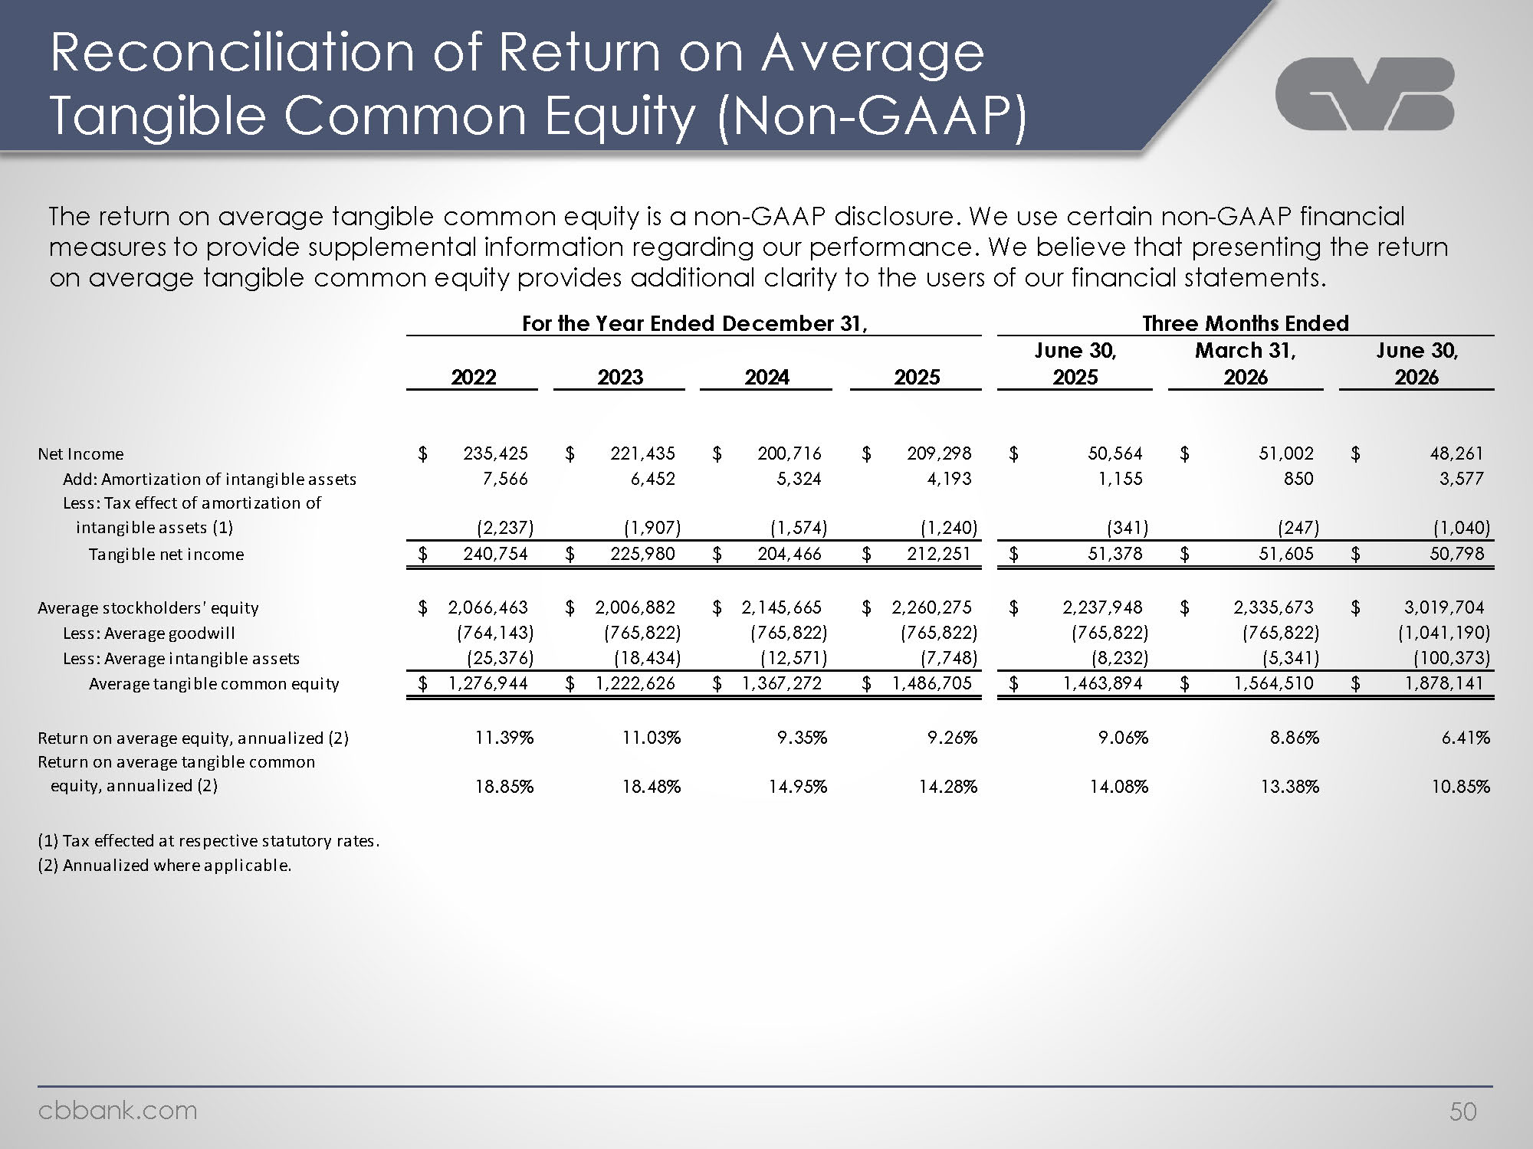
Logo Reconciliation of Return on Average Tangible Common Equity (Non-GAAP) The return on average tangible common equity is a non-GAAP disclosure. We use certain non-GAAP financial measures to provide supplemental information regarding our performance. We believe that presenting the return on average tangible common equity provides additional clarity to the users of our financial statements. For the Year Ended December 31, Three Months Ended 2022 2023 2024 2025 June 30, 2025 March 31, 2026 June 30, 2026 Net Income $ 235,425 $ 221,435 $ 200,716 $ 209,298 $ 50,564 $ 51,002 $ 48,261Add: Amortization of intangible assets 7,566 6,452 5,324 4,193 1,155 850 3,577 Less: Tax effect of amortization of intangible assets (1) (2,237) (1,907) (1,574) (1,240) (341) (247) (1,040) Tangible net income $ 240,754 $ 225,980 $ 204,466 $ 212,251 $ 51,378 $ 51,605 $ 50,798 Average stockholders' equity $ 2,066,463 $ 2,006,882 $ 2,145,665 $ 2,260,275 $ 2,237,948 $ 2,335,673 $ 3,019,704 Less: Average goodwill (764,143) (765,822) (765,822) (765,822) (765,822) (765,822) (1,041,190) Less: Average intangible assets (25,376) (18,434) (12,571) (7,748) (8,232) (5,341) (100,373) Average tangible common equity $ 1,276,944 $ 1,222,626 $ 1,367,272 $ 1,486,705 $ 1,463,894 $ 1,564,510 $ 1,878,141 Return on average equity, annualized (2) 11.39% 11.03% 9.35% 9.26% 9.06% 8.86% 6.41% Return on average tangible common equity, annualized (2) 18.85% 18.48% 14.95% 14.28% 14.08% 13.38% 10.85% (1) Tax effected at respective statutory rates.(2) Annualized where applicable. Cbbank.com 50

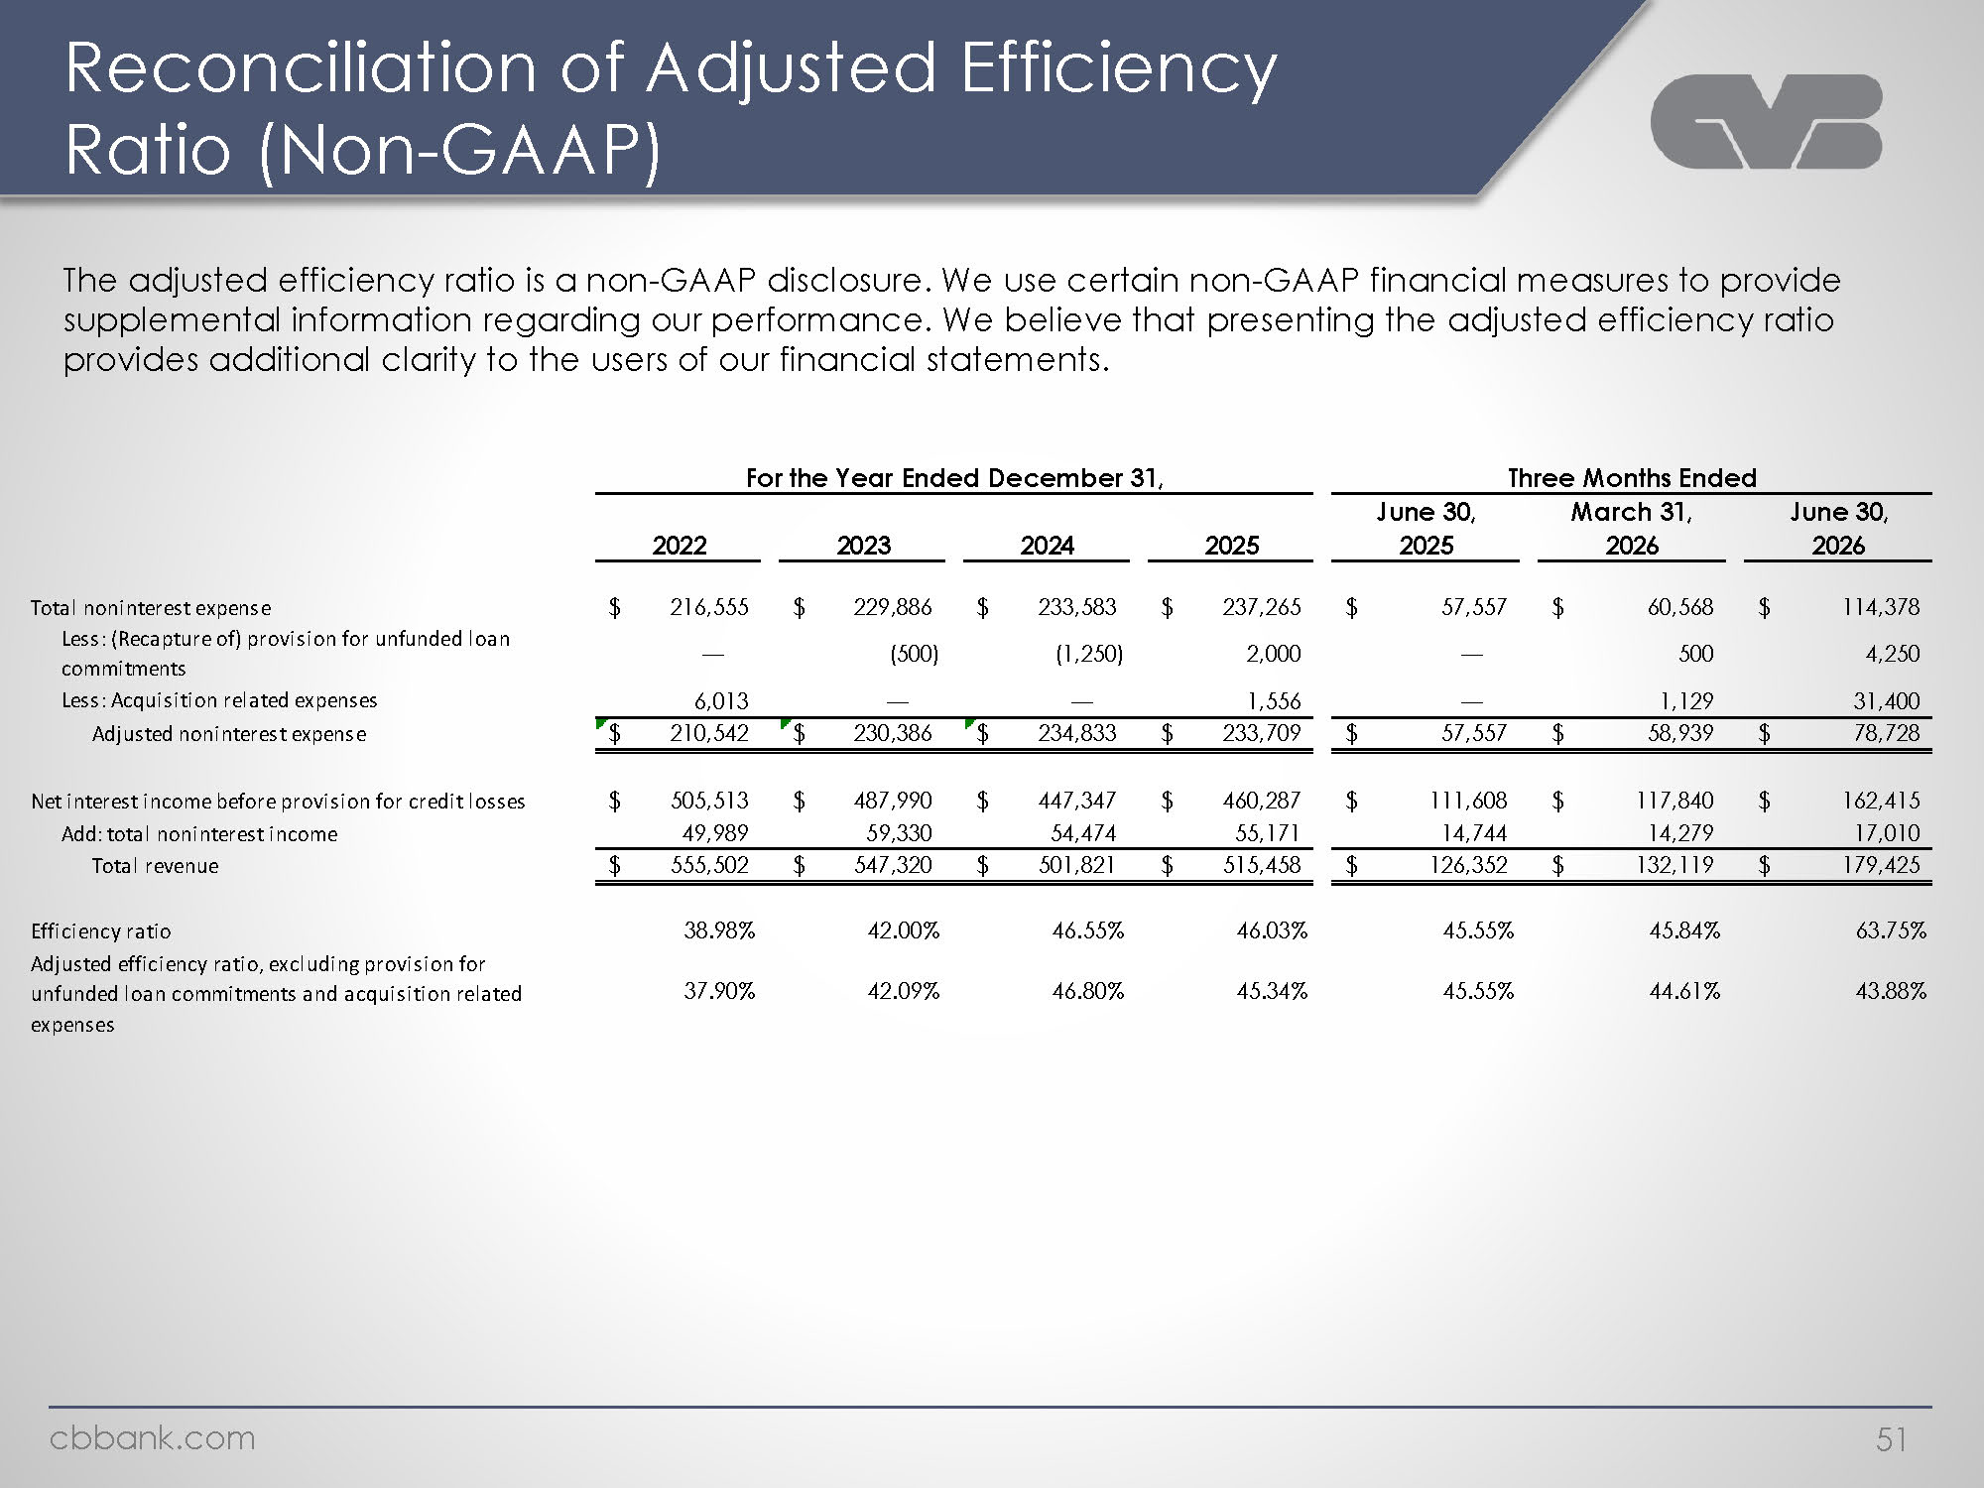
Logo Reconciliation of Adjusted Efficiency Ratio (Non-GAAP) The adjusted efficiency ratio is a non-GAAP disclosure. We use certain non-GAAP financial measures to provide supplemental information regarding our performance. We believe that presenting the adjusted efficiency ratio provides additional clarity to the users of our financial statements. For the Year Ended December 31, Three Months Ended Total noninterest expense 2022 2023 2024 2025 June 30, 2025 March 31, 2026 June 30, 2026 Less: (Recapture of) provision for unfunded loan commitments (500) $ 216,555 $ 229,886 $ 233.583 $ 237,265 $ 57,557 $ 60,568 $ 114,378 Less: Acquisition related expenses 6,013 1,556 (1.250) 2.000 500 4.250 Adjusted noninterest expense $ 210,542 $ 230,386 $ 234,833 $ 233,709 $ 57,557 $ 58,939 1,129 31,400 $ 78,728 Net interest income before provision for credit losses. $ 505,513 49,989 $ 487,990 $ 447,347 $ 460,287 $ 111,608 $ 117,840 $ 162,415 Add: total noninterest income $ 555,502 $ 547,320 59,330 54,474 55,171 14,744 14,279 17,010 Total revenue 38.98% $ 501,821 $ 515,458 $ 126,352 $ 132.119 $ 179,425 Efficiency ratio 37.90% 42.00% 46.55% 46.03% 45.55% 45.84% 63.75% Adjusted efficiency ratio, excluding provision for unfunded loan commitments and acquisition related expenses 42.09% 46.80% 45.34% 45.55% 44.61% 43.88% Cbbank.com 51

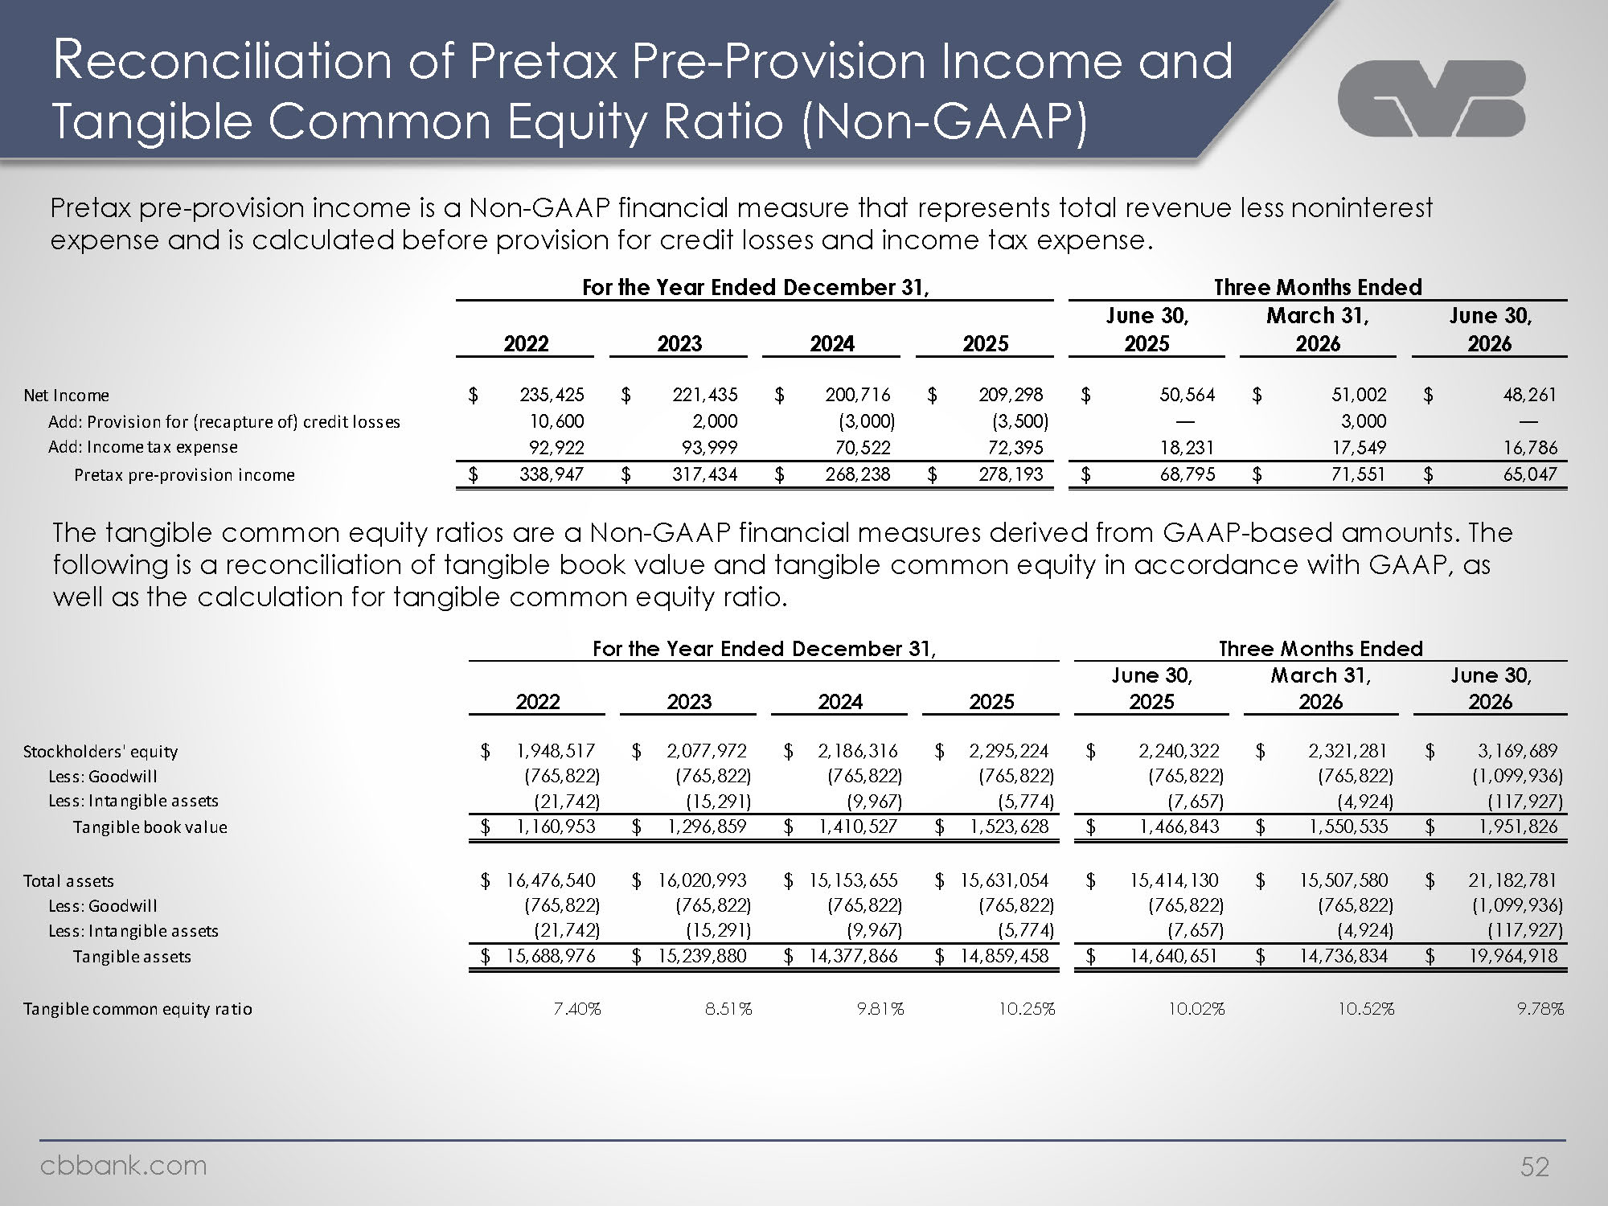
Logo Reconciliation of Pretax Pre-Provision Income and Tangible Common Equity Ratio (Non-GAAP) Pretax pre-provision income is a Non-GAAP financial measure that represents total revenue less noninterest expense and is calculated before provision for credit losses and income tax expense. For the Year Ended December 31 Three Months Ended 2023 2024 2025 June 30, 2025 March 31, 2026 June 30, 2026 Net Income $ 235,425 $ 221,435 $ 200,716 $ 209,298 $ 50,564 $ 51,002 $ 48,261 Add: Provision for (recapture of) credit losses 10,600 2,000 (3,000) (3,500) — 3,000 — Add: Income tax expense 92,922 93,999 70,522 72,395 18,231 17,549 16,786 Pretax pre-provision income $ 338,947 $ 317,434 $ 268,238 $ 278,193 $ 68,795 $ 71,551 $ 65,047 The tangible common equity ratios are a Non-GAAP financial measures derived from GAAP-based amounts. The following is a reconciliation of tangible book value and tangible common equity in accordance with GAAP, as well as the calculation for tangible common equity ratio. For the Year Ended December 31 Three Months Ended 2022 2023 2024 2025 June 30, 2025 March 31, 2026 June 30, 2026 Stockholders' equity $ 1,948,517 $ 2,077,972 $ 2,186,316 $ 2,295,224 $ 2,240,322 $ 2,321,281 $ 3,169,689 Less: Goodwill (765,822) (765,822) (765,822) (765,822) (765,822) (765,822) (1,099,936) Less: Intangible assets (21,742) (15,291) (9,967) (5,774) (7,657) (4,924) (117,927) Tangible book value $ 1,160,953 $ 1,296,859 $ 1,410,527 $ 1,523,628 $ 1,466,843 $ 1,550,535 $ 1,951,826 Total assets $ 16,476,540 $ 16,020,993 $ 15,153,655 $ 15,631,054 $ 15,414,130 $ 15,507,580 $ 21,182,781 Less: Goodwill (765,822) (765,822) (765,822) (765,822) (765,822) (765,822) (1,099,936) Less: Intangible assets (21,742) (15,291) (9,967) (5,774) (7,657) (4,924) (117,927) Tangible assets $ 15,688,976 $ 15,239,880 $ 14,377,866 $ 14,859,458 $ 14,640,651 $ 14,736,834 $ 19,964,918 Tangible common equity ratio 7.40% 8.51% 9.81% 10.25% 10.02% 10.52% 9.78% Cbbank.com 52


Logo CVB Financial Corp. Copy of presentation at WW.Cbbank.com Cbbank.com

